HWB Weekly Overview - Week Beginning: 7/02/21
Here are some suggested activities for HWB this week. This term our focus will be Food and Health.
If you can, try to complete some of these activities as part of your home learning for HWB.

This week the activities all link to the Achieving wellbeing indicator.
Primary 1 | L.I - Select and prepare ingredients to follow a simple recipe, with support. HWB 0-30a | 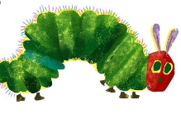  Activities – Hopefully you had a chance to listen to the story of ‘The Very Hungry Caterpillar’. The caterpillar ate lots of healthy fruits during the week.  *Have a look at the Fruit Smoothie Recipe cards. These are all made with the fruits the very hungry caterpillar ate. Try to follow one of the recipes and make your own smoothie with help from an adult. I’m sure they will taste yummy!  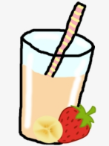  *Once you have made your smoothie. Use the sheet below to write or draw the ingredients you used and how you made it.
Primary 2 | L.I – Demonstrate a range of simple practical and problem-solving skills when preparing and cooking food. HWB 1-30b | Activities – We should be drinking around 6 glasses of water based drinks a day to keep our bodies healthy.  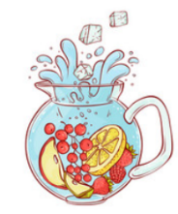  *Create some delicious new flavours for your water bottles. You might try adding just one natural flavour (fruit, vegetable or herb) or you could add a few different flavours at a time.  *Follow the instructions and complete the activity sheet below.
Primary 3 | L.I – Demonstrate a range of simple practical and problem-solving skills when preparing and cooking food. HWB 1-30b | Activities – We should be drinking around 6 glasses of water based drinks a day to keep our bodies healthy.  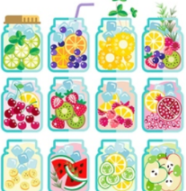  * Create a set of experiments to design some delicious new flavours for your water bottles eg try adding a combination of a squeeze of lemon, a drop of mint, or a handful of frozen cherries to the mix.
Primary 4 | L.I – Demonstrate a positive attitude towards preparing, cooking and tasting different healthy food and drink. HWB 1-30b  Write up the steps taken to prepare a simple dish/snack/meal. LIT 1-26a | Activities – Think of a basic snack/lunch you enjoy.  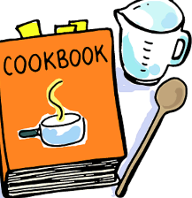  * Have a go at making it and write up the steps taken to prepare your simple dish/snack/meal. Use the activity sheet below to design your recipe. Remember to add how much of each thing you need.  Try add drawings to you recipe to make it look interesting.
Primary 5 | L.I- To understand how preparing and cooking foods with others can be enjoyable and develop lifelong skills. HWB 2-20a | Activities – Practical skills development. Develop your skills when preparing different foods or helping with lunch/dinner.  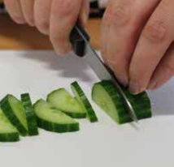  *Watch some of these skills and techniques videos in the links below. When helping to prepare food at home try practising these skills.  Bridge and Claw cutting technique  Peeling fruit and vegetables  *Send in some pictures of you practising these cutting techniques. Apples, cucumbers, tomatoes, potatoes are all good foods to use.
Primary 6 | L.I- To recognise the importance of using locally sourced foods for sustainability.  HWB 2-34a  To manage money, compare costs and determine what I can afford to buy. MNU 2-09a | Activities – Plan and budget for a celebratory Scottish feast when your class returns to school. Your imaginary meal must have ingredients locally sourced in Scotland and have foods from at least 3 of the main food groups.  *Please see information on the video below with full instructions.  *Use the Scottish food map below to help you understand what foods are produced in Scotland and where they are produced.  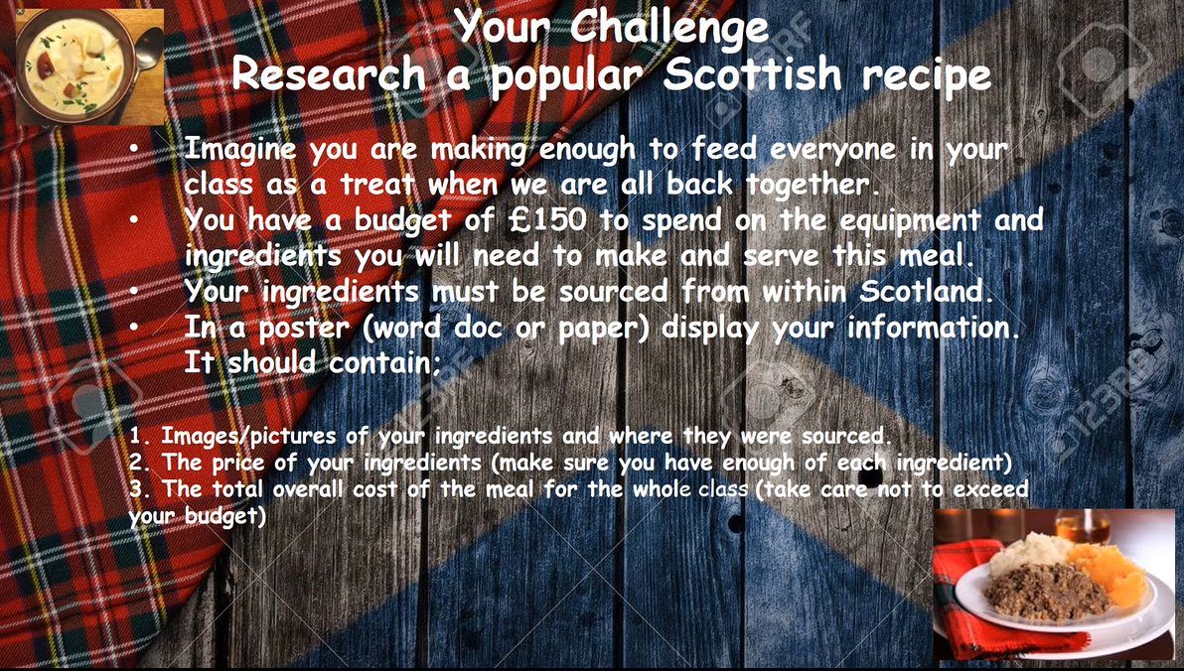  Video instructions are on your Teams page.
Primary 7 | L.I- To recognise the importance of using locally sourced foods for sustainability.  HWB 2-34a  To manage money, compare costs and determine what I can afford to buy. MNU 2-09a | Activities –– Plan and budget for a celebratory Scottish feast when your class returns to school. Your imaginary meal must have ingredients locally sourced in Scotland.  *Please see information on the video below with full instructions.  *Use the Scottish food map below to help you understand what foods are produced in Scotland and where they are produced.  Video instructions are on your Teams page.

Click on the link to watch a video of Mrs Bradley making Origami Animals and try making your own.

