HWB Weekly Overview - Week Beginning: 18/01/21
Here are some suggested activities for HWB this week. This term our focus will be Food and Health.
+If you can, try to complete some of these activities as part of your home learning for HWB.

Again, the activities all link to the Safe wellbeing indicator.
Primary 1 | L.I - Describe, in simple terms, what germs are and how I can stop them from spreading. HWB 0-15a | Activities –  Watch the germs PowerPoint below.  (Double click picture)  Everything You Touch:This is a great exercise for teaching children about germs and how quickly they manage to spread. Ask your children to draw lots of little pictures of germs. However they wish to represent a germ will do. Tell them that for the next half an hour, they have to stick a little germ to everything that they touch. When half an hour is up, they can look around at the room to see how much germs spread – and that’s only for one person!  Hand washing song click on the link to sing and dance along to this song from the ‘Bounce Patrol’
Primary 2 | L.I – Understand the different ways in which germs can be spread and controlled. HWB 1-15a | Activities – How germs are spread Watch this cartoon that helps show you how germs are spread.  Double click on and try this activity below. When it mentions ‘partner’ this could be your mum, dad, brother or sister.  Have a game of ‘GERMS’ snakes and ladders with your family.
Primary 3 | L.I – Understand the different ways in which germs can be spread and controlled. HWB 1-15a | Germs are everywhere. We can’t seem them but they are all around us. Some germ hotspots are - our hands, kitchen tops, phones and tablets, and toilets. When germs get into our bodies they can make us very unwell.  REMEMBER - We must wash our hands regularly to stop germs from entering our body.  We should sneeze and cough into our elbow or tissue to stop germs spreading through the air.  Activities - Can you design your own ‘GERM’  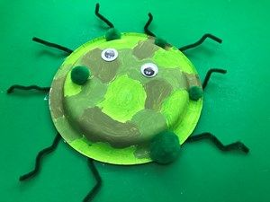  * make a list of symptoms your germ might cause if it enters your body.
Primary 4 | L.I – Understand and explain the different ways in which germs can be spread and controlled. HWB 1-15a | Activities – Double click on the picture below to watch the PowerPoint.  Create/design your own GERM – you could draw it or use recycled materials to make it.  Write down what symptoms a person might have if this germ gets into their body. What could you do to prevent getting sick?
Primary 5 | L.I- Understand ways to prevent food poisoning. HWB 2-15a /HWB 2-33a | 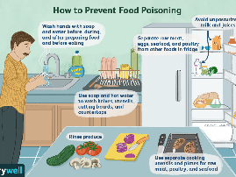  Activities – Have a look at the information on this link NHS information about the causes of food poisoning  Make a poster showing how you can prevent food poisoning.  Ctrl+click on picture to see full poster to help.
Primary 6 | L.I- Understand ways to prevent food poisoning. HWB 2-15a /HWB 2-33a | Activities – Use your knowledge of good food hygiene when preparing and cooking a meal of your choice. Are you following all the food hygiene rules to ensure you don’t become unwell?  (double click to watch the PowerPoint)
Primary 7 | L.I- Understand and explain ways to prevent food poisoning. HWB 2-15a /HWB 2-33a | Activities – Activities – Use your knowledge of good food hygiene when preparing and cooking a meal of your choice. Are you following all the food hygiene rules to ensure you don’t become unwell?  (double click to watch the PowerPoint)  List some of the steps you have taken, when preparing, cooking and storing your food.

*P6/7 – Here is a link to some recipes you might want to try – BBC Good Food Recipes

