Monday June 22nd

Planning a trip to Disneyworld Florida

1*Choose your own movement activity and do at least 20 minutes. (You don't have to stick to just one)

Keep Fit with The Incredibles
Disney Dance Challenge
Choose which songs are your favourite dance a-longs
Mousekersize with Mickey Mouse

2*
Let's get to Disney World

Scroll down

Flight Prices.

Glasgow to Orlando | One way
Seat | £400
Children under 2 | free

Orlando to Glasgow | One way
Seat | £300
Children under 2 | free

How much to get your whole family there AND back again?

3* Ask everyone in your family what would be in their dream hotel. Design a poster advertising it.

4* You have arrived at your dream hotel now you must buy tickets to the park.

Family ticket (2 adults and 4 children) | $90
Adult ticket | $50
child ticket (under 16) | $40
Family ticket (2 adults and 4 children) | $50
Adult ticket | $30
child ticket (under 16) | $20

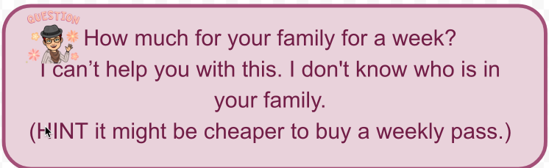

4b* Now that you have your answer. Design a Disney themed ticket that shows me the price you would pay.

And we have arrived.
Have a look around
The Magic Kingdom

Epcot Park

