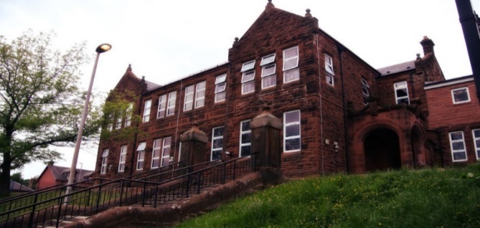

Learning across the Curriculum

We have been learning:

* About the Easter story.
* How to work effectively in groups to research and produce a poster on an aspect of WW2.

Next we will be learning about:

* Relationships and sexual health.
* Athletics.

General update from teacher

Hello everyone!

Welcome back to the final term of P7!

This term, we will be discussing lots about moving on to secondary and answering any questions you might have. We hope to have some transition time at Loudoun but will let you know as soon as we hear anything from them. We will also be starting to gather athletics scores towards awarding our Sports Champions! King Charles’ Coronation will be marked by some fun acitivites on May 5th – more details to follow!

Numeracy

We have been learning:

* How to solve simple equations.

Next we will be learning to:

* Solve more complex equations.

**Darvel Primary School**

**P7 April Newsletter**

**Mrs Route**

**December 2022**

Literacy

We have been learning:

* Spelling – We have been concentrating on the phoneme ‘f’ and it’s different graphemes.
* Writing – we have sent off our Young Writers’ pieces for the competition.
* Reading – we have now completed our WW2 novels.

Next we will return to guided reading groups and will read a transition novel.