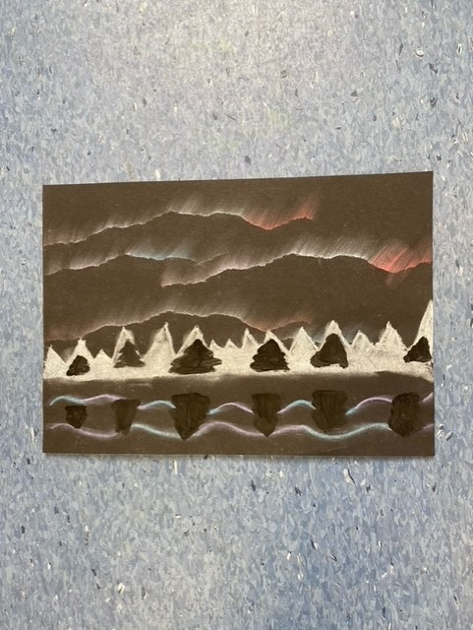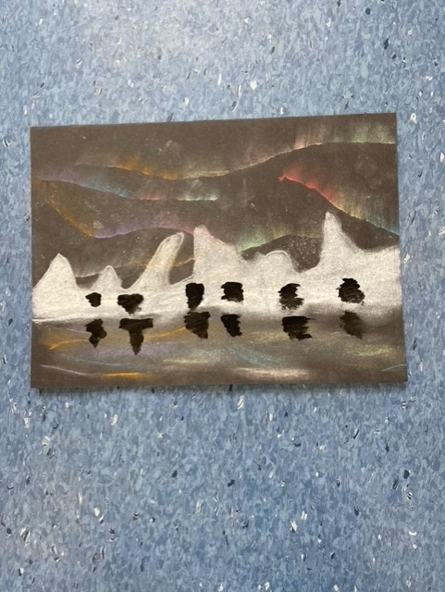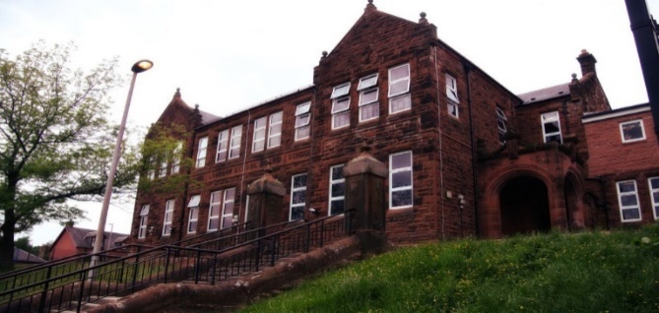

Learning across the Curriculum

We have been learning:

* About evacuation and rationing.
* We created beautiful chalk drawings of the Northern Lights as seen below.

Next we will be learning about:

* Easter
* My changing body and how to keep ourselves safe.

General update from teacher

Hello everyone!

Well, P7 is certainly marching on! We have been issued with a new WW2 homework grid and I am enjoying seeing the wonderful work you are producing! Please continue to bring your pieces in to share with us!

Well done to our Burns winners, Courtney, Danni-Lee and Skye – I know it was a tricky poem to learn but we all made such a wonderful effort!

Good luck to our class members who have volunteered for our school choir and will represent us this weekend!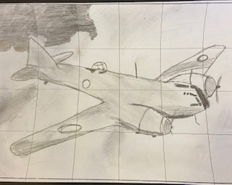

Numeracy

We have been learning:

* About rounding whole numbers and decimals

Next we will be learning to:

* Use simple algebra.

Literacy

We have been learning:

* Spelling – We have been concentrating on the phoneme ‘oo’ and its different graphemes.
* Writing – we have used our knowledge of ‘The Blitz’ to create a poem using figurative language.
* Reading – we continue to read our class novel called ‘Carrie’s War’ and will compare the movie to the book at the end of term.

Next we will prepare to enter our writing into a Young Writers’ competition.

**Darvel Primary School**

**P7 March Newsletter**

**Mrs Route**

**December 2022**