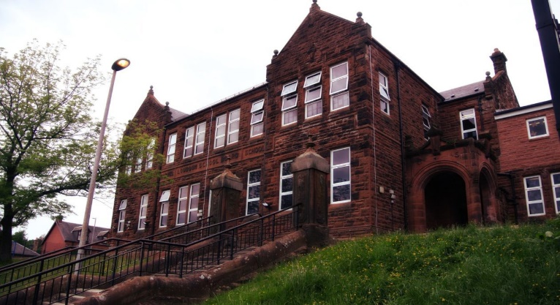

General update from teacher

Hello everyone!

Room 10 have had a busy start to the year and we were all very excited to have some of Darvel FC players in school. We also had a visit from Super Tattie – our school lunch mascot.

We have already made a good start to our new topic WW2 and the children are keen to learn more!

We have had confirmation that our swimming will start on February 23rd and will run for 5 weeks.

Please note we are on holiday from Thursday this week and look forward to seeing the children back in school on Thursday 16th February.

Enjoy!

Learning across the Curriculum

We have been learning:

* About the Outbreak of WW2.
* How to apply gymnastics skills to large apparatus.

Next we will be learning about:

* World War 2.
* Current affairs.

Numeracy

We have been learning:

* About equivalent fractions and how to simplify them.

Next we will be learning to:

* Convert between percentages, fractions and decimal numbers.

Literacy

We have been learning:

* Spelling – We have been concentrating on the phonemes ‘i’ and ‘oe’ and their different graphemes.
* Writing – Our writing this term will be based around our novel and WW2. Our first piece is a diary entry written after listening to Neville Chamberlain’s speech declaring war.
* Reading – our new class novel is ‘Carrie’s War’ and so far, we are really enjoying it.
* ‘Address to a Haggis’ by Robert Burns.

**Darvel Primary School**

**P7 Class Newsletter**

**Mrs Route**

**February 2023**