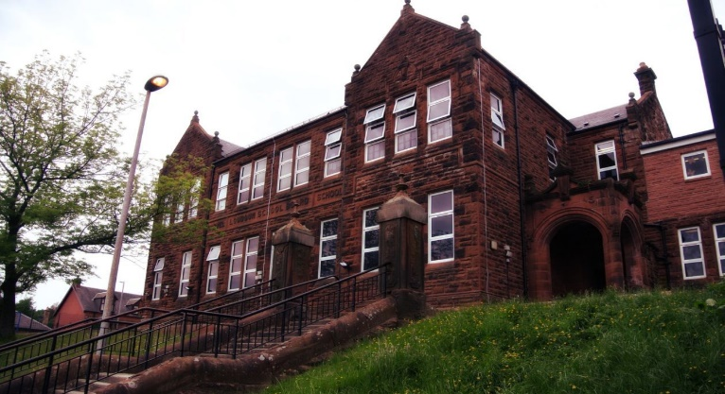

General update from teacher

Happy New Year to all! I hope you managed to have a fun and relaxing holiday. It is lovely to be back at school with everyone and we’re looking forward to whatever 2023 brings. This is an especially exciting year as it’s a year of big changes for you all!

Please see December/January newsletter for details of some of the work we will be covering this month.

We are finally getting to go on our residential trip to Lockerbie Manor – the children have been looking forward to it for a while! I hope everyone has a lovely time and I can’t wait to hear all about it on their return. For those who are not going, we hope to have some fun activities in school for them.

The children have already been asking about our swimming lessons which were cancelled in November. We are waiting for confirmation from Loudoun Academy, but we’re hoping they will go ahead this term. We will, of course, let you know the details as soon as we know.

Our next normal newsletter will be posted at the beginning of February.



**Darvel Primary School**

**P7 Class Newsletter**

**Mrs Route**

**January 2023**