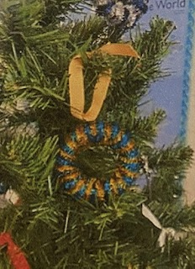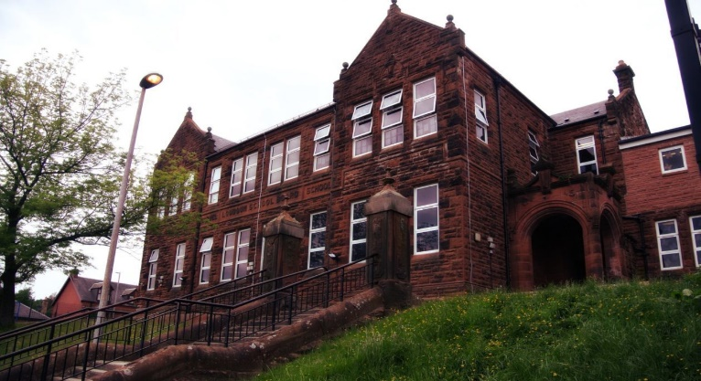

Numeracy

We have been learning:

* Use maths ninja to double 2 digit numbers.
* Sequence, add, subtract and multiply decimal numbers.

Next we will be learning to:

* Use various ways to interpret and display data.
* Plot coordinates

One of the tree decorations which we sold at the fayre.

General update from teacher

It’s been yet another busy month. Our decorations for the Christmas Fayre were gorgeous and sold very quickly. The children enjoyed making the wooly hat tree decoration and I hope they found the perfect place to hang it.

We have been super role models in school by helping the infants with their nativity and you may have spotted some of us at the door giving out programmes.

We are all now really looking forward to the holidays and we wish you a very merry Christmas and a wonderful 2023!

Learning across the Curriculum

We have been learning:

* About Life cycles and inherited characteristics.
* Massage in schools programme.
* Current affairs

Next we will be learning about:

* World War 2.

Literacy

We have been learning:

* Spelling – We have been concentrating on the phonemes ‘ie’ and ‘e’ and its different graphemes. We have also learnt topic words.
* Writing – we have been looking at poetry in a range of forms.
* As a class we have been working on our Reading Schools journey and enjoy reading daily for enjoyment.

**Darvel Primary School**

**P7 Class Newsletter**

**Mrs Route**

**December 2022/January 2023**