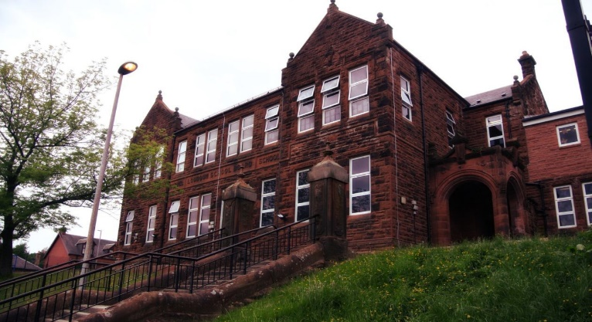

Some of our symmetrical creations

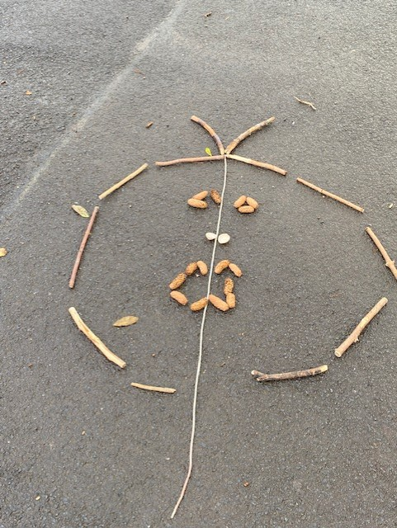

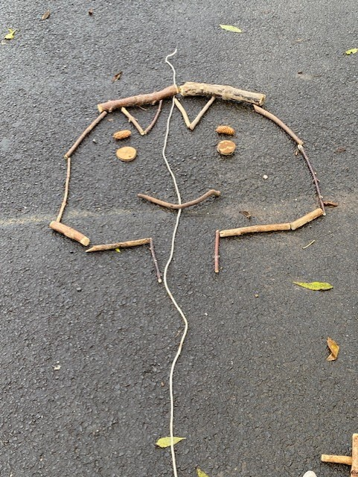

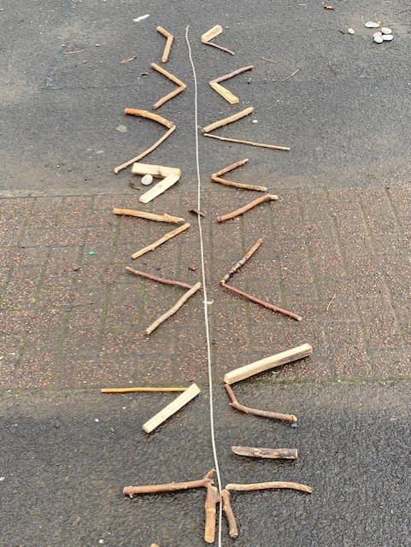 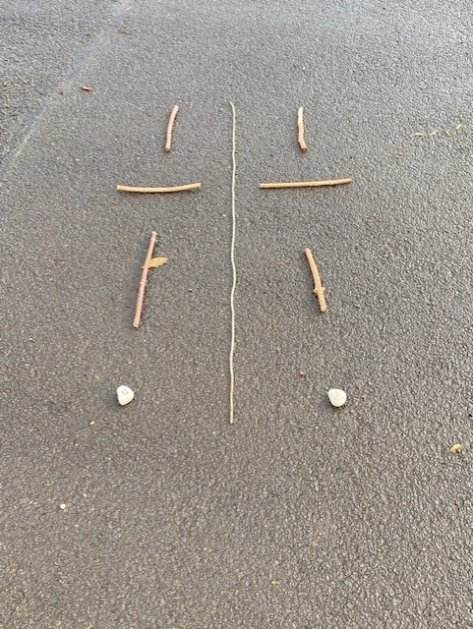

General update from teacher

It’s been another busy month. The pupils created some very interesting symmetrical pictures and patterns during outdoor learning. Our Henri Rousseau inspired rainforest pictures are beautiful and I’m sure you will enjoy seeing them at our upcoming open afternoon. We all had lots of fun at our Hallowe’en party and we had some interesting and spooky characters.

Please remember homework should be returned on a Thursday.

Our swimming block at Loudoun Academy will start on Monday 28th November and will finish on Monday 16th January (excluding 9th January)

Learning across the Curriculum

We have been learning:

* About deforestation.
* How to regulate our big emotions.

Next we will be learning about:

* Life cycles and inherited characteristics.
* Remembrance.
* Current affairs.

Literacy

We have been learning:

* Spelling – We have been concentrating on the phonemes ‘d’ and its different graphemes. We have also learnt topic words.
* Writing – we have been learning about effective notetaking and the features of a balanced argument.
* We are beginning our Reading Schools journey and will read daily for enjoyment.

Numeracy

We have been learning:

* To use the 4 operations with increasing challenge.
* Number bonds to 100.
* Mental maths strategies

Next we will be learning to:

* Use maths ninja to double 2 digit numbers.
* Apply our knowledge of shape to look at properties of quadrilaterals.
* Sequence, add, subtract and multiply decimal numbers.

**Darvel Primary School**

**P7 Class Newsletter**

**Mrs Route**

**November 2022**