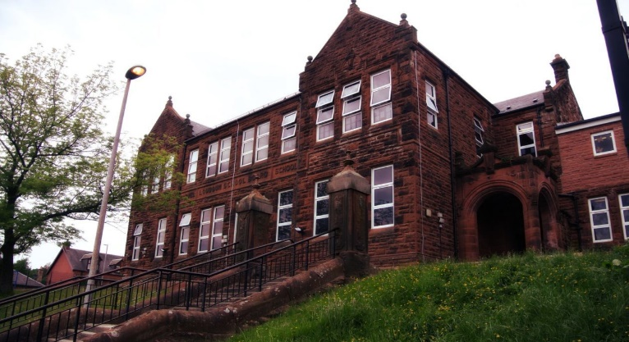

As a class we discussed the death of Queen Elizabeth and celebrated her life by using fine pencil drawings to complete her portrait.

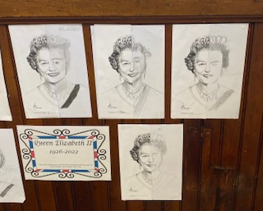

Literacy

We have been learning:

* Spelling – We have been concentrating on the phonemes ‘a’ and ‘b’ and their different graphemes.
* Writing – we have been working on how to create an effective setting and character.

Next we will be applying our East Ayrshire literacy skills in guided reading groups.

Learning across the Curriculum

We have been learning:

* About how specific animals are suited to their rainforest layer.
* How our brain works.

Next we will be learning about:

* Endangered animals and deforestation.
* Black History Month.
* Current affairs.

General update from teacher

Hello everyone! We have been so busy and it has been another very quick month! Over the past few weeks, we have been working together with COACH enjoying outdoor learning and learning lots. We are hoping to build on this and take our outdoor learning out of the playground and into the wider environment. Our swimming block will take place next term and more info will follow.

Numeracy

We have been learning:

* To the 4 operations with increasing challenge.
* About Prime numbers, multiples and factors.

Next we will be learning to:

* Use maths ninja for the 8 and 9 times tables.
* Apply our knowledge of shape to look at properties of quadrilaterals.

**Darvel Primary School**

**P7 Class Newsletter**

**Mrs Route**

**October 2022**