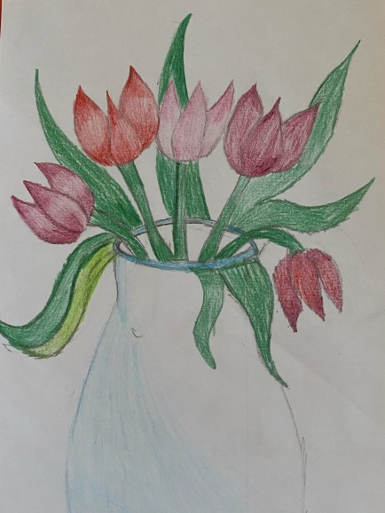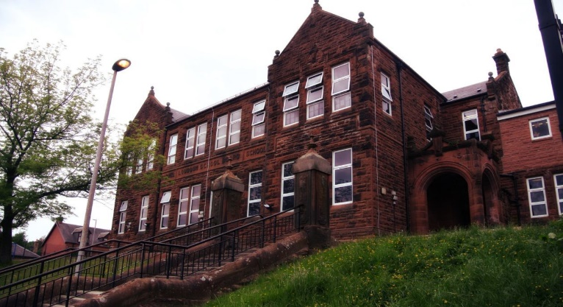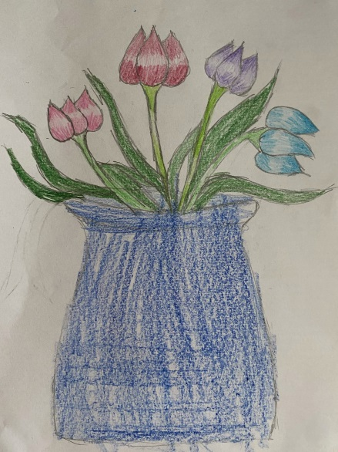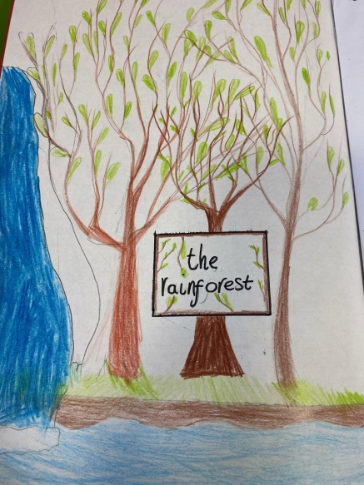

Numeracy

We have been learning to

* Use the 4 operations with increasing challenge.
* Negative numbers.

Next we will be learning to

* Use maths ninja for the 6, 7, 8 and 9 times tables.
* Apply our knowledge of multiplication and division to word problems.

Literacy

We have been learning:

* Spelling – We have been concentrating on the phoneme /ae/
* Writing – we have been working on up-levelling our work
* Class novel – Kensuke’s Kingdom.  
  Next we will be learning to use active literacy strategies in reading.

Learning across the Curriculum

We have been learning

* Where rainforests can be found.
* How our brain works.

Next we will be learning

* The layers of the rainforest and the plants and animals that live there.
* Online safety.
* Current affairs.

General update from teacher

Hello everyone! We are beginning to settle into Primary 7 and are enjoying the responsibilities of being a buddy and working with the Primary 1s. We produced some beautiful artwork for the Darvel Flower Show – we hope you were able to pop along. Our P.E. days are a Wednesday and Friday, so please ensure you have your kit on these days. Remember we are off on Friday 16th and Monday 19th. Have fun!

**Darvel Primary School**

**P7 Class Newsletter**

**Mrs Route**

**September 2022**