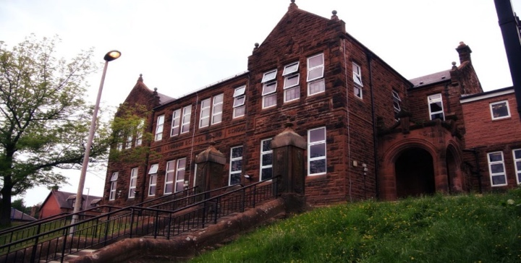
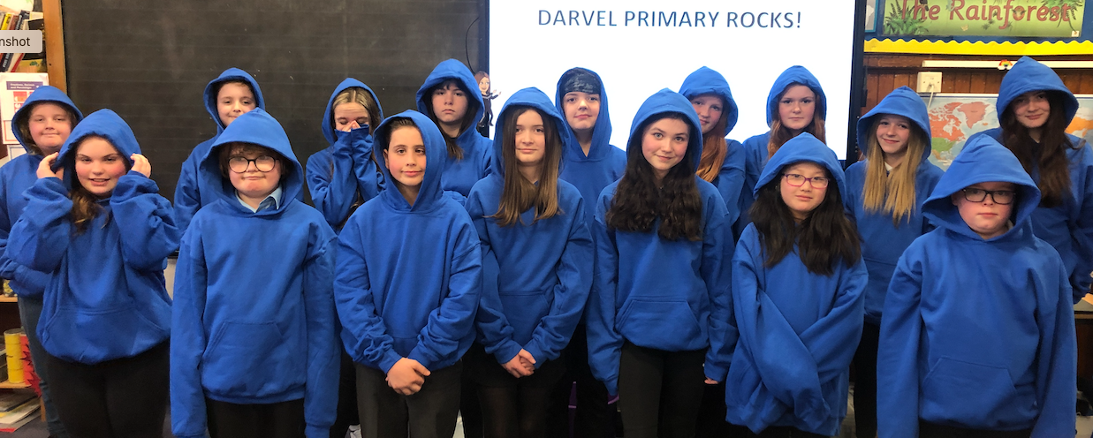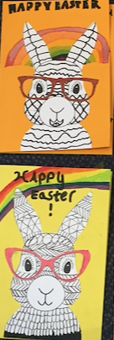
General update:
Another busy month for Primary 7C. We are excited to be on the last term of primary school and looking forward, with mixed emotions, to secondary. We will be discussing moving forward with the children and answering any questions. The transition days for Loudoun are on the 6th, 7th and 8th June – details to follow.

Kings Charles’ Coronation is the 5th May and we will be participating in activities linked to this.

We also enjoyed making our Easter bunny cards and there was great excitement on receiving our hoodies!

Numeracy
We have been learning:
- About fractions, decimals and percentages.

Next we will be learning to:

- Solve simple equations

Learning across the Curriculum
We have been learning:
- About the Christian festival of Easter.
- How to work effectively in pairs to create an A to Z poster on WW2.
- About propaganda posters in WW2 and made our own.
Next we well be learning about:
- Relationships and sexual health.
- Athletics

Literacy
We have been learning:
- Spelling – we have been concentrating on the phoneme ‘f’ with different graphemes and common words.
- Writing – we have submitted ‘The Incredible Diary of…’ for our Young Writer’s competition.
- Reading – we have completed our WW2 novel Carrie’s War.

Darvel Primary School
P7C R9 Class Newsletter
Mrs Strang
April 2023

