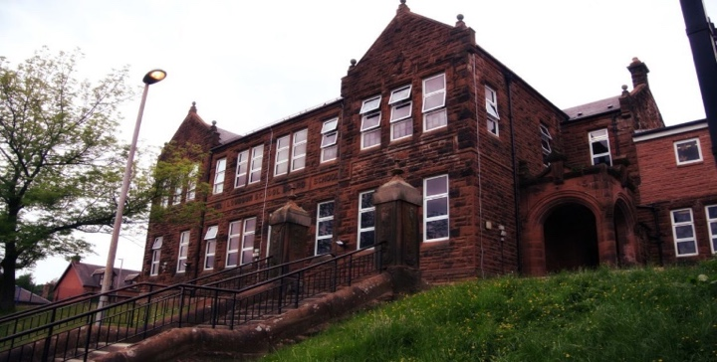
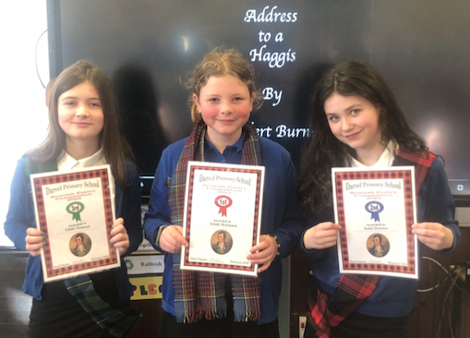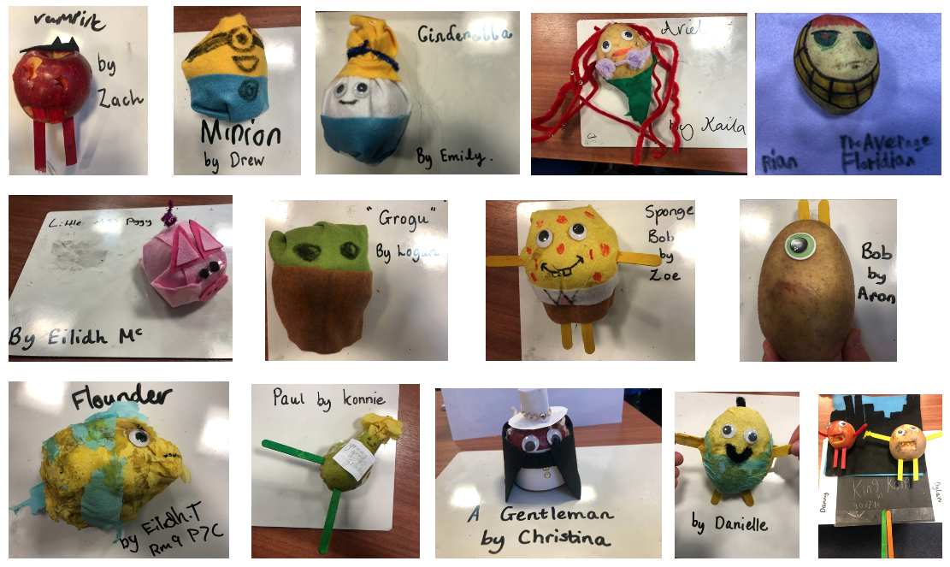
General update:
Room 9 really enjoyed dressing in our pyjamas for World Book Day. We had a visit from the chief executive of East Ayrshire, Eddie Fraser.
I have included the children’s creative potatoes dressed up as different characters. I think our lunch mascot ‘Super Tattie’ would love them! I think you’ll agree a super effort made.

Also, a massive well done to our Burns winners for Address to the Haggis!

Numeracy
We have been learning:

- to identify prime and composite numbers
- averages represented in four different ways: mean, mode, median and range.
- Multiplication of 3/4 digit numbers

Next, we will be revising our measurement facts and then studying fractions/decimals and percentages.

Learning across the Curriculum
We have been learning about:
- Social Studies – WW2 and rations, Anne Frank, why the Americans entered the war
- PE – ball skills and netball

Next we will be learning about:
- WW2 – the experiences of Jewish children during the war
Art – WW2 propaganda posters

Literacy
We have been learning:
- spelling – Graphemes ou/ow/o_e and common words
- about different authors on World Book Day – Adrian Edmondson
- writing – we have been writing Blitz acrostic poems and an explanation text for why America entered into WW2
Next, we will be using our imagination to write about travelling in a time machine.

Darvel Primary School
P7C R9 Class Newsletter
Mrs Strang
March 2023

