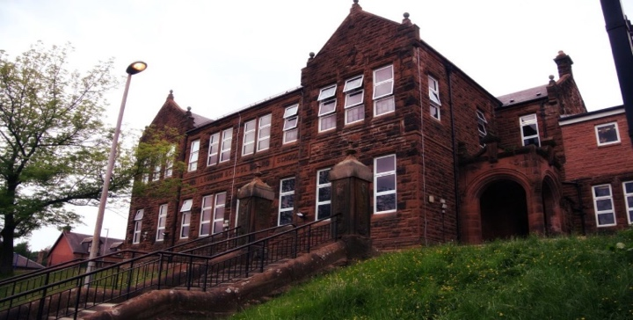
WW2 and Darvel FC t-shirts
Numeracy
We have been learning:
- about information handling and how it connects to the world of work
- the layout of partition maths to assist with multiplying 2- or 3-digit numbers
- within mental maths revision of fractions of a number, area, perimeter, percentages, and measurement conversions.
Next, we will be creating surveys to collect information. In groups we will collate, organise, and communicate the results in an appropriate way.

General update:
Room 9 has had a busy start to the year with their residential, Darvel FC being in the school and starting our new WW2 topic. We have enjoyed showcasing our skills in gymnastics and are looking forward to netball lessons.

Please note we are on holiday from Thursday this week and look forward to seeing the pupils back on Thursday 16th February.
Learning across the Curriculum
We have been learning about:
- Social Studies – the outbreak of WW2 and the Battle of Britain.
- PE – how to apply gymnastic skills to large apparatus.

Next we will be learning about:
- WW2 – to find out about the experiences and feelings of evacuees. Art – make out own gas masks.
- PE – Learning to play Netball

Literacy
We have been learning:
- Spelling – Phonemes ‘i’/ ‘oe’ and common words
- Reading- we have a new class novel called ‘Carrie’s War’ by Nina Bawden.
- Reading for Gold.
- ‘Address to a Haggis’ by Robert Burns.
- Writing – we have been writing our own ‘dear diary’ account of Chamberlain’s announcement of WW2, 1939.
Next we will be researching WW2 using our own Eyewitness encyclopaedias and the internet.

Darvel Primary School
P7C R9 Class Newsletter
Mrs Strang
February 2023

