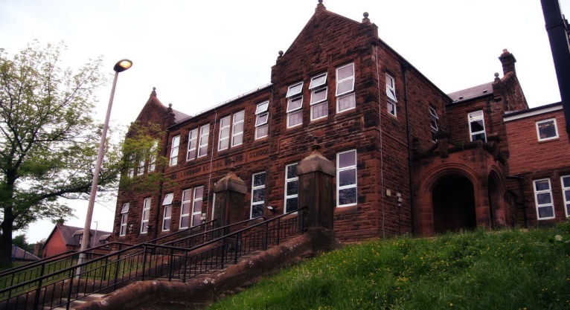
General Update
Happy New Year all! I hope you had a lovely Christmas break. I am looking forward to the coming year. There will be lots of new experiences and learning. This will be inspiring as it’s a year of big changes for Primary 7!

Literacy – we will be continuing with reading for gold and our class novel will be Carrie’s War by Nina Bawden. This ties in with our WWII topic work.

Maths – we will continue Ninja Maths and Essential Mental Maths. We will be focusing on information handling.

Learning across the curriculum – we will begin our WWII topic which I think will be fascinating!

The children loved their residential trip to Lockerbie Manor! Some activities they took part in included: abseiling, archery, climbing and the blind trail. I have included some of the photos.

We had a special assembly for Darvel FC to wish them all the best in the Scottish Cup fourth round against Aberdeen. Mick Kennedy, Jordan Allan and Darren Miller were delighted to meet and greet the children. https://twitter.com/eacdarvelps?lang=en

Our next normal newsletter will be posted at the beginning of February.

Our next normal newsletter will be posted at the beginning of February.

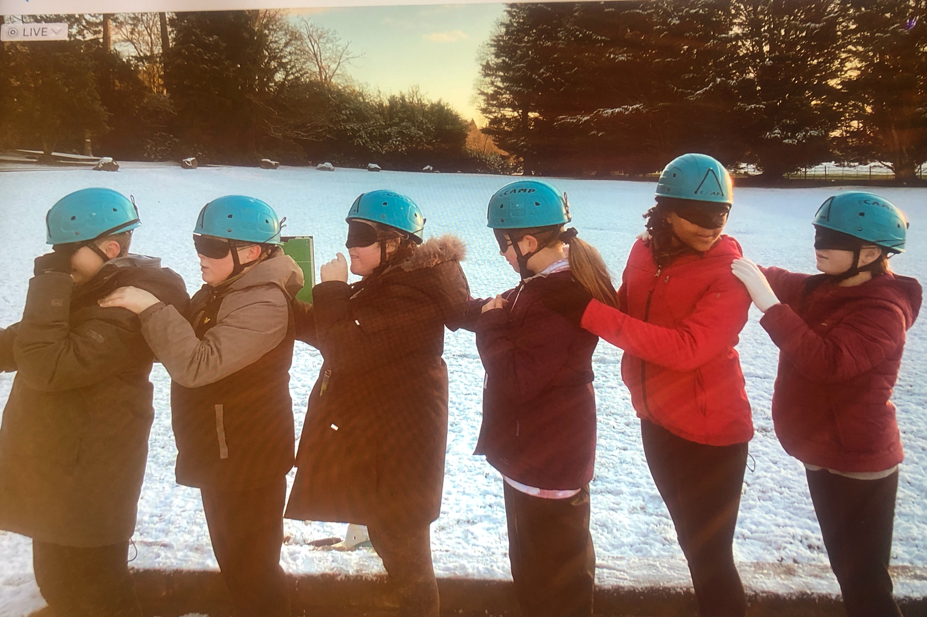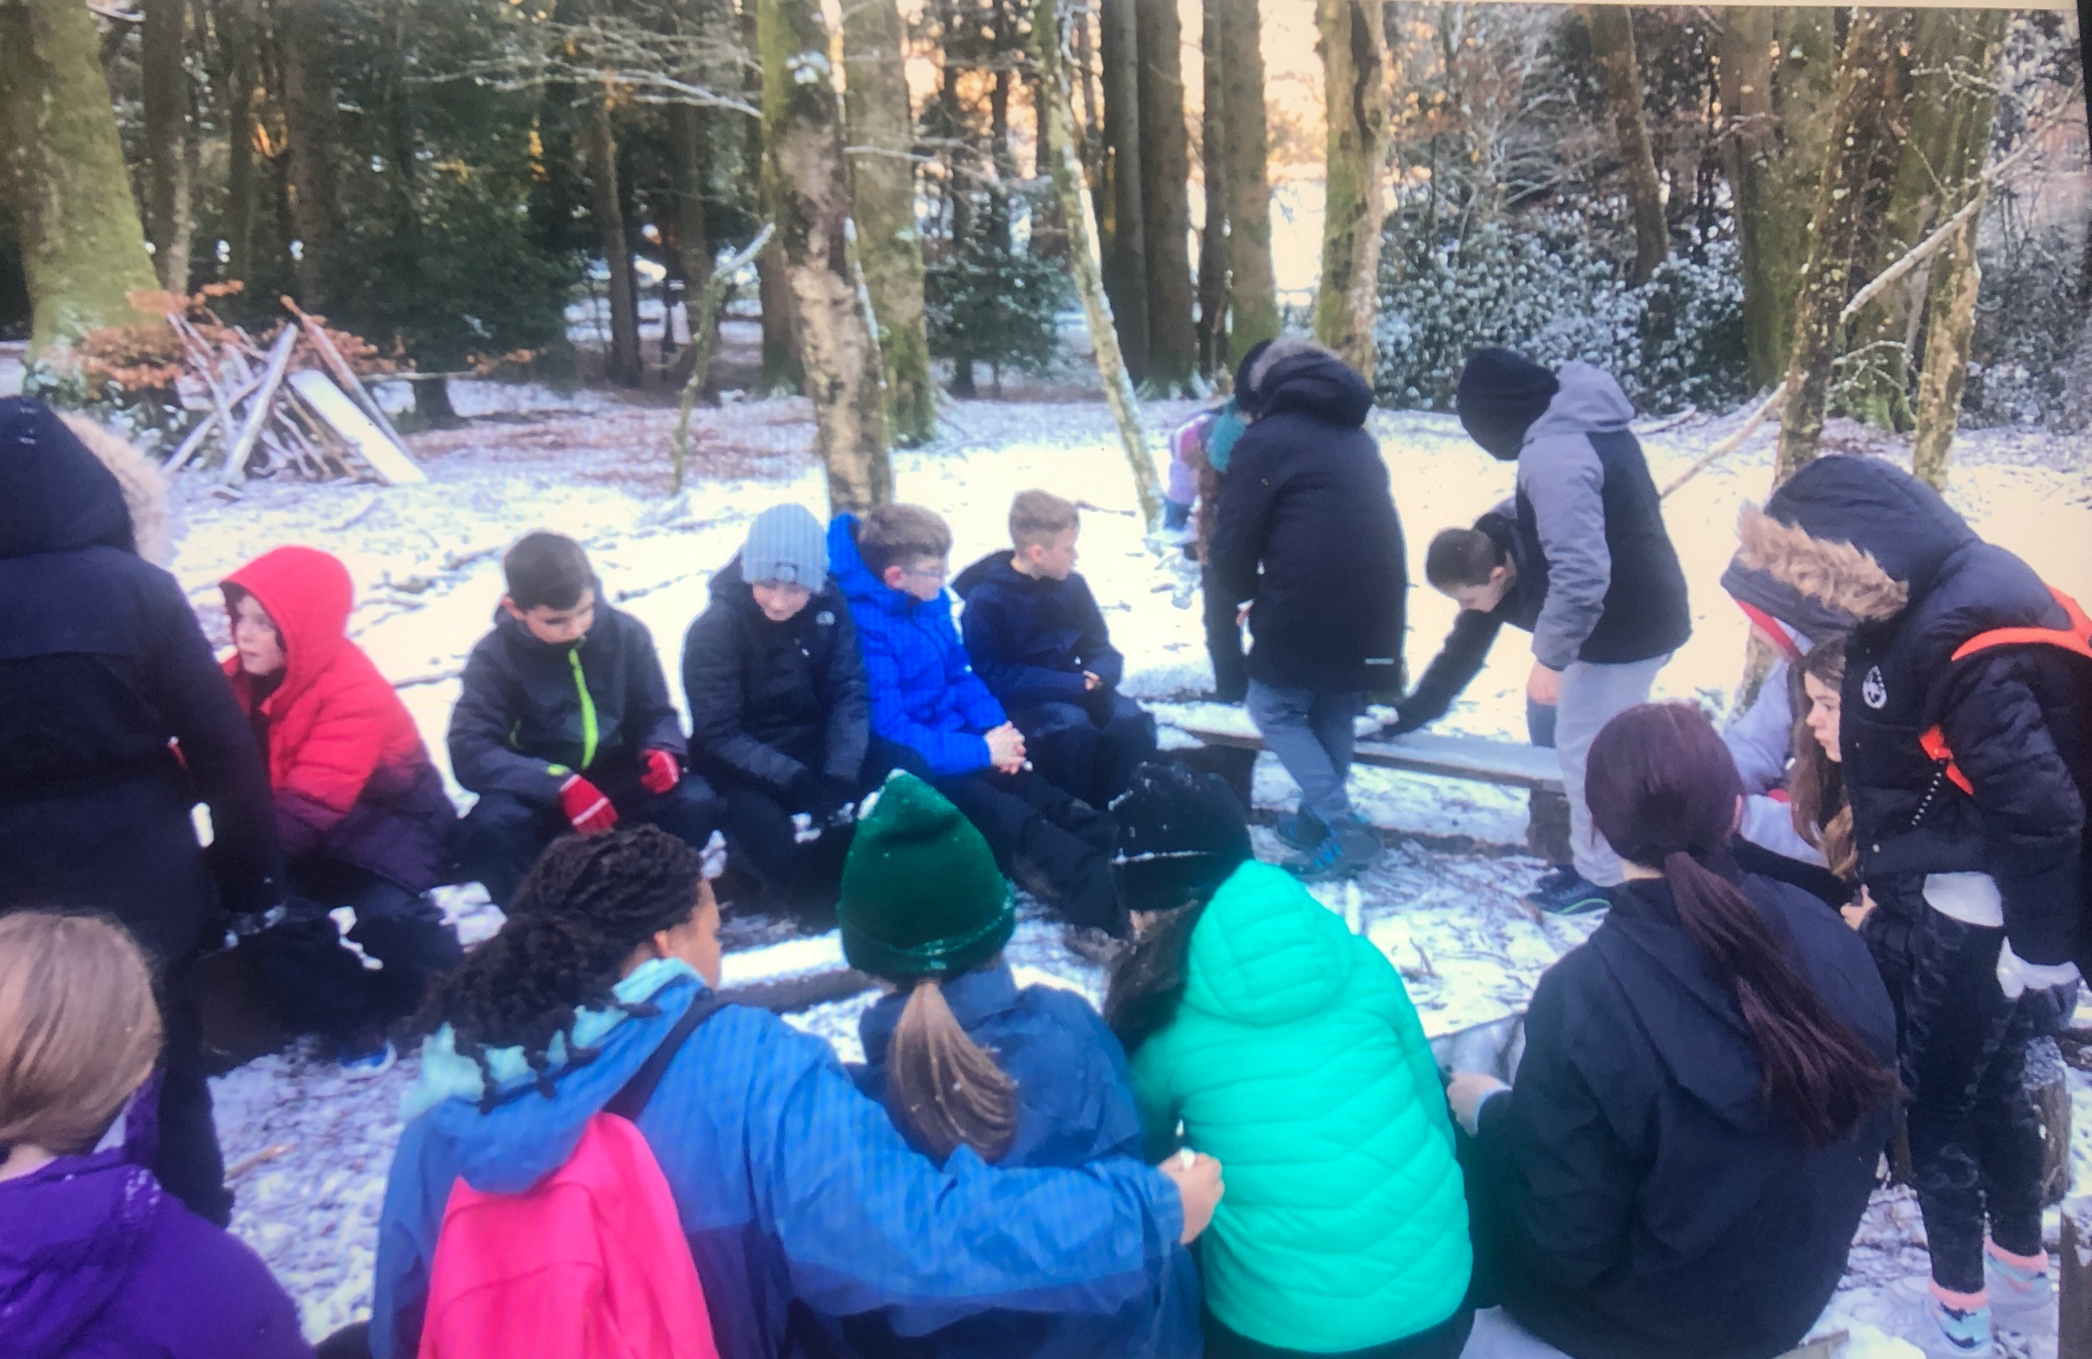
Darvel Primary School
P7 Class Newsletter
Mrs Strang
January 2023

