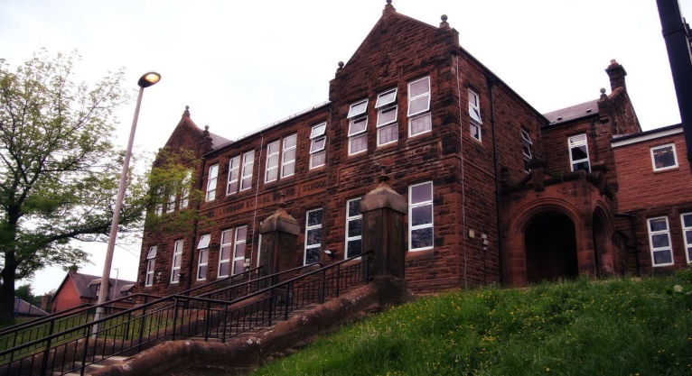
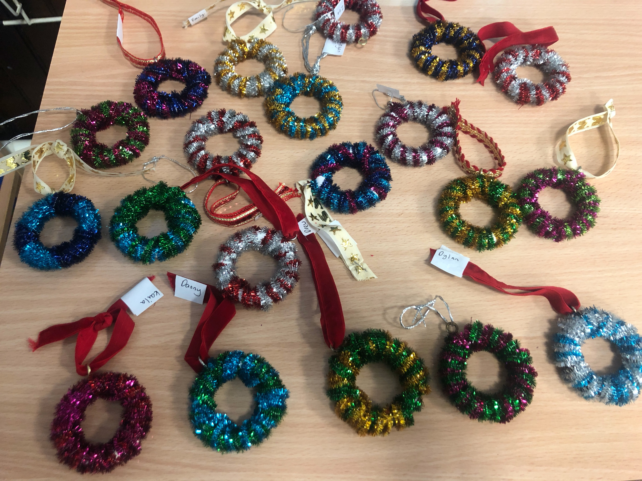
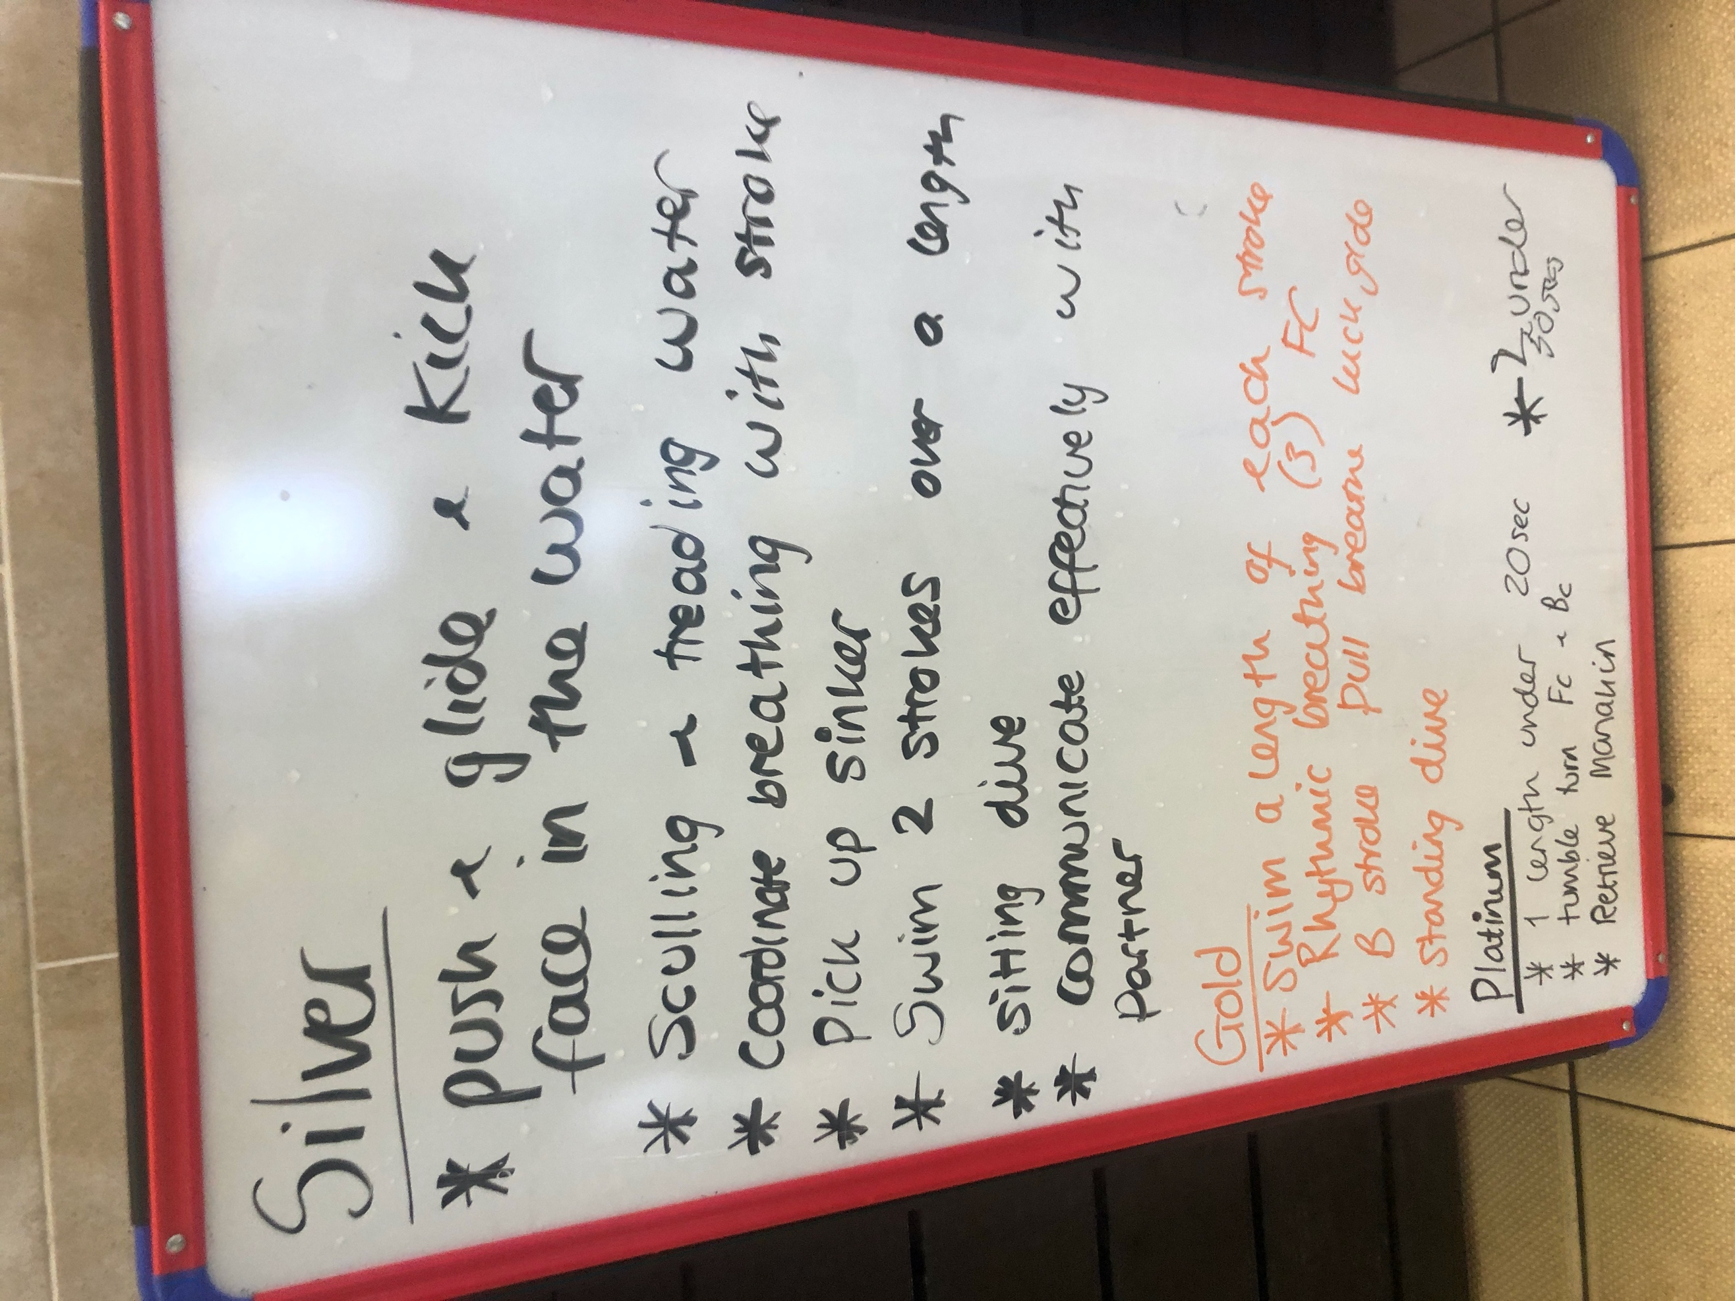
Literacy
We have been learning:
Spelling – We have been concentrating on the phonemes ‘ie’ and ‘e’ and it’s different graphemes. We have also learnt topic words.
Writing – we have been looking at poetry in a range of forms.
As a class we have been working on our Reading Schools journey.

We have enjoyed writing book reviews for Reading for Gold. Some children have read 10+ books this month. We are making good progress. We all received a swimming certificate from Loudoun Academy. The pupils were assessed using the criteria shown. Our decorations for the Christmas fayre were beautiful and sold fast. We helped the infants with their nativity rehearsals and sent our buddies Christmas letters. We are all now looking forward to the holidays. Merry Christmas and all the best for 2023 from P7C!

Learning across the Curriculum we have been learning about:
- Life cycles and inherited characteristics.
- Massage in Schools programme.
- Sacred texts within Judaism and Hinduism
- Current Affairs

- Next we will be learning about:
• World War 2.

Numeracy
We all loved participating in the Sumdog competition, and I’m delighted to report we were 2nd in East Ayrshire. We have also been learning:
- To work with positive and negative numbers
- About multiples, factors and prime numbers.
Next we will be learning:
- To use various ways to interpret and display data.
Darvel Primary School
P4 R9 Class Newsletter
Mrs Strang
December 2022

