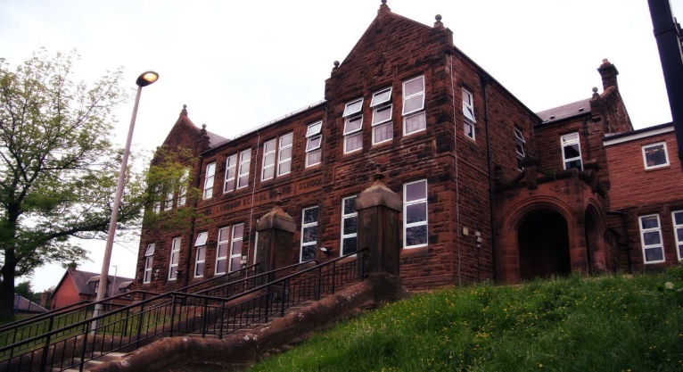
- 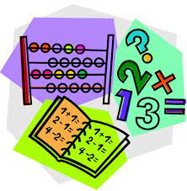with “I”
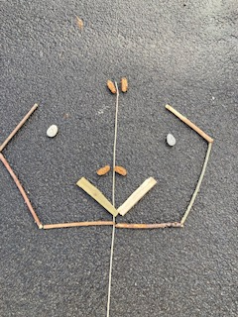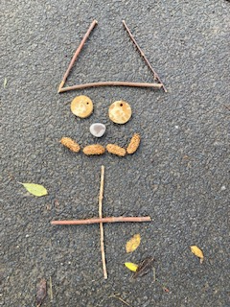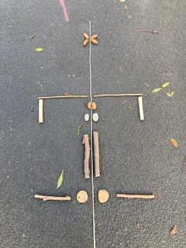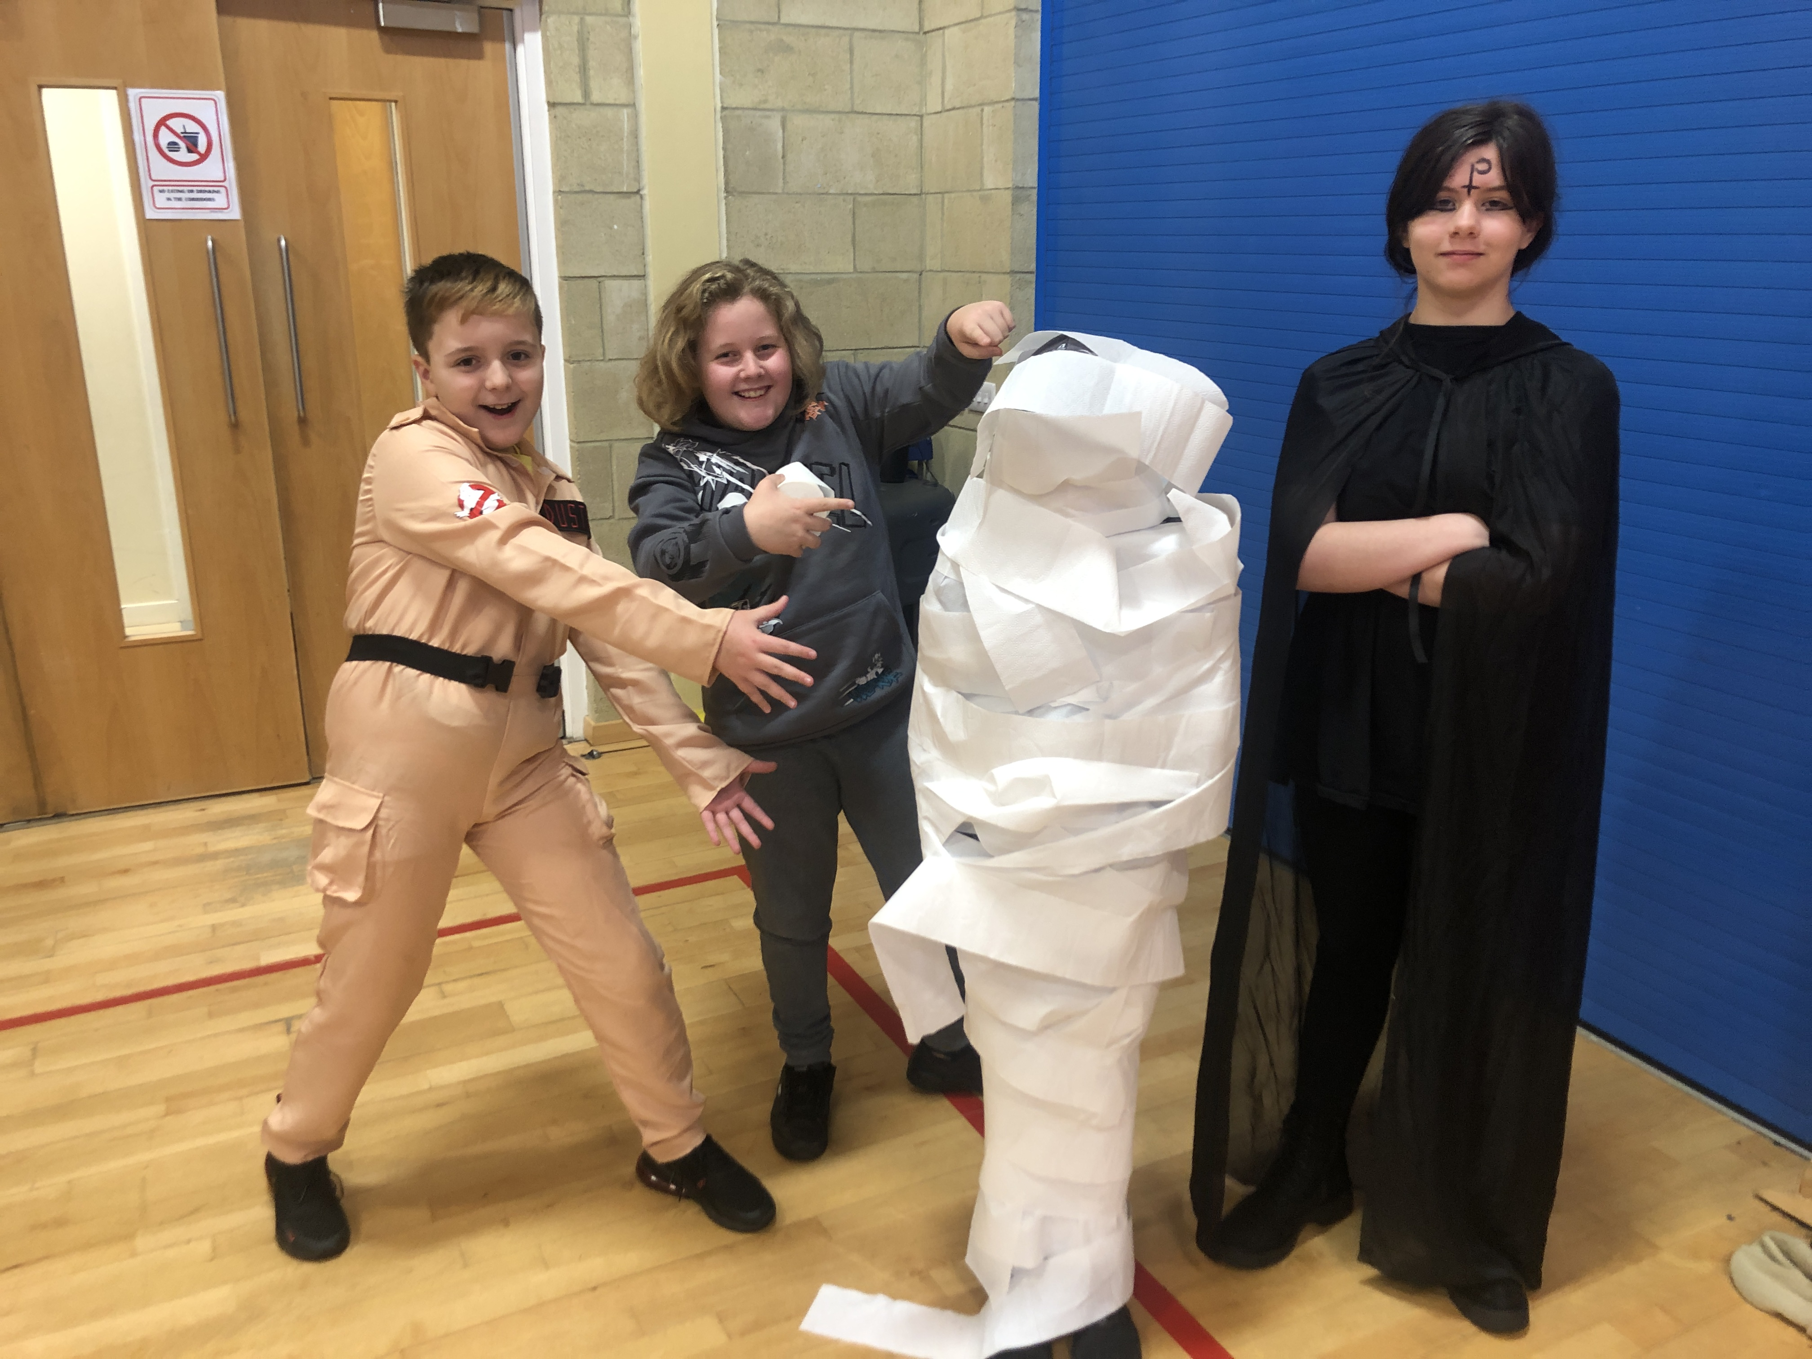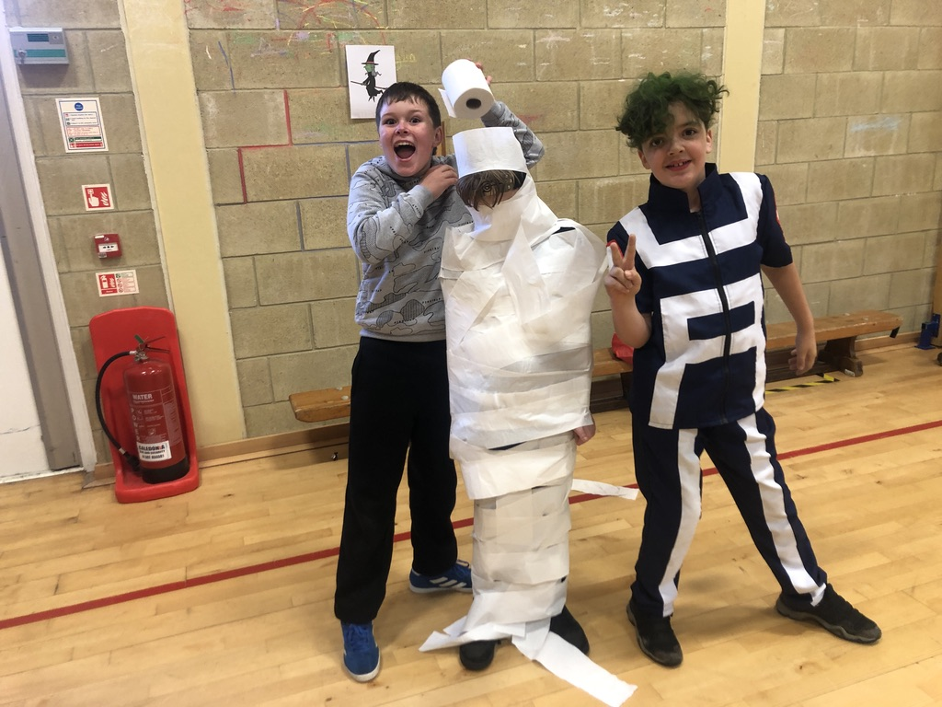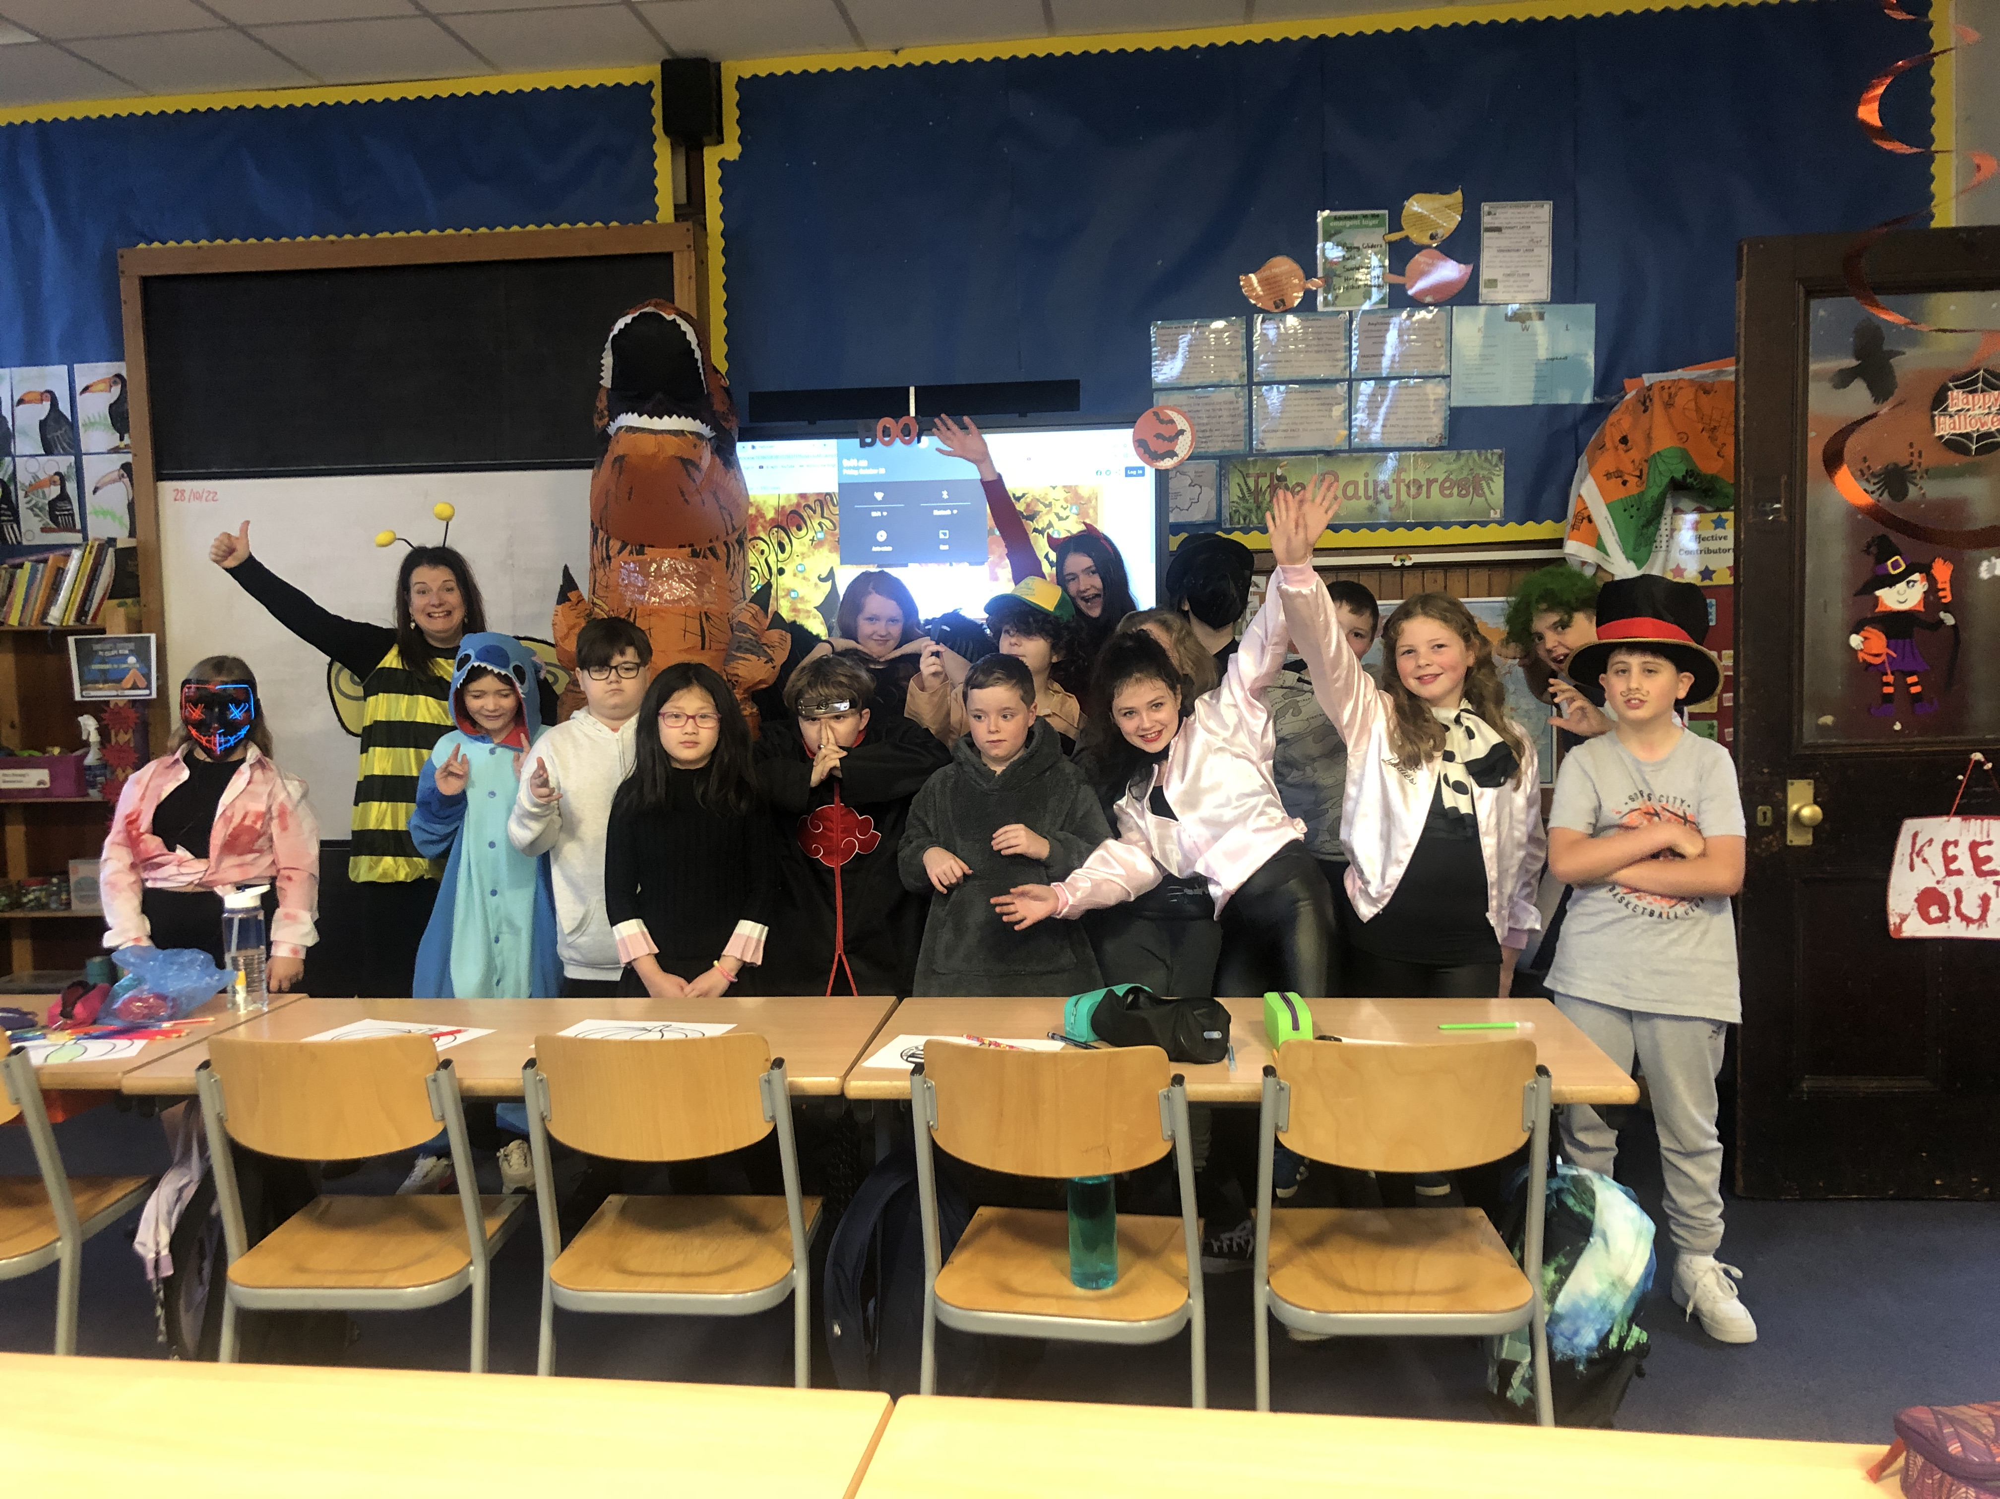
Learning across the Curriculum
We have been learning:
- About deforestation.
- How to regulate our big emotions.
- Current affairs
Next we will be learning about:
- Life cycles and inherited characteristics.
- Remembrance.
- Anti-bullying week
- Massage

The pupils are enjoying outdoor learning and have been very creative with symmetry. In swimming we have been learning breaststroke, front/back crawl and how to dive from a sitting position.
Our Henri Rousseau inspired rainforest pictures are beautiful and I’m sure you will enjoy seeing them at our upcoming open afternoon.
Our fun Hallowe’en party consisted of many interesting characters.
Thank you with your continued support with homework. We have been returning it on a Thursday.

We have been learning:
- Spelling – We have been concentrating on the phoneme ‘d’ and the different graphemes. We have also learnt topic words for the rainforest.
- Writing – we have been learning about effective notetaking and the features of a balanced argument.
- We are beginning our Reading Schools journey and will read daily for enjoyment. In addition, we have started Guided Reading.
- Grammar – using speech marks in writing.

Numeracy
We have been learning
- To use the 4 operations with increasing challenge.
- Number bonds to 100
- About sequencing, adding, subtracting, multiplying decimals.
Next we will be learning to:
- Double 2-digit numbers within Ninja Maths
- Apply our knowledge of shape to look at properties of quadrilaterals.

Darvel Primary School
P7C R9 Class Newsletter
Mrs Strang
November 2022

