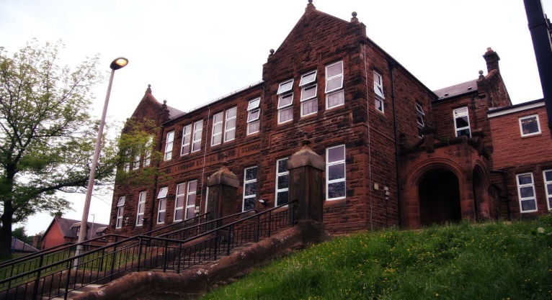
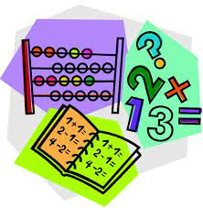with “I”
We were creating a setting for our story.

Learning across the Curriculum
We have been learning:
- About how specific animals are suited to their rainforest layer.
- How our brain works.
Next we will be learning about:
- Endangered animals and deforestation.
- Black History Month.
- Current affairs.


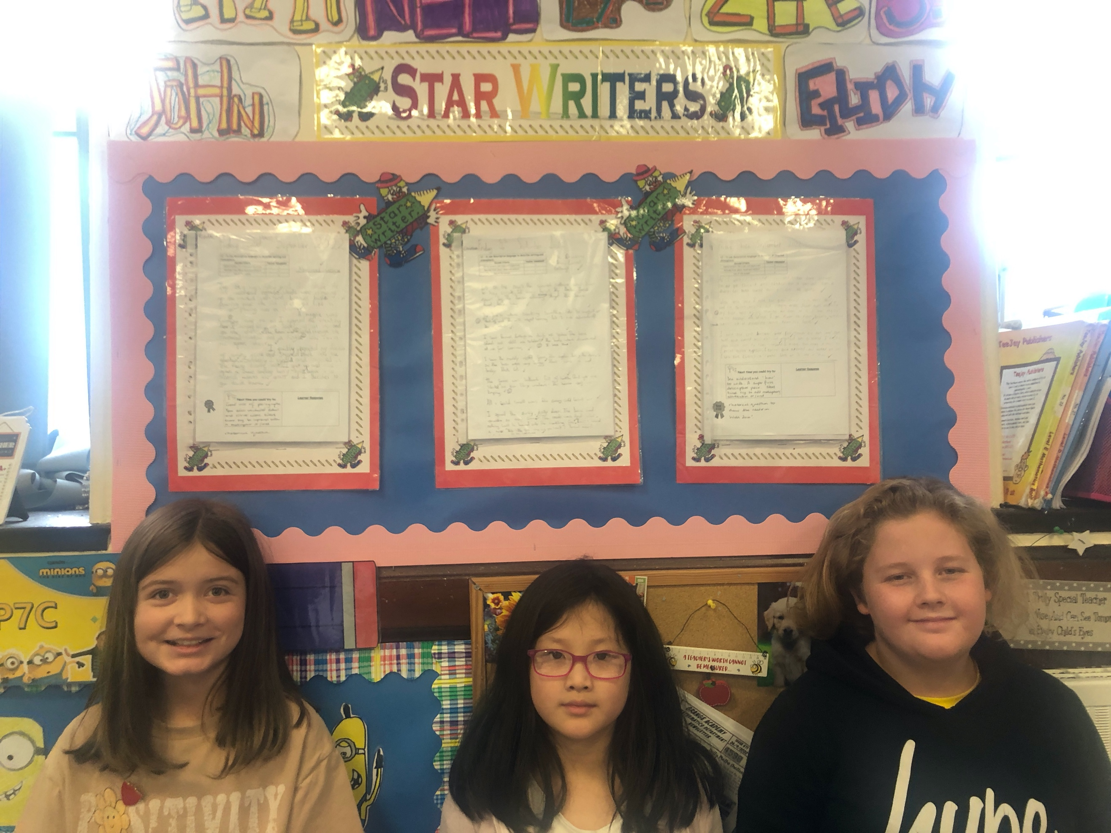
Numeracy
We have been learning
- To the 4 operations with increasing challenge.
- About Prime numbers, multiples and factors.
Next we will be learning to:
- Use maths ninja for the 8 and 9 times tables.
- Apply our knowledge of shape to look at properties of quadrilaterals.

Literacy
We have been learning
- Spelling – We have been concentrating on the phonemes ‘a’ and ‘b’ and their different graphemes (written sounds).
- Writing – we have been working on how to create an effective setting and character.
- Reading – we have finished our book This Morning I Met a Whale.
Next we will be identifying the main idea in text.

This month we have been working hard on our listening skills, concentration and working as a team. As part of Maths Week Scotland we covered 3D shape, co-ordinates, angles and symmetry. Thank you for the Maths homework handed in.
I have enjoyed celebrating new Star Writers each week. The pupils have really embraced the learning opportunities presented.
The pupils have now started outdoor learning and swimming lessons. They are becoming more confident in the water.

Darvel Primary School
P7C R9 Class Newsletter
Mrs Strang
October 2022

