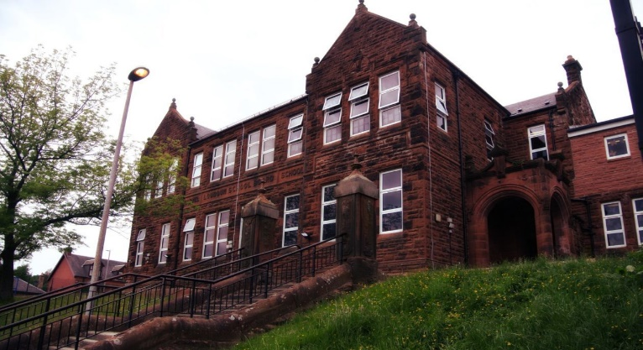

Literacy

We have been:

* Edit and up level previous work.
* Continue with class novel study and daily reading sessions.
* Expand knowledge and use of paragraphs and topic sentences.

Next we will-

* Writing newspaper reports.
* Reading for enjoyment and writing book reviews.
* Develop listening and talking skills with group discussions.

**Darvel Primary School**

**P5a R11 Class Newsletter**

**Miss Duffy**

**June 2022**

**Mrs McFadzean (Mon,Tues,Wed)**

**Mrs MacLeod (Thurs,Fri)**

**January 2022**

Numeracy

We have been learning:

* Estimate and measure lengths in mm, cm and m.
* Convert cm to m and m to cm.
* Calculate area.

Next we will be learning to:

* Discuss properties of 2D and 3D shapes.
* Explore angles and transformation of shapes.
* Data handling and interpreting information.

Learning across the Curriculum

We have been learning about:

* PE- Team games and athletics.
* ICT- sending emails and attachments.
* HWB- Bullying and Cyber resilience.

Next we will be learning about:

* ICT- Begin to look at coding.
* PE- Athletics
* HWB- RHSP.

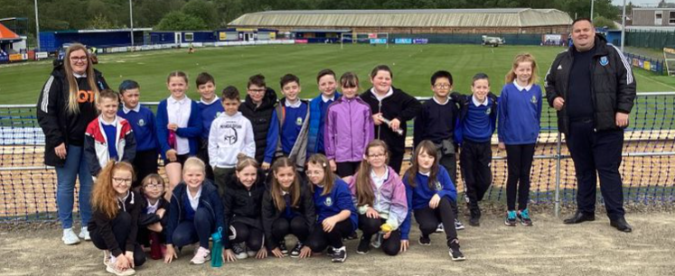

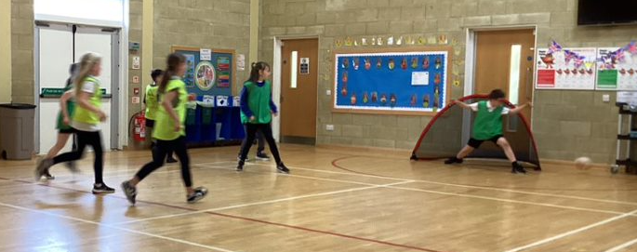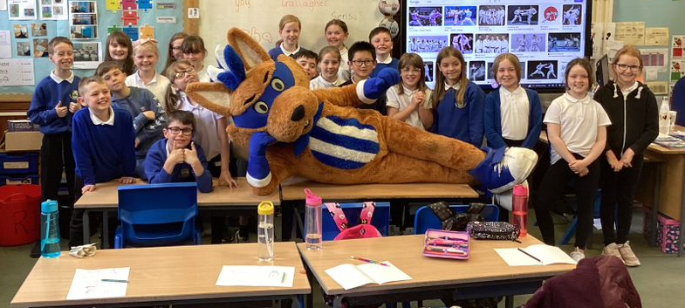

This month has felt very busy indeed. We had the last of our inputs from Kilmarnock Football Club which everyone really enjoyed.

An amazing health week with visits to Darvel Football Club as well as many other fantastic activities, and of course the fun of sports day!

Not long to go till summer. P5 have worked so hard this year, well done to all of you!