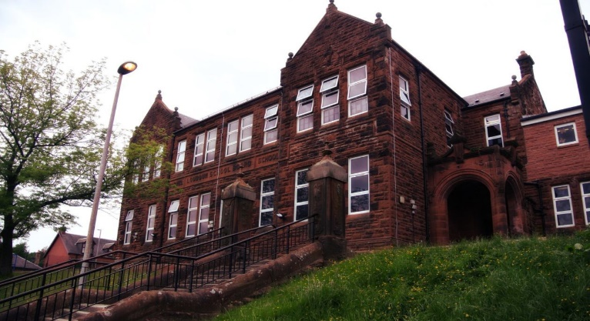

Literacy

We have been:

* Explore similes, metaphors and other figures of speech.
* Look at the features of a report and begin to write these on various topics.
* Combine independent reading with comprehension strategies, such as writing a summary or book report.

Next we will-

* Edit and up level previous work.
* Continue with class novel study and daily reading sessions.
* Expand knowledge and use of paragraphs and topic sentences.

**Darvel Primary School**

**P5a R11 Class Newsletter**

**Miss Duffy**

**May 2022**

**Mrs McFadzean (Mon,Tues,Wed)**

**Mrs MacLeod (Thurs,Fri)**

**January 2022**

Numeracy

We have been learning:

* 12 hour time both digital and analogue.
* 24 hour time and the conversion from 12 and analogue.
* Strategies to calculate durations of time and associated word problems.

Next we will be learning to:

* Estimate and measure lengths in mm, cm and m.
* Convert cm to m and m to cm.
* Calculate area.

Learning across the Curriculum

We have been learning about:

* PE- Football cont. with KFC/ athletics
* Art- still live and various mediums.
* ICT- getting to grips with the new chrome books.

Next we will be learning about:

* PE- Team games and athletics.
* ICT- sending emails and attachments.
* HWB- Bullying and Cyber resilience.

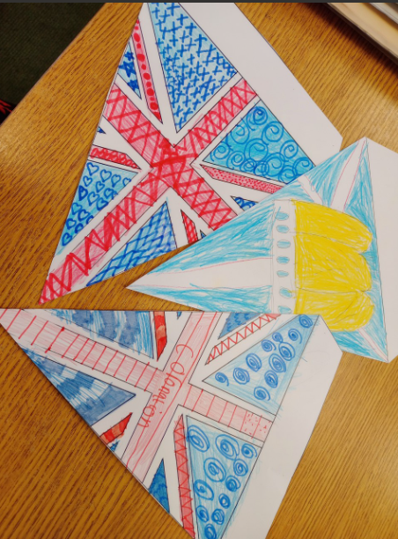

A short newsletter this month because of the Easter break.

As ever Primary 5 have settled in great after their holiday and are working hard. Looking forward to a great last term.

We have also been getting ready for the coronation making lovely bunting.