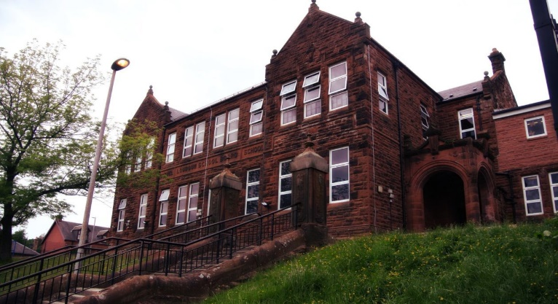

Literacy

We have been:

* Linking debate strategies to our persuasive writing.
* Looking at apostrophes, speech marks and pronouns.
* Starting a new class novel.

Next we will-

* Explore similes, metaphors and other figures of speech.
* Look at the features of a report and begin to write these on various topics.
* Combine independent reading with comprehension strategies, such as writing a summary or book report.

**Darvel Primary School**

**P5a R11 Class Newsletter**

**Miss Duffy**

**April 2022**

**Mrs McFadzean (Mon,Tues,Wed)**

**Mrs MacLeod (Thurs,Fri)**

**January 2022**

Numeracy

We have been learning:

* To add and subtract decimals.
* To find percentages of quantities.
* A revision of money and to explore mental strategies to perform a range of money calculations.

Next we will be learning to:

* 12 hour time both digital and analogue.
* 24 hour time and the conversion from 12 and analogue.
* Strategies to calculate durations of time and associated word problems.

Learning across the Curriculum

We have been learning about:

* PE- Football
* Art- Scottish artists study
* ICT- word processing skills

Next we will be learning about:

* PE- Football cont. with KFC/ athletics
* Art- still live and various mediums.
* ICT- getting to grips with the new chrome books.

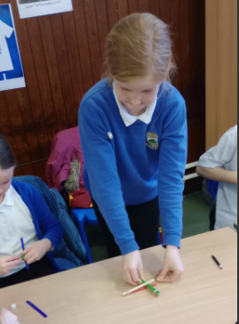

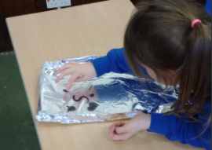

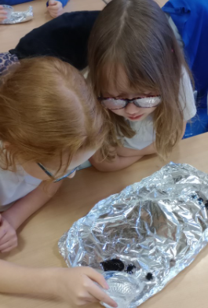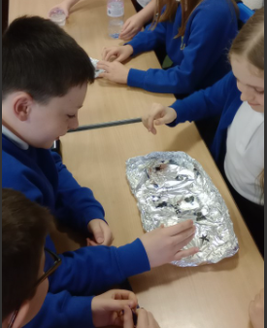

Another month of hard work from Primary 5.

For science week we looked at making whiteboard pen drawings swim on tinfoil trays and lollypop stick catapults to fire mini marshmallows crazy heights.

They have also enjoyed all the Easter arts and crafts, I hope you all have had a lovely, well-deserved break.