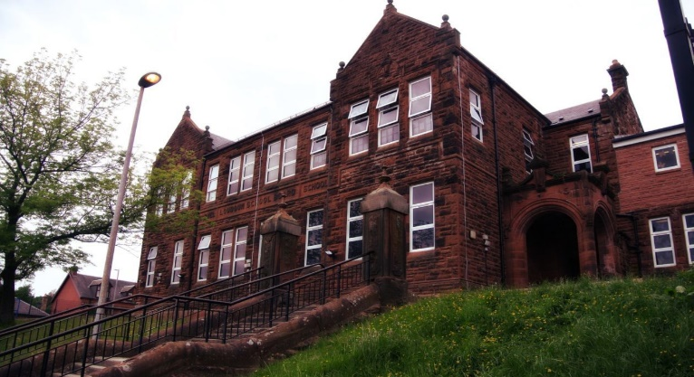

Literacy

We have been:

* Continuing our class novel ‘How to train your Dragon’ looking at reading comprehension strategies.
* Looking at persuasive writing.
* Learning our Scots poems.

Next we will-

* Link debate strategies to our persuasive writing.
* Look at apostrophes, speech marks and pronouns.
* Continue with our Scottish poem for the Burns assembly performance.

**Darvel Primary School**

**P5a R11 Class Newsletter**

**Miss Duffy**

**February 2022**

**Mrs McFadzean (Mon,Tues,Wed)**

**Mrs MacLeod (Thurs,Fri)**

**January 2022**

Numeracy

We have been learning:

* To order and compare fractions.
* Find equivalent fractions in order to compare them.
* Make the connection between fractions, percentages and decimals.

Next we will be learning to:

* Add and subtract decimals.
* Find percentages of quantities.
* Revise money and begin to explore mental strategies to perform a range of money calculations.

Learning across the Curriculum

We have been learning about:

* PE-Netball continued (Social dancing delayed this).
* Topic- Scottish Wars.
* RME – Daily life- Judaism and Christianity.

Next we will be learning about:

* PE- Football
* Art- Scottish artists study
* ICT- word processing skills

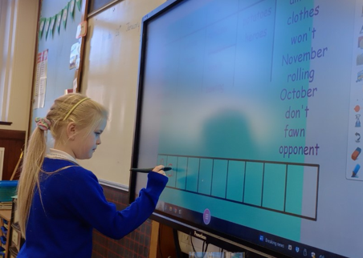

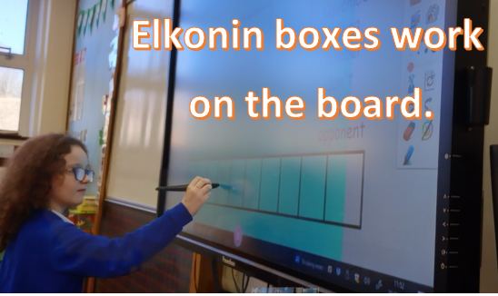

I can’t believe that January is over so quick. Primary 5 have settled back into the swing of things really well after the holidays and have been producing great work.

We have been using the smartboard to help us with our spelling this term and everyone seems to enjoy this.