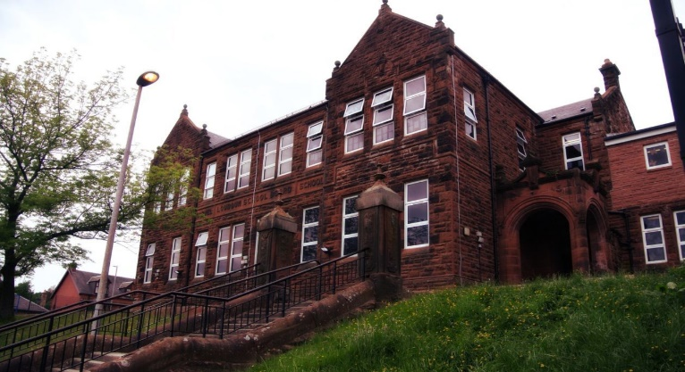

Literacy

We have been –

* Looking at biographies and writing our own autobiography.
* Developing our fluency in reading with class passages.
* Focusing on personal targets in literacy and selecting appropriate targets for tasks.

Next we will-

* Continue our class novel ‘How to train your Dragon’ looking at reading comprehension strategies.
* Persuasive writing.
* Learning our Scots poems.

**Darvel Primary School**

**P5a R11 Class Newsletter**

**Miss Duffy**

**January 2022**

**Mrs McFadzean (Mon,Tues,Wed)**

**Mrs MacLeod (Thurs,Fri)**

**January 2022**

Numeracy

We have been learning

* A revision of rounding to the nearest 10, 100 and 1000.
* Introducing fractions of objects and groups.
* Using our knowledge of multiplication and division facts to solve fraction problems.

Next we will be learning to:

* Order and compare fractions.
* Find equivalent fractions in order to compare them.
* Make the connection between fractions, percentages and decimals.

Learning across the Curriculum

We have been learning about:

* HWB- Massage in schools.
* ICT- further developing skills in creating PowerPoints.
* Art- Christmas related art and craft activities.

Next we will be learning about:

* PE-Netball continued (Social dancing delayed this).
* Topic- Scottish Wars.
* RME – Daily life- Judaism and Christianity.

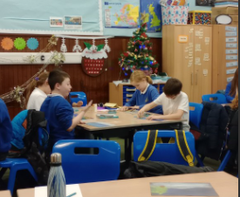

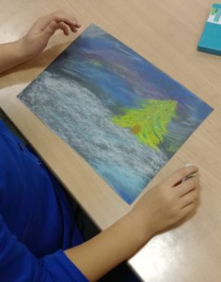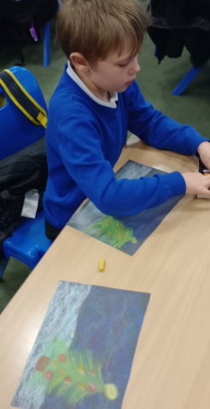

What a busy December! Primary 5 had a blast at their party and doing all the fantastic things in the lead up to Christmas.

I hope everyone had a fantastic break and are ready for 2023!