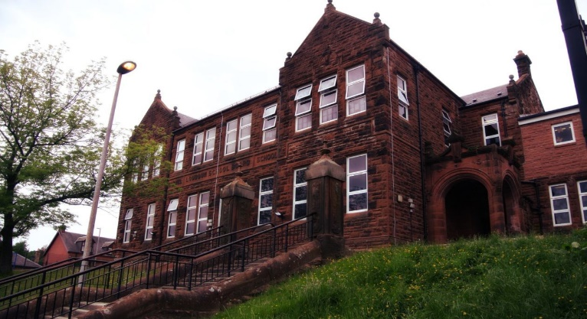

Literacy

We have been -

* Be looking at predictions and summarising in reading.
* Continue with instructional writing and look at redrafting our work.
* In grammar look at alliteration, adjectives and verbs to up level our work.

Next we will-

* Looking at biographies and writing our own autobiography.
* Developing our fluency in reading with class passages.
* Focusing on personal targets in literacy and selecting appropriate targets for tasks.

**Darvel Primary School**

**P5a R11 Class Newsletter**

**Miss Duffy**

**December 2022**

**Mrs McFadzean (Mon,Tues,Wed)**

**Mrs MacLeod (Thurs,Fri)**

**January 2022**

Numeracy

We have been learning

* Use multiplication facts to help with division.
* Use an empty number line to complete division questions.
* Continue to work on mental maths and word problems.

Next we will be learning to:

* A revision of rounding to the nearest 10, 100 and 1000.
* Introducing fractions of objects and groups.
* Using our knowledge of multiplication and division facts to solve fraction problems.

Learning across the Curriculum

We have been learning about:

* HWB- Continuing to learn about emotion works and growth mindset.
* PE- Netball
* Art- Scottish landscapes.

Next we will be learning about:

* HWB- Massage in schools.
* ICT- further developing skills in creating PowerPoints.
* Art- Christmas related art and craft activities.

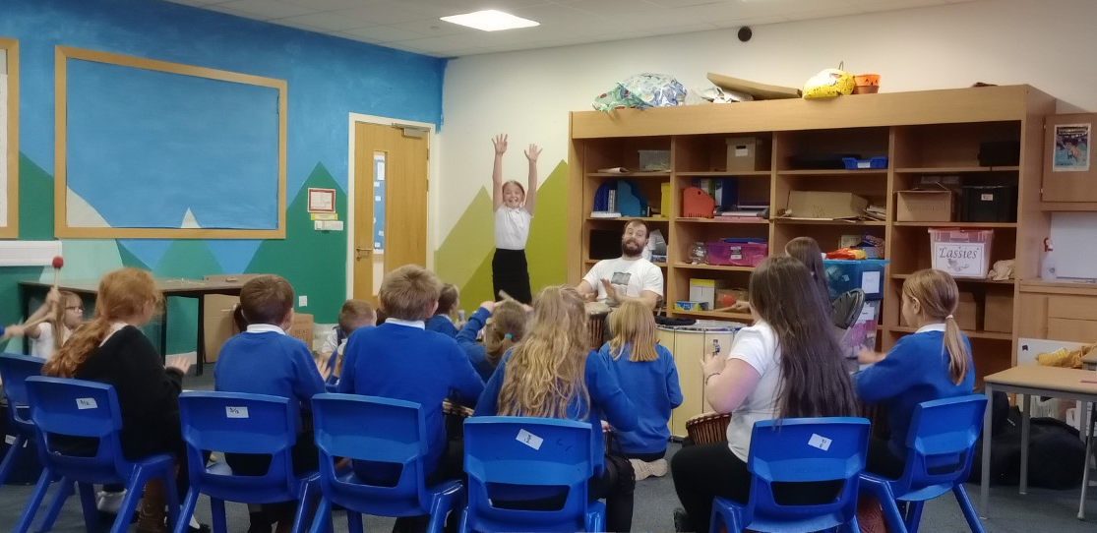

**Samba**

Primary 5 have had a fantastic time learning Samba all through November, they even performed to the whole school and were spectacular!

They have also been enjoying the massage in schools input and have been a quality audience and able to practice their new skills with each other.

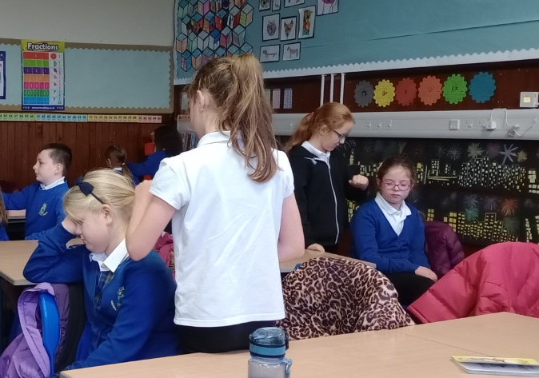

**Massage**