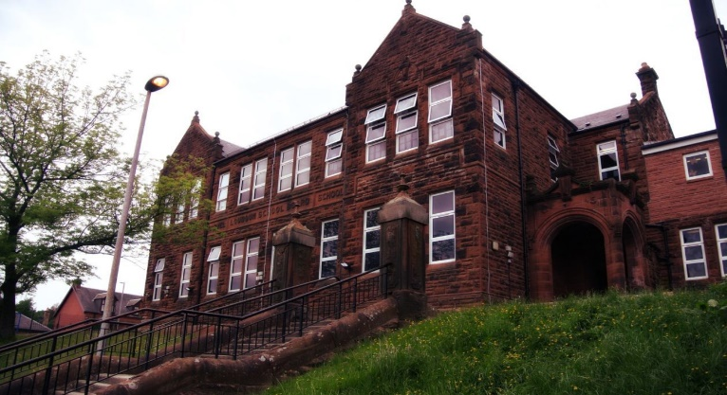

Literacy

We have been -

* Developing skills in grammar, looking at synonyms, antonyms, and homonyms.
* Move on to poetry and instructional writing.
* Develop fluency in reading and look at visualisation and prior knowledge.

Next we will-

* Be looking at predictions and summarising in reading.
* Continue with instructional writing and look at redrafting our work.
* In grammar look at alliteration, adjectives and verbs to up level our work.

**Darvel Primary School**

**P5a R11 Class Newsletter**

**Miss Duffy**

**November 2022**

**Mrs McFadzean (Mon,Tues,Wed)**

**Mrs MacLeod (Thurs,Fri)**

**January 2022**

Numeracy

We have been learning

* Make links with the 3 and 6 times tables.
* Explore the 9 times table.
* Work on the formal method for multiplication.

Next we will be learning to:

* Use multiplication facts to help with division.
* Use an empty number line to complete division questions.
* Continue to work on mental maths and word problems.

Learning across the Curriculum

We have been learning about:

* HWB- Introduce Emotion works.
* PE – Team building games and communication.
* Art – optical illusions.

Next we will be learning about:

* HWB- Continuing to learn about emotion works and growth mindset.
* PE- Netball
* Art- Scottish landscapes.

Another busy month has flown by in P5. The children had a fantastic Halloween- making different crafts and learning about the traditions.

This month coming, we are looking forward to parents evening and the open afternoon.

