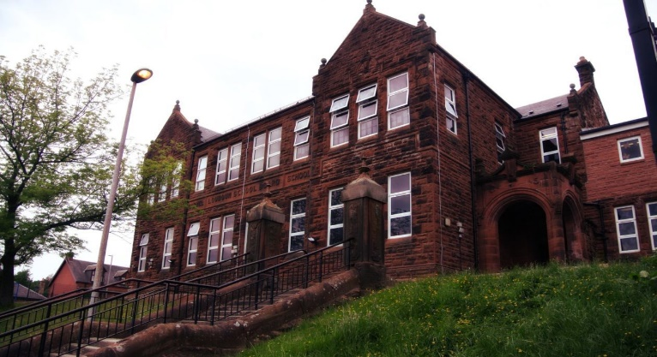

Literacy

* We have been exploring sounds in spelling, using new strategies following the East Ayrshire spelling progression.

* We have written descriptions using plans to help.
* We have looked at metalinguistic and questioning in our class novel ‘The Iron Man’

Next we will be:

* Developing skills in grammar, looking at synonyms, antonyms, and homonyms.
* Move on to poetry and instructional writing.
* Develop fluency in reading and look at visualisation and prior knowledge.

**Darvel Primary School**

**P5a R11 Class Newsletter**

**Miss Duffy**

**October 2022**

**Mrs McFadzean (Mon,Tues,Wed)**

**Mrs MacLeod (Thurs,Fri)**

**January 2022**

Numeracy

We have been learning

* Revise multiplication strategies looking at the 2,4 and 8 times table.
* Use partitioning to help multiply 2 and 3 digit numbers by 1 digit.
* Continued Number talks with a focus on multiplication strategies.

Next we will be learning to:

* Make links with the 3 and 6 times tables.
* Explore the 9 times table.
* Work on the formal method for multiplication.

Learning across the Curriculum

We have been learning about:

* HWB – What to do in an emergency.
* RME- Holy books.
* PE- Fitness and Games

Next we will be learning about:

* HWB- Introduce Emotion works.
* PE – Team building games and communication.
* Art – optical illusions.

Primary 5 have had a busy September. We have taken part in Maths week Scotland – looking and listening for the beauty in maths. We have been busy outside creating challenge obstacle courses for each other and we have looked at the different strategies in our new spelling routine. Well done for all your hard work P5!

