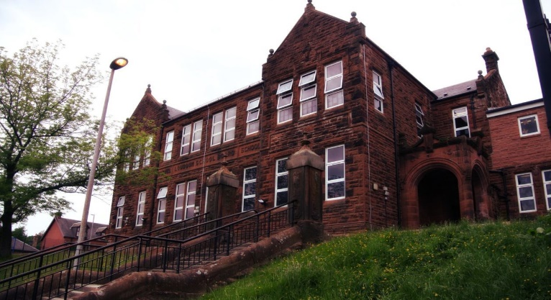

Literacy

* We have been assessing spelling and reading ready for our new spelling scheme.

* We have written some friendship poems and a recipe for friendship soup.
* We have also introduced ‘slow writing’ as a technique to create amazing paragraphs.

Next we will be:

* Developing skills in grammar, looking at capital letters, nouns and pronouns.
* Begin descriptive writing.
* Look at questioning in reading and the different types of questions used in comprehension.

**Darvel Primary School**

**P5a R11 Class Newsletter**

**Miss Duffy**

**September 2022**

**Mrs McFadzean (Mon,Tues,Wed)**

**Mrs MacLeod (Thurs,Fri)**

**January 2022**

Numeracy

* Revision- Solving addition and subtraction problems using partitioning.
* Using an empty number line to solve addition and subtraction problems.
* Making 10s, friendly numbers and doubles in number talks.

Next we will be learning to:

* Revise multiplication strategies.
* Develop our understanding of repeated addition, use of empty number lines, grouping and arrays to aid in multiplication questions.
* Continue Number talks with a focus on subtraction.

Learning across the Curriculum

We have been learning about:

* HWB – Class charter and Well-being indicators.
* Social Studies – Friendship.
* PE- Fitness and Games

Next we will be learning about:

* HWB- what to do in an emergency.
* PE – making the most of the good weather and continuing games outside.
* Art – Geometric art.

Primary 5 have had a great first few weeks. They have settled well and have been producing excellent work so far. I am blown away by their manners, politeness, and friendliness to each other. I am looking forward to a wonderful year with them all.

