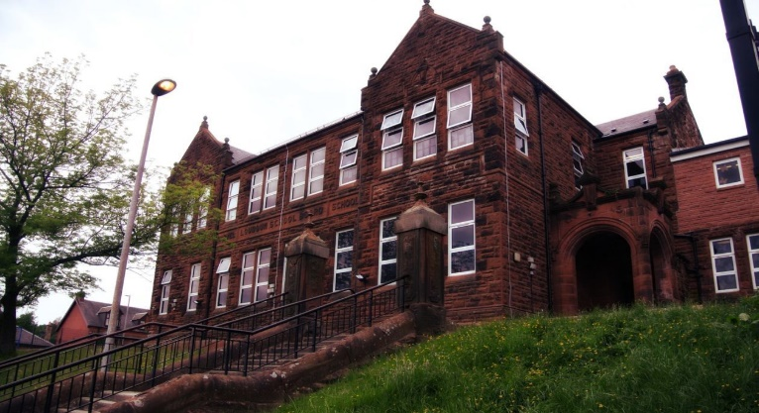

**Darvel Primary School**

**P3 R4 Class Newsletter**

**Mrs McFadzean**

**June 2023**

**Mrs McFadzean (Mon,Tues,Wed)**

**Mrs MacLeod (Thurs,Fri)**

**January 2022**

Literacy

We have been learning to:

* Spelling – ‘ou’ phoneme and common words,

phonics and high frequency words assessments

* Grammar – commas, alphabetical order
* Reading – Rising Stars and related tasks
* Writing – Roald Dahl spider diagram, descriptive writing, recounts

Next we will be learning to:

* Spelling – ‘oe’ (toe), ‘ou’ (you) and ‘oul’ (could) phonemes and common words
* Grammar – using a dictionary, speech marks
* Reading – ‘The Pennycross Ponies’ by Joe Gallagher (Health related)
* Reading and Writing – First Level Assessments
* Writing – acrostic poetry

Numeracy

We have been learning about:

* Consolidation of 2, 3, 4, 5 and 10 times tables
* Money – addition and subtraction of money, giving change
* Division by 2, 5 and 10
* Fractions – finding fractions of amounts by knowledge

of division

Next we will be learning to:

* Numeracy and Mathematics – First Level Assessments
* Time – half past, quarter past and quarter to using analogue and digital 12 hour clocks
* Measure – Length and Weight

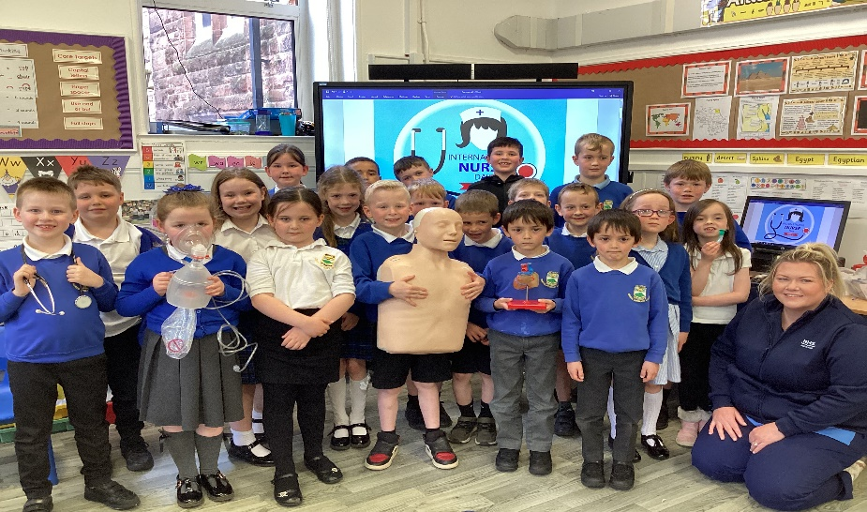

Lic

Learning across the Curriculum

We have been learning about:

* Art – International Nurses’ Day art competition, Coronation art, Newmilns Show art competition
* French – numbers up to 20
* Health and Wellbeing – nurse visit, Children’s 1st visit, kindness activities
* P.E. – sports day races, clubbersize, interhouse competition, karate,

Kilmarnock Football Club activities

Next we will be learning about:

* French – colours
* P.E. – tennis, striking and fielding games
* R.E. – Islam : Key Beliefs
* Health and Wellbeing –

safe medicines, relationships, sexual health

