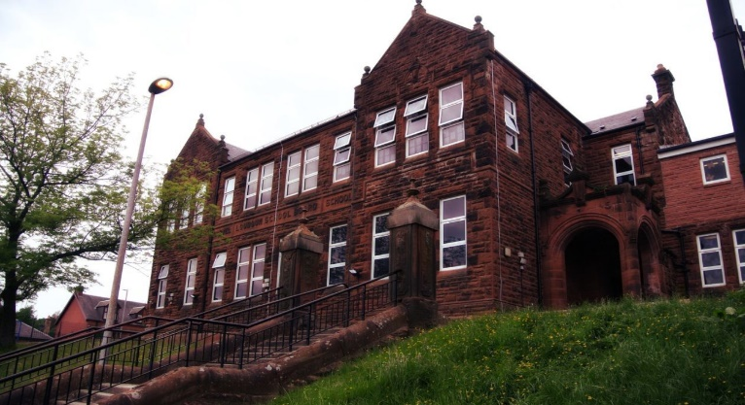

**Darvel Primary School**

**P3 R4 Class Newsletter**

**Mrs McFadzean**

**May 2023**

**Mrs McFadzean (Mon,Tues,Wed)**

**Mrs MacLeod (Thurs,Fri)**

**January 2022**

Literacy

We have been learning to:

* Spelling – ‘ea’ (break), ‘ey’ (/ae/) and ‘ie’ (field) phonemes and common words
* Grammar – connectives, plurals, common and proper nouns
* Reading – book study ‘The Magic Finger’ by Roald Dahl
* Writing – Roald Dahl spider diagram, descriptive writing, recounts

Next we will be learning to:

* Spelling – ‘ou’ (pour), ‘oe’ (toe), ‘ou’ (you) and ‘oul’ (could) phonemes and common words
* Grammar – commas, alphabetical order
* Reading – Rising Stars and related tasks, cloze procedure, main idea
* Writing – Acrostic poetry, preparing questions for nurse visitor as part of
* International Nurses’ Day

Numeracy

We have been learning about:

* Quick recall of 2, 5 and 10 times tables
* Introduction of 3 and 4 times tables
* Money – recognising coins and notes up to the value of £20, writing amounts using decimal notation

Next we will be learning to:

* Consolidation of 2, 3, 4, 5 and 10 times tables
* Money – addition and subtraction of money, giving change
* Division by 2, 5 and 10
* Fractions – finding fractions of amounts by knowledge

of division

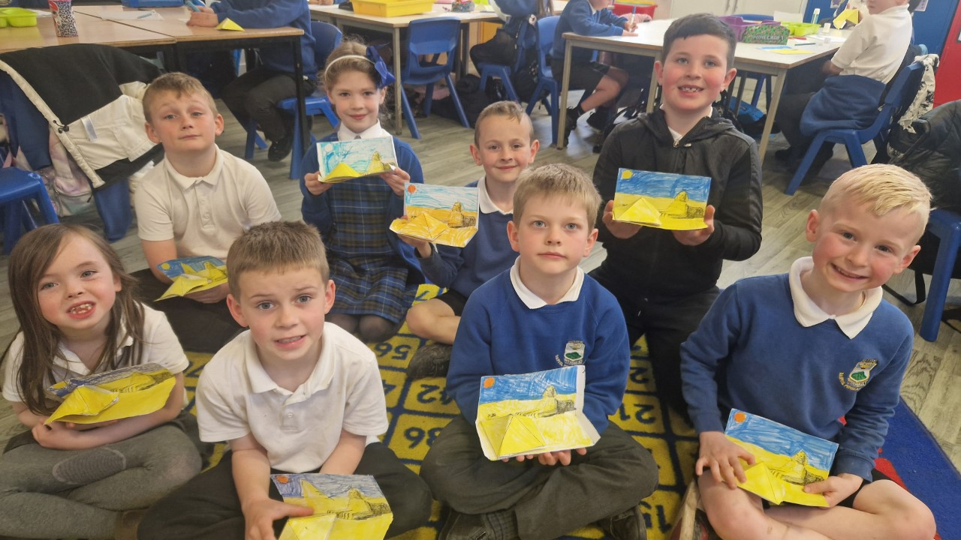

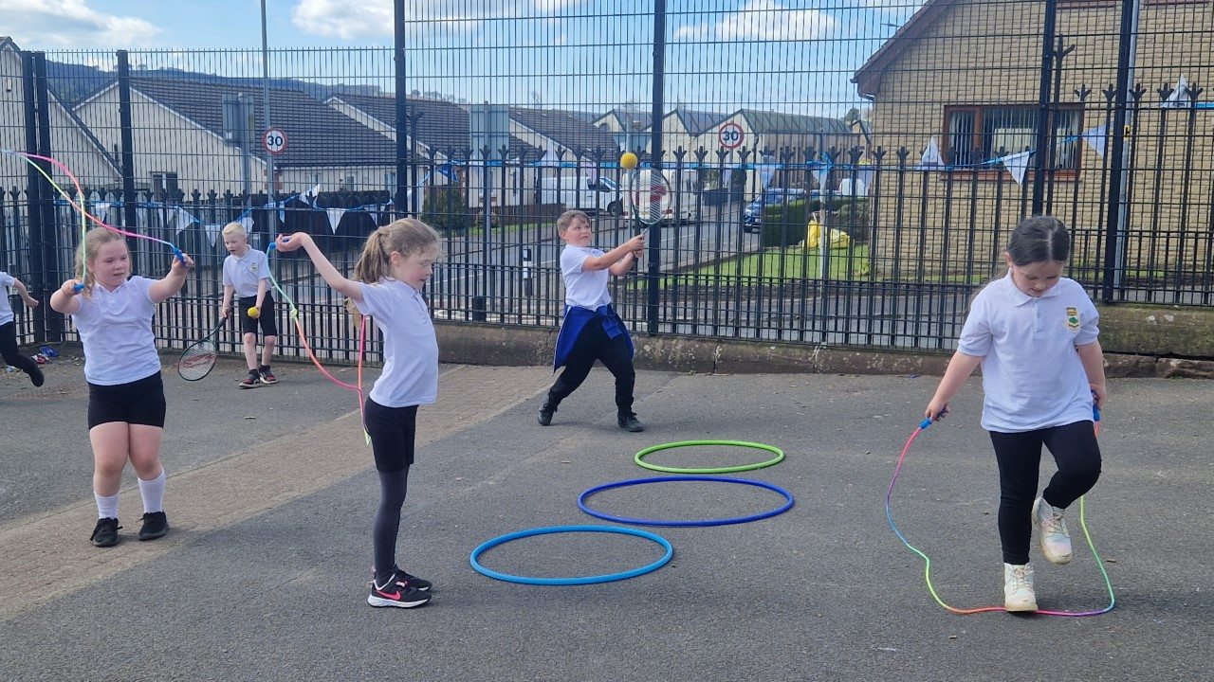

Lic

Learning across the Curriculum

We have been learning about:

* Art – Egyptian pharaoh drawings
* Health and Wellbeing – the role of a nurse
* P.E. – Gymnastics, Egyptian Dance
* Social Studies – Egyptian artefacts
* Technology – desert/pyramid model

Next we will be learning about:

* Art – International Nurses’ Day art competition, Coronation art, Newmilns Show art competition
* French – numbers up to 20
* R.E. – Islam : Key Beliefs
* Health and Wellbeing – Health Fayre,

Safe Medicines

* Social Studies – King Charles III Coronation