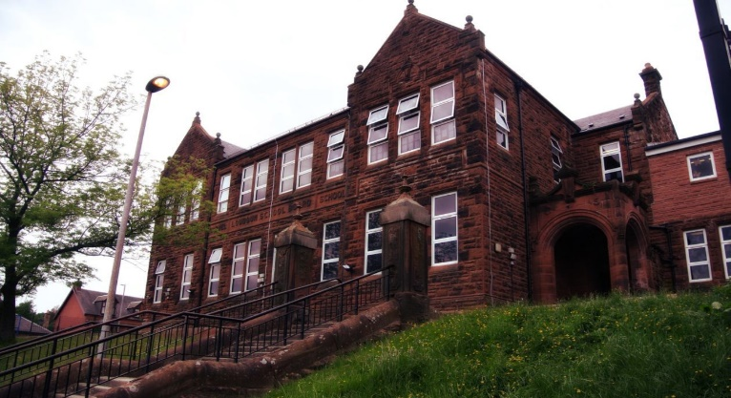

**Darvel Primary School**

**P3 R4 Class Newsletter**

**Mrs McFadzean**

**March/April 2023**

**Mrs McFadzean (Mon,Tues,Wed)**

**Mrs MacLeod (Thurs,Fri)**

**January 2022**

Literacy

We have been learning to:

* Spelling – ‘tch’, ‘se’ and ‘ve’ phonemes and common words
* Scottish Poetry Competition – ‘The Sair Finger’ by Walter Wingate
* Functional Writing – how to make pancakes, descriptive writing
* World Book Day – sharing favourite book, writing book reviews

Next we will be learning to:

* Spelling – consolidation of ‘tch’, ‘se’ and ‘ve’ phonemes, ‘c’ (city), ‘g’ (gem), ‘ea’ (break) and ‘ey’ phonemes and common words
* Grammar – connectives, plurals, common/proper nouns
* Reading – book study ‘The Magic Finger’ by Roald Dahl
* Writing – Roald Dahl spider diagram, descriptive writing, recounts

Numeracy

We have been learning about:

* Multiplication – 2, 5 and 10 times tables
* Solving subtraction word problems
* Symmetry

Next we will be learning to:

* Quick recall of 2, 5 and 10 times tables
* Weekly Big Maths Beat That Tests
* Introduction of 3 and 4 times tables
* Money – recognising coins and notes up to the value of £20, addition and subtraction of money, giving change
* Rounding to the nearest 10 and nearest 100
* Handling Data

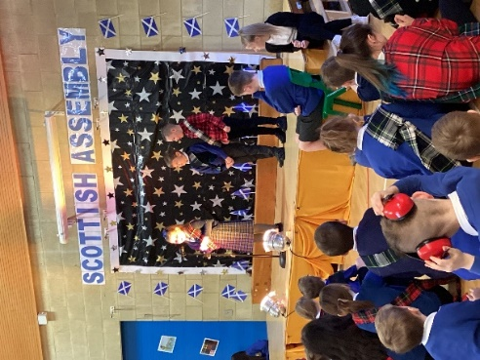

Lic

Congratulations to our Scottish Poetry Competition Winners. Your recitals of ‘The Sair Finger’ were amazing!

1st Place – Aaron

2nd Place – Obadiah

3rd Place – Millie

Well done to all the boys and girls in the class for all your hard work and effort learning the poem and participating

in the competition!

Learning across the Curriculum

We have been learning about:

* French – Classroom commands
* ICT/Topic – Egyptians research
* R.E. – Shrove Tuesday/Ash Wednesday
* Social Studies – countries of the United Kingdom, map of Egypt, locating Egypt

Next we will be learning about:

* Art – Easter activities, Egyptian pharaohs and hieroglyph drawings, International Nurse Day art competition
* R.E. – Easter Story
* Health and Wellbeing – Emotion Works Programme
* French – Greetings, Personal Information
* Topic – Egyptians

