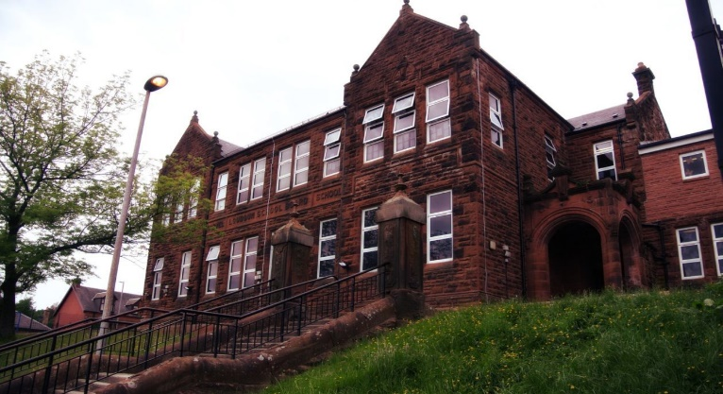

**Darvel Primary School**

**P3 R4 Class Newsletter**

**Mrs McFadzean**

**February 2023**

**Mrs McFadzean (Mon,Tues,Wed)**

**Mrs MacLeod (Thurs,Fri)**

**January 2022**

Numeracy

We have been learning about:

* Tens and Ones/Hundreds, Tens and Ones subtraction (with exchange)
* Array patterns
* Multiplication – 2, 5, 10 times tables

Next we will be learning to:

* Subtraction word problems
* Consolidation of 2, 5, 10 times tables
* Handling Data

Literacy

We have been learning to:

* Spelling – consolidation of ‘ea’, ‘ie’, ‘u’ phonemes, assessments
* Understand Scots language
* Reading – implementation of new reading scheme ‘Rising Stars’
* Grammar – full stops, question marks, exclamation marks

Next we will be learning to:

* Poetry Competition - ‘The Sair Finger’ by Walter Wingate
* Reading – book study ‘The Magic Finger’ by Roald Dahl
* Writing – functional writing, descriptive writing

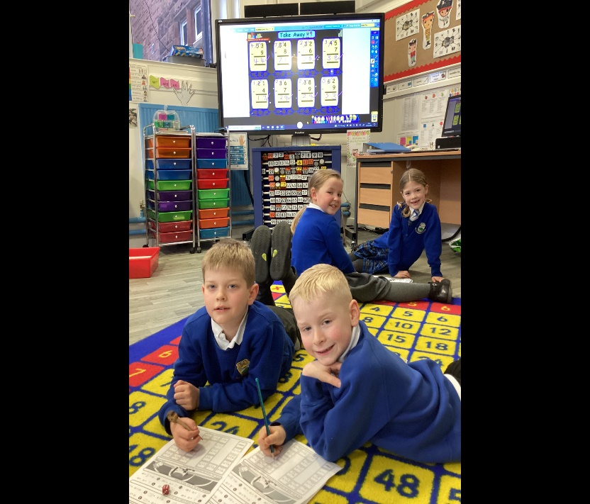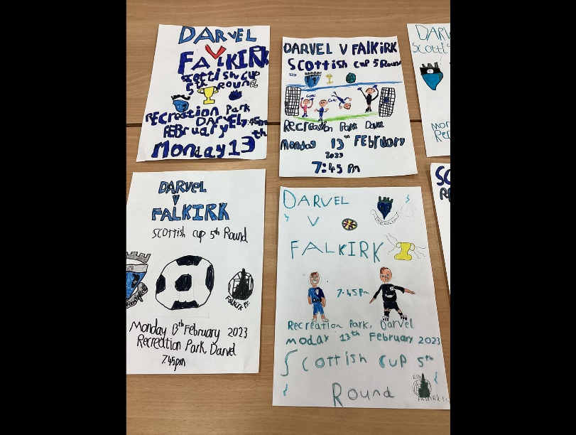

lic

Learning across the Curriculum

We have been learning about:

* French – cultural awareness, All About France
* Social Studies – Robert Burns
* Art – football bunting and posters, tartan

Next we will be learning about:

* Health and Wellbeing – Massage in Schools
* French – Classroom commands, Greetings
* Topic – Egyptians

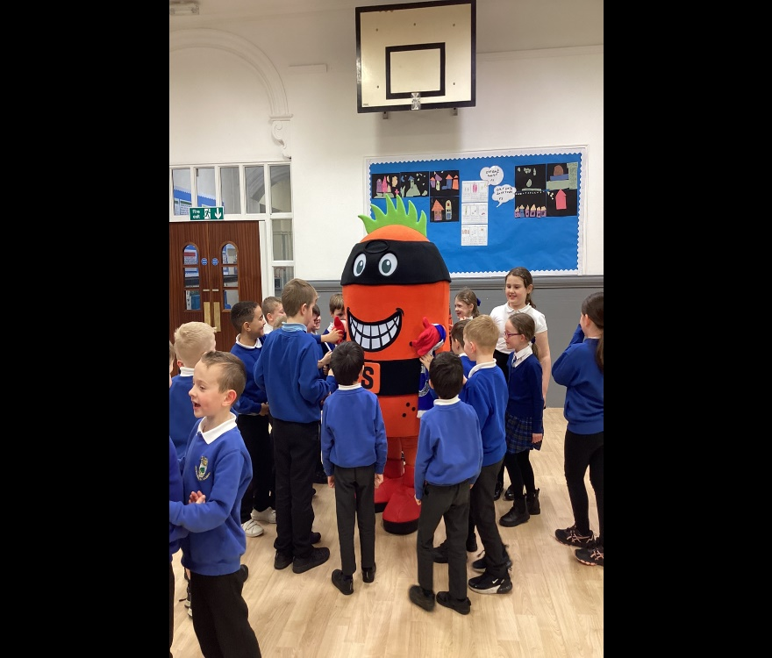

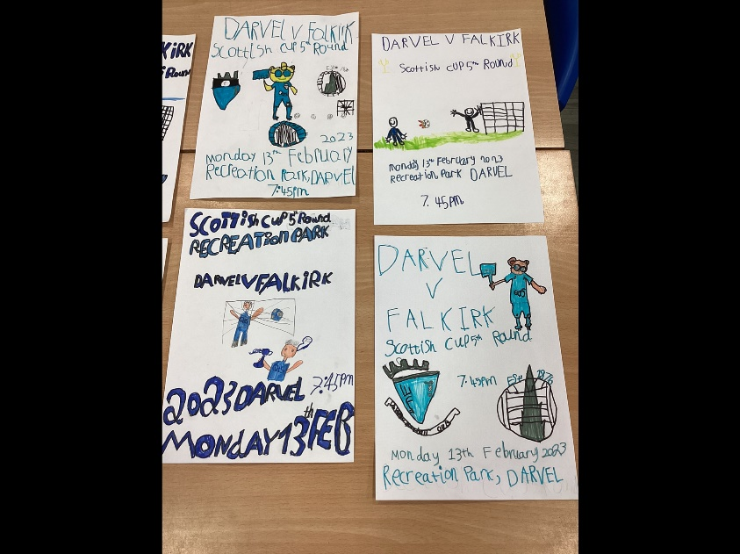

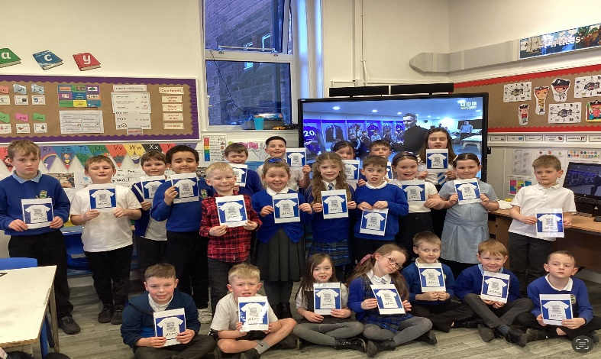

. We are delighted to announce we raised an amazing £ for the school funds through our Tea Towel Enterprise

all orders placed. We would like to wish everyone an enjoyable festive season