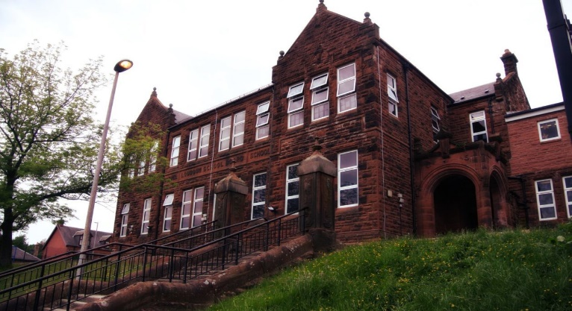

**Darvel Primary School**

**P3 R4 Class Newsletter**

**Mrs McFadzean**

**January 2023**

**Mrs McFadzean (Mon,Tues,Wed)**

**Mrs MacLeod (Thurs,Fri)**

**January 2022**

Numeracy

We have been learning about:

* Tens and Ones/Hundreds, Tens and Ones subtraction (without exchange)
* Christmas problem solving and puzzles
* Symmetry

Next we will be learning to:

* Tens and Ones/Hundreds, Tens and Ones Subtraction (with exchange)
* Array patterns
* Multiplication – 2, 5, 10 x tables

Literacy

We have been learning to:

* Spelling – Pirates, Christmas vocabulary, vowel digraph ‘ie’
* Reading – book study ‘The Dog That Saved Christmas’
* Grammar – punctuating sentences

using full stops and question marks

Next we will be learning to:

* Spelling – ‘u’ (oo) + (yoo), consolidation of ‘ea’, ‘ie’ and ‘u’ phonemes
* Understand Scots language
* Poetry - learn and recite ‘The Sair Finger’ by Walter Wingate
* Reading – implementation of new reading scheme ‘Rising Stars’

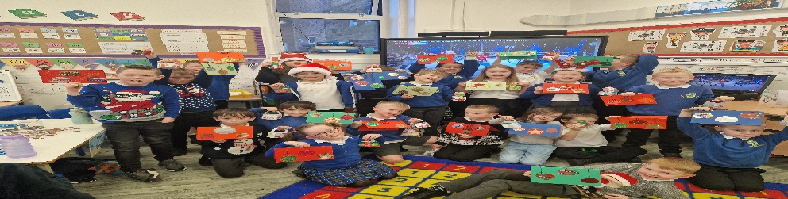

lic

Learning across the Curriculum

We have been learning about:

* Art – Christmas activities
* P.E. – Social Dancing

Next we will be learning about:

* Health and Wellbeing – Massage in Schools
* French – cultural awareness, All About France
* Topic – Egyptians

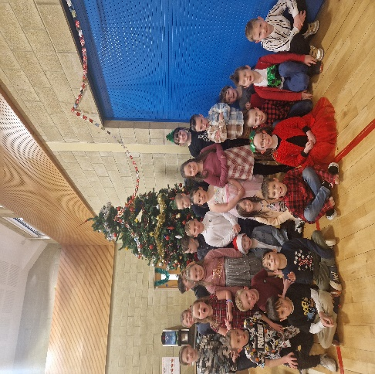

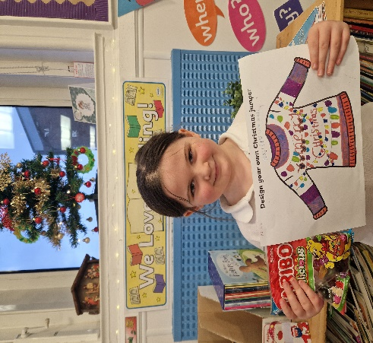

Happy New Year everyone!

Congratulations to Hallie who won our class ‘Design your own Christmas jumper’ competition!

We are delighted to have raised an amazing total of £618.94 for Darvel Primary school funds through our tea towel Enterprise project. A huge thank you to everyone who placed an order.

. We are delighted to announce we raised an amazing £ for the school funds through our Tea Towel Enterprise

Last week we were excited to receive our samples of the school tea towels and are extremely grateful for

all orders placed. We would like to wish everyone an enjoyable festive season!