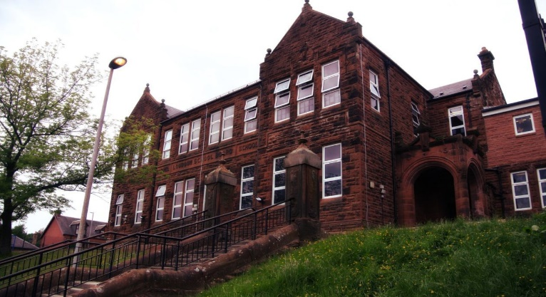

**Darvel Primary School**

**P3 R4 Class Newsletter**

**Mrs McFadzean**

**December 2022**

**Mrs McFadzean (Mon,Tues,Wed)**

**Mrs MacLeod (Thurs,Fri)**

**January 2022**

Literacy

We have been learning to:

* Active Literacy Stage 3 – ‘wa’, ‘a’, ‘al’, ‘ea’ sounds, common words, pirate words
* Develop reading skills through paired reading
* Grammar – a/an, question marks
* Imaginative writing, character mind map and character description

Next we will be learning to:

* Active Literacy Stage 3 sounds – ‘ie’, ‘u’, common words, Christmas words
* Grammar – exclamation marks
* Reading – book study ‘The Dog That Saved Christmas’
* Writing – Christmas poems, letters to Santa, Christmas riddles

Numeracy

We have been learning about:

* Tens and Ones/Hundreds, Tens and Ones Addition ( no regrouping, with regrouping)
* Solving addition word problems
* Counting in 2’s, 5’s, 10’s
* Creating tiling patterns

Next we will be learning to:

* Tens and Ones/Hundreds, Tens and Ones Subtraction (without exchange)
* Christmas problem solving and puzzles
* Symmetry

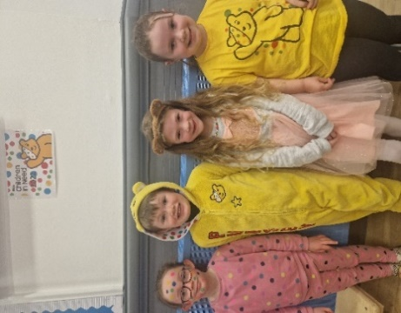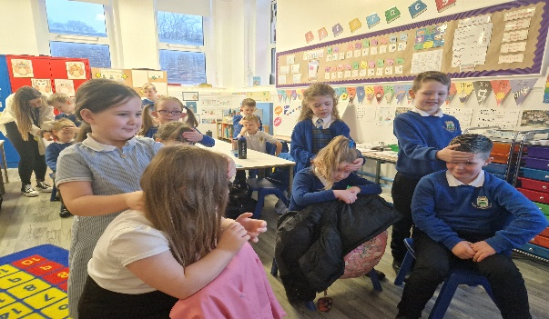

Learning across the Curriculum

We have been learning about:

* Health and Wellbeing – Emotion Works feelings and emotions, massage sessions
* Art – fireworks paintings, Christmas Fayre crafts
* Social Studies – Protecting Seas Workshop, Visit to Maritime Museum
* Enterprise/School Funding- tea towel order form for school app, daily order updates

Next we will be learning about:

* Art – Christmas Activities
* Enterprise – tea towel delivery sorting
* P.E. – Social Dancing
* R.E. – Christmas Story

Tea towel fundraising project

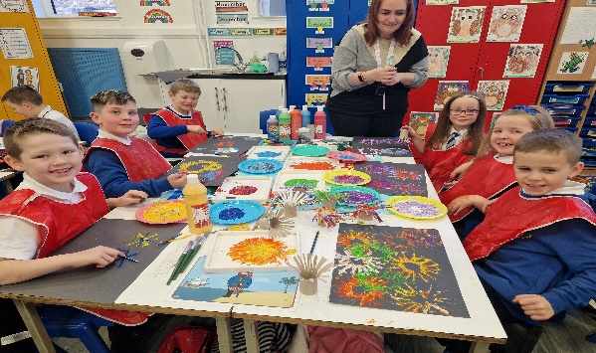

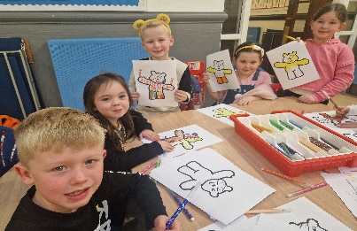

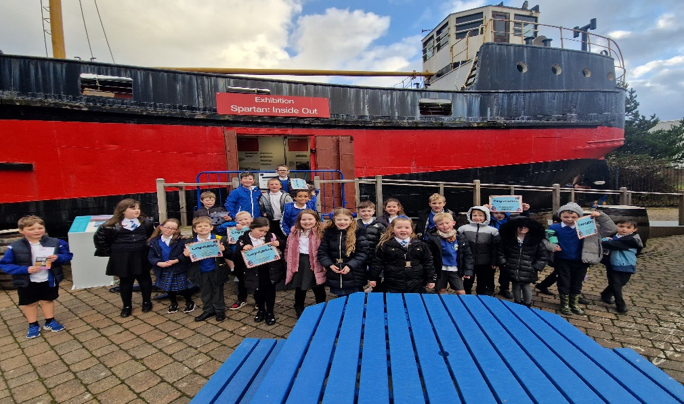

Last week we were excited to receive our samples of the school tea towels and are extremely grateful for

all orders placed. We would like to wish everyone an enjoyable festive season!