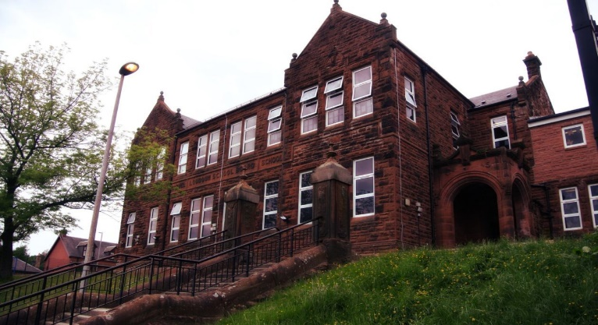

**Darvel Primary School**

**P3 R4 Class Newsletter**

**Mrs McFadzean**

**October 2022**

**Mrs McFadzean (Mon,Tues,Wed)**

**Mrs MacLeod (Thurs,Fri)**

**January 2022**

Literacy

We have been learning to:

* Active Literacy Stage 2 – revision of digraphs and common words
* Shared Reading – ‘The Owl who was Afraid of the Dark’
* Personal writing – what I’m thankful for

(linking with Harvest)

Next we will be learning to:

* Moving onto Active Literacy Stage 3

sounds and common words

* Developing our reading skills through ‘The Owl who was Afraid of the Dark’
* Writing – book study related, Halloween

Numeracy

We have been learning about:

* Baseline Maths assessments - revision work
* Recognise odd and even numbers
* Identify and recognise properties of 2D shapes
* Maths Week Scotland – various activities and challenges

Next we will be learning to:

* Place value, partitioning 2 and 3 digit numbers
* ‘Big Maths Beat That’ weekly assessments
* Identify and recognise properties of 3D shapes
* Identify and create patterns, tiling and symmetrical shapes

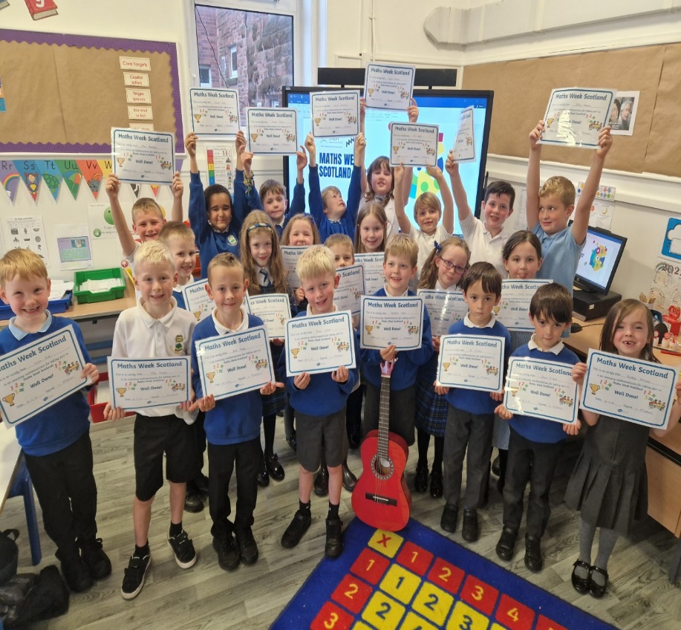

Learning across the Curriculum

We have been learning about:

* Health and Wellbeing – classroom responsibilities, respect
* Social Studies – remembering Queen Elizabeth 11
* Art – black line drawings of the Queen
* R.E. - Harvest

Next we will be learning about:

* RE – story of Joseph
* Health and Wellbeing – Hello Yellow Day, World Mental Health Day
* Social Studies : Enterprise -

Tea towel fundraising project

Our class are recycling blue, green and red milk bottle tops. Thank you to everyone who has already been collecting and bringing to school. Please continue to collect and send with your child, your help is greatly appreciated. Along with the Primary 3/4 and Primary 4 classes we are excited to announce all three classes are organising a whole school tea towel fundraising project this term.

Reminder – Our P.E. days are Monday and Tuesday. Please remember to bring your P.E. kit to school these days.