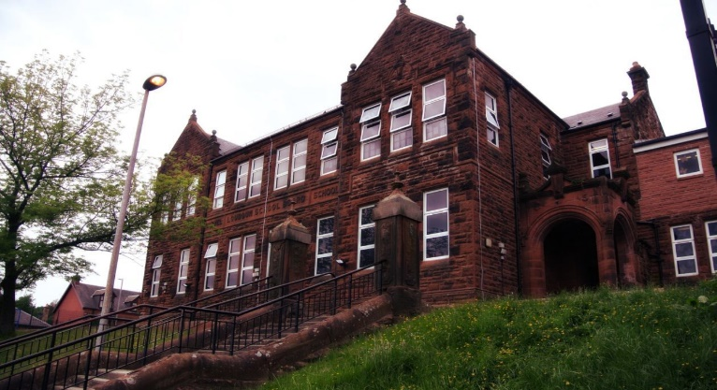

**Darvel Primary School**

**P3 R4 Class Newsletter**

**Mrs McFadzean**

**November 2022**

**Mrs McFadzean (Mon,Tues,Wed)**

**Mrs MacLeod (Thurs,Fri)**

**January 2022**

Literacy

We have been learning to:

* Active Literacy Stage 2 – digraph and common words revision
* Active Literacy Stage 3 – ‘wr’
* Develop our prediction, comprehension, visualisation and inference skills
* Personal writing – My feelings about the dark, introduction to VCOP

Next we will be learning to:

* Active Literacy Stage 3 sounds – ‘wa’, ‘a’, ‘al’, ‘ea’ and ‘ie’ and common words
* Grammar – a/an, question and exclamation marks
* Writing – character description

Numeracy

We have been learning about:

* Use concrete materials to show how HTU numbers are constructed
* Place Value, partitioning 2 and 3-digit numbers
* Identify and recognise properties of 3D shapes

Next we will be learning to:

* Addition and money (Enterprise related)
* TU/HTU Addition ( no regrouping, with regrouping)
* Creating patterns, tiling and symmetrical shapes

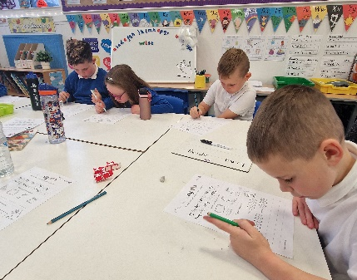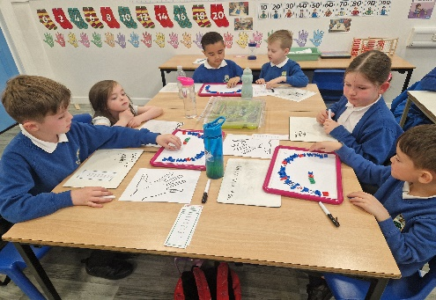

Learning across the Curriculum

We have been learning about:

* Health and Wellbeing – respect
* Art – drawing self-portrait for tea towel
* R.E. – the story of Joseph

Next we will be learning about:

* Health and Wellbeing – Introduction to ‘Emotion Works’, massage sessions
* Social Studies : Enterprise, Pirates

Remembrance Day, St. Andrew’s Day

* Art – fireworks related art work

Tea towel fundraising project

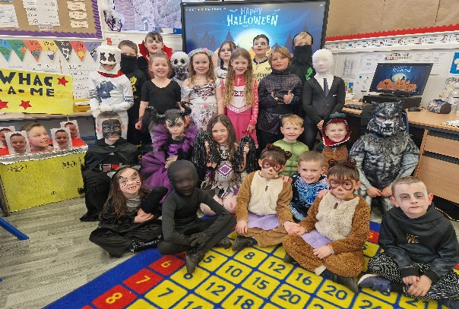

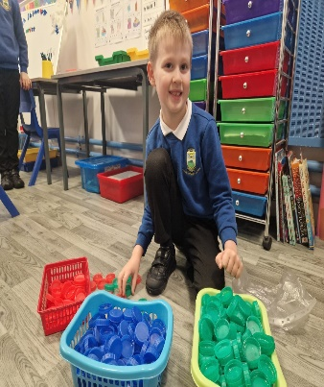

We have been working hard on our Enterprise tea towel project and everyone in the school has now completed their self-portrait. Next we will be organising the layouts for our P1 - P4 and P5 – P7 tea towels

and sending them off to the company to screen print our samples.

It was fantastic to see the children dressed up in their Halloween costumes. Everyone had lots of fun participating in various activities and enjoyed our Halloween party along with P3/4 and P4 pupils too! 