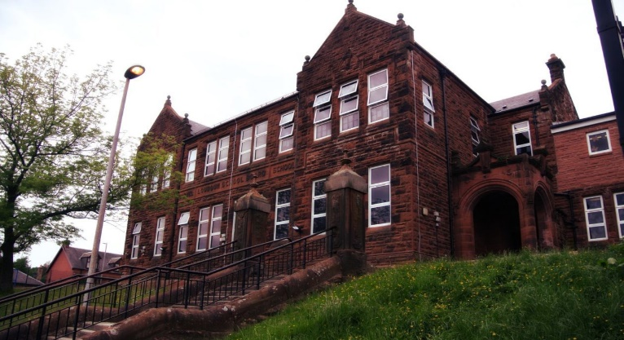

**Darvel Primary School**

**P3 R4 Class Newsletter**

**Mrs McFadzean**

**September 2022**

**Mrs McFadzean (Mon,Tues,Wed)**

**Mrs MacLeod (Thurs,Fri)**

**January 2022**

Literacy

We have been learning to:

* Recognise and spell common words
* Shared Reading - ‘The Day the Crayons Quit’ and complete related reading activities
* Write about ourselves

Next we will be learning to:

* Revise sounds and common words
* Grammar and Punctuation – use correct punctuation in sentence writing
* Book study – ‘The Owl who was Afraid of the Dark’
* Writing – how we feel about the dark

Numeracy

We have been learning about:

* Number bonds to 20
* Doubles and halves
* Making links between addition and subtraction

Next we will be learning to:

* Progression of number bonds within 20 and links between addition and subtraction
* Recognise odd and even numbers to 100
* Tens and units place value, partitioning 2-digit numbers in different ways
* Identify and recognise properties of 2D shapes

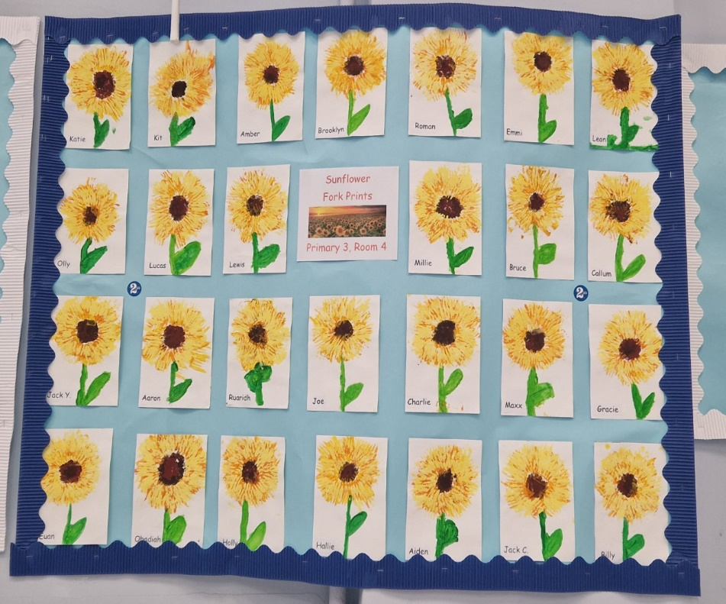

Learning across the Curriculum

We have been learning about:

* Health and Wellbeing – getting to know each other, creating a class charter
* P.E. - co-operative games, circle games, tennis skills
* Art – sunflower prints

Next we will be learning about:

* R.E. – Harvest
* Health and Wellbeing – our classroom responsibilities, respect
* P.E. - Ball Skills, Fitness Stations

Welcome to our first Primary 3 newsletter! The children have settled great into our first term and are happy to be working in their newly refurbished classroom. It has been really lovely getting to know all of the children. We are delighted to have gained 2nd prize in the Darvel Flower Show with our beautiful sunflower fork prints. All pupils made a fantastic effort in their art work and should be very proud!

Reminder – Our P.E. days are Monday and Tuesday. Please remember to bring your P.E. kit to school these days.