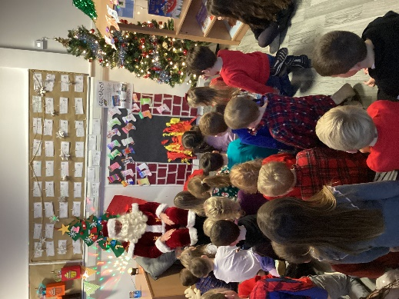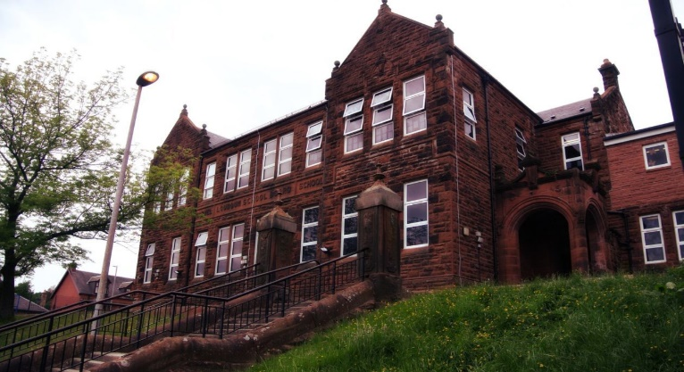

Learning across the Curriculum

January is going to be a busy month as P1’s will be practising their Scottish poem for Burn’s Day celebrations. As our Topic, we will also be learning more about Scotland and look forward to reading Scottish stories, singing some Scottish songs and tasting some Scottish food!



The pupils enjoyed lots of Christmas arts and crafts with Mrs McAulay. They did finger painting to create a ‘R udolf the red nosed Reindeer’ card!

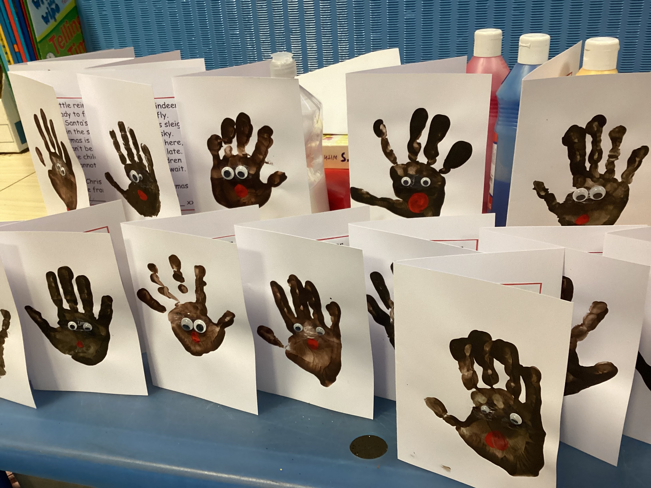

Numeracy

This term we will continue to learn addition of numbers and subtracting numbers within 20. We will also be looking at symmetry and position and movement. We will be taking every opportunity to learn in a variety of active ways including outdoor learning.

Literacy 

We will continue to reinforce our initial sounds using Jolly Phonics Programme. This term we will be learning joined phonemes. We will be using our knowledge of sounds to read and write words as well as writing a sentence using descriptive words.

Happy New Year everyone!

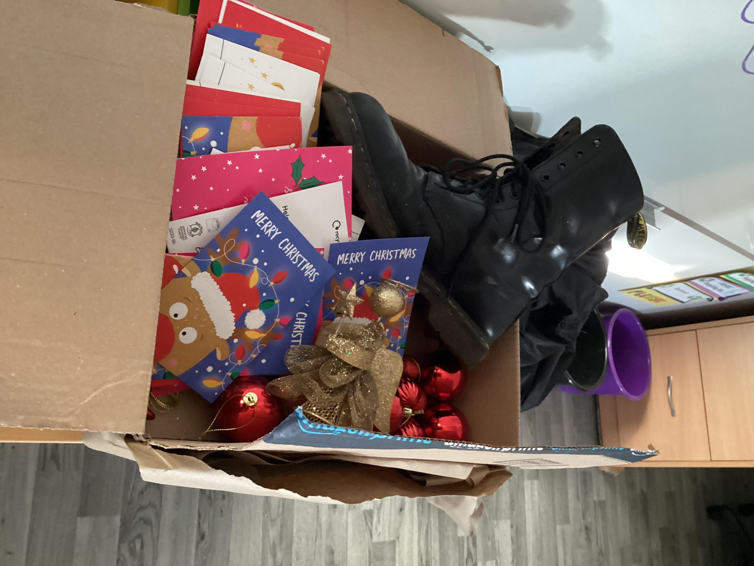

The pupils all had a fantastic time at Christmas. They had a letter from Santa to find his missing boot! They solved riddles as clues and found Santa’s boot!

They also enjoyed a visit from Santa!

**Darvel Primary School**

**P1 Class Newsletter**

**Mrs Wilson/Mrs McAllister**

**January 2023**