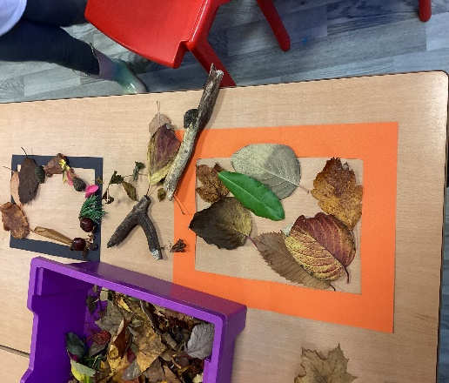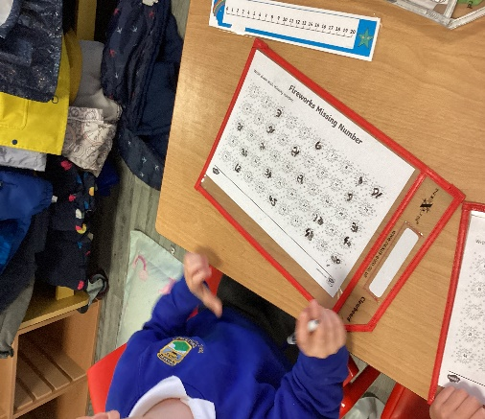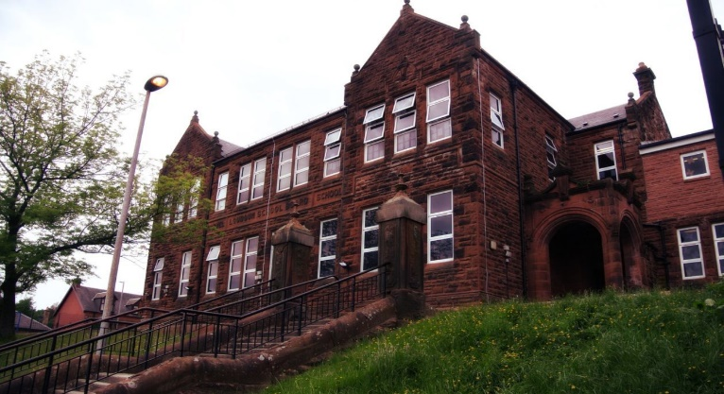

Literacy

We continue to learn our initial sounds using Jolly Phonics Programme. The pupils have been blending their sounds to read and write words. We have been learning more tricky words too! It won’t be long till we are able to use these to write a sentence!

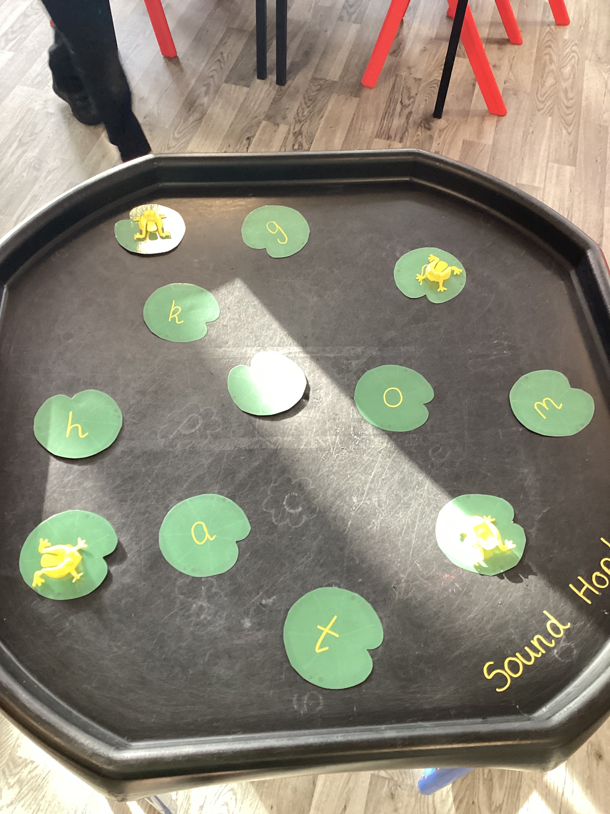 

Numeracy

We have been learning more about missing numbers, and before/after numbers using a number line. We have also been using numicons to add numbers together. We will be learning about patterns and shapes soon.

Hi everyone,

November already!

It’s going to be a busy month as P1’s are practicing songs for the Nativity – what wonderful singing!

We have the school Disco 10th November to look forward to!

We cannot wait to meet you at Parent’s Evening and share with you how well your child is doing!

We had our visit from Child Smile and the pupils are starting tooth brushing next week!

Learning across the Curriculum

In Art, with Mrs McAulay, we have been learning about printing and used a variety of materials.

We have been working collaboratively with P6 pupils to work positive relationships. We have been playing games and reading books together.

Miss Smith taught the children about firework safety. We have also been learning why fireworks are different colours – ask your child to tell you why!

**Darvel Primary School**

**P1 Class Newsletter**

**Mrs Wilson/Mrs McAllister**

**November 2022**