

Learning across the Curriculum

We are learning about the Seasons and months of the year. We have been enjoying experimenting with lots of different media to create Autumnal pictures.

Miss Smith has been teaching us the importance of keeping ourselves safe when crossing the road as well as ‘Stranger Danger’.

We are looking forward to our visit to the library too!



Hi everyone,

October already!

Pupils have settled in very quickly and learned their daily routines. We are all having so much fun learning through using many different active learning games.

Tooth brushing will be starting soon! P1’s have their visit from Child Smile at the end of this month to teach the pupils the importance of brushing their teeth.

Please can you ensure that all items belonging to your child are labelled and bottles of water are too. Thanks.

Numeracy

We are learning how to sequence numbers, missing numbers in sequence, numbers before and after and ordinals. We will continue to explore numbers, representing these in quantities and explore addition and subtraction.

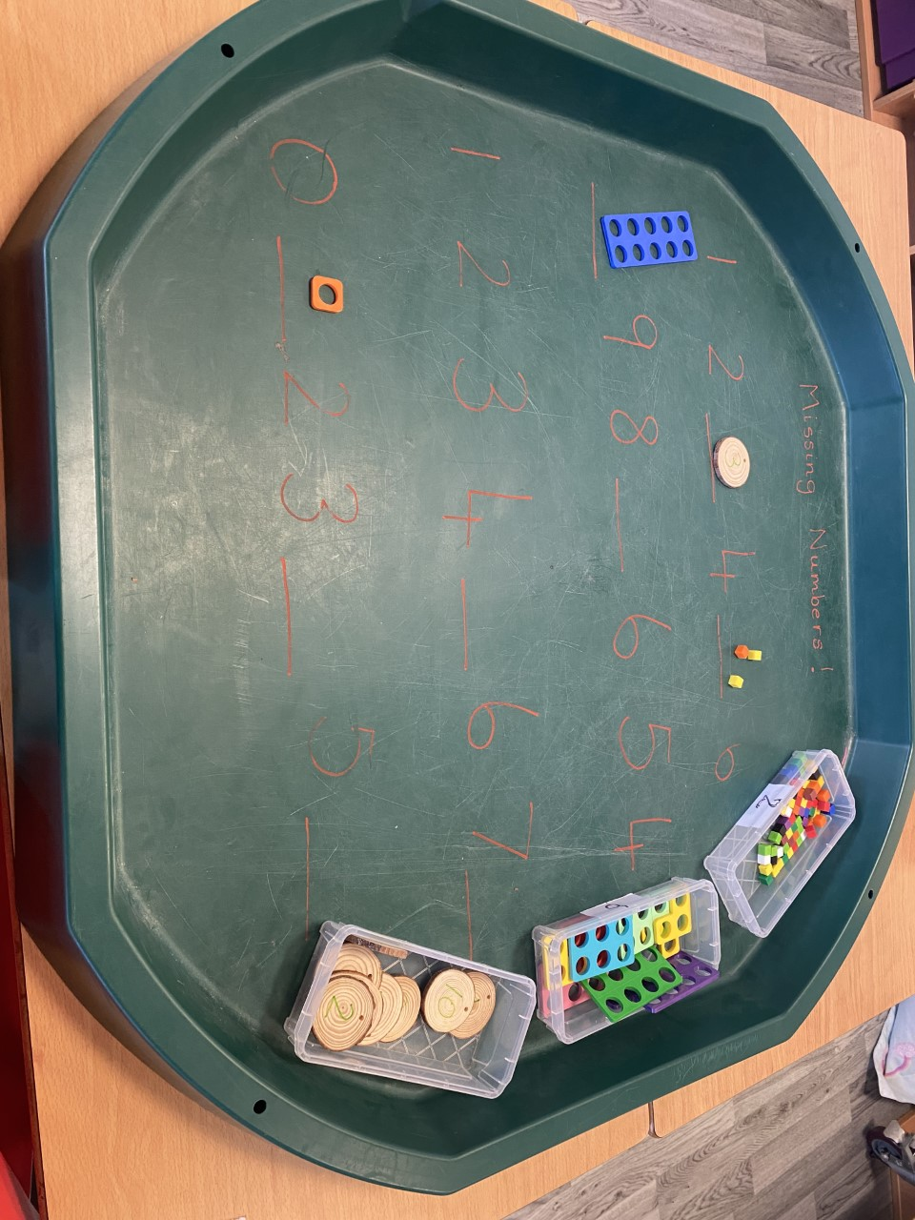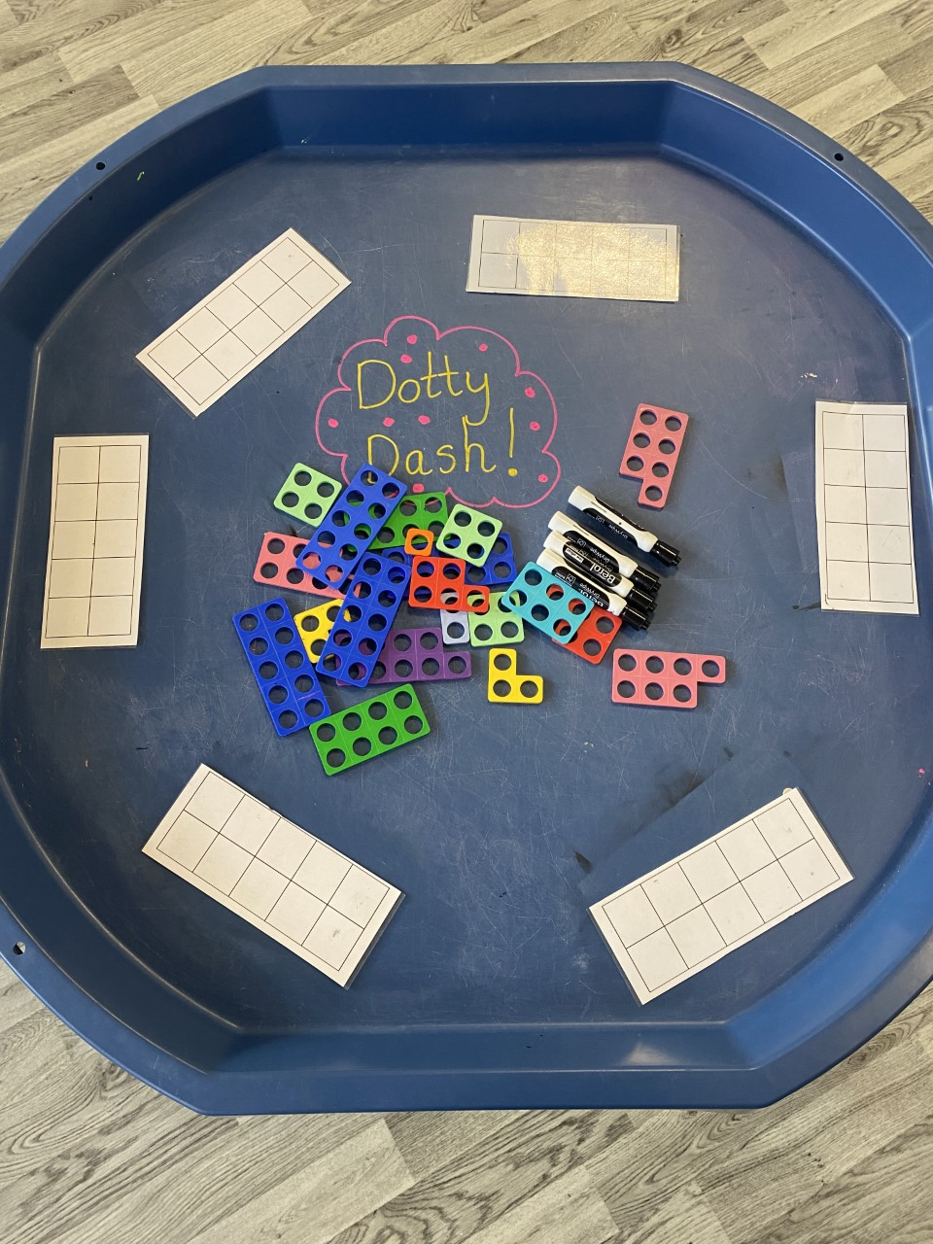

Literacy

We continue to learn our initial sounds using Jolly Phonics. We have implemented Octopus (East Ayrshires Literacy Programme – ‘Our clear teaching of phonics underpins spelling’) as a learning tool moving to teach pupils reading and spelling using phonics.

We have been using our sounds learned to blend them to read and write cvc words (eg: cat, net, tin). We have also been learning tricky words – ones that we cannot always sound out – I/the. These words will help us start to write short sentences.

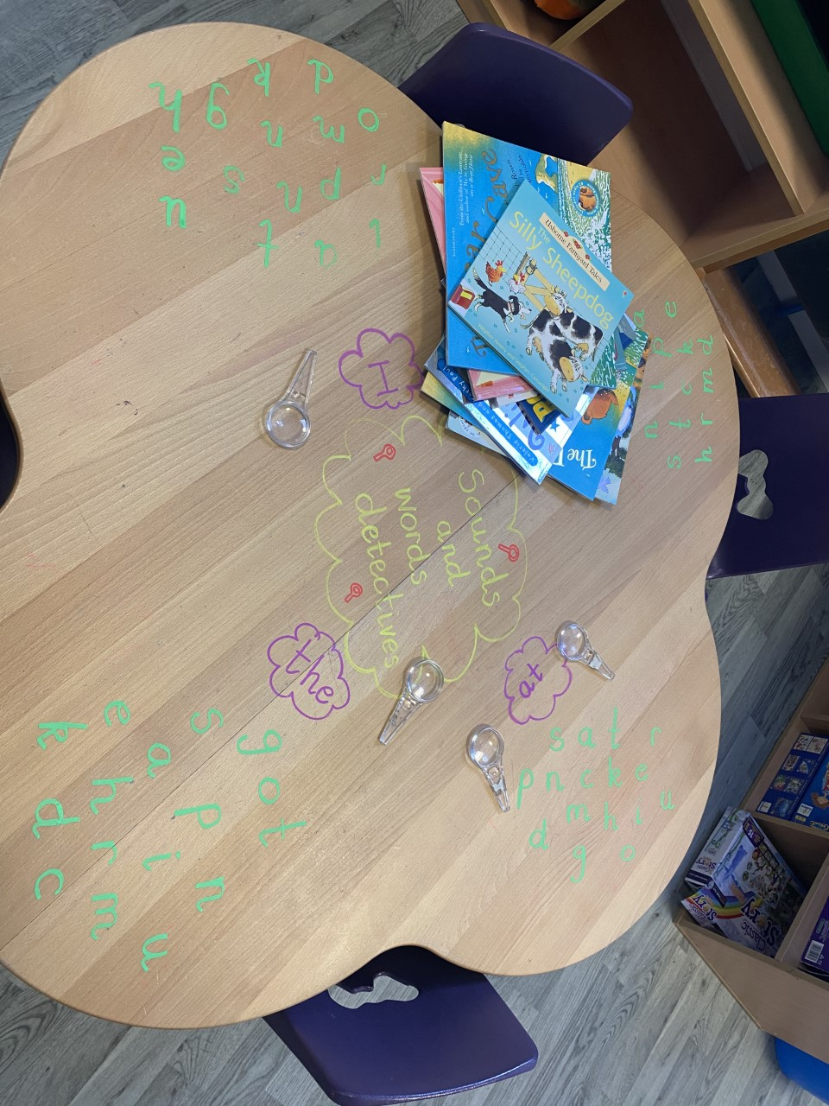 

**Darvel Primary School**

**P1 Class Newsletter**

**Mrs Wilson/Mrs McAllister**

**October 2022**