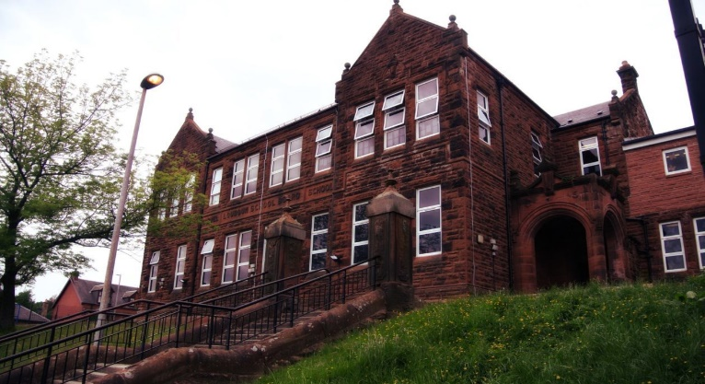

Numeracy

We have been working on

* Finishing fractions, decimals and percentages

Next we will be doing for the last term

* Time and
* Measure

We continue daily practice of speed and accuracy.

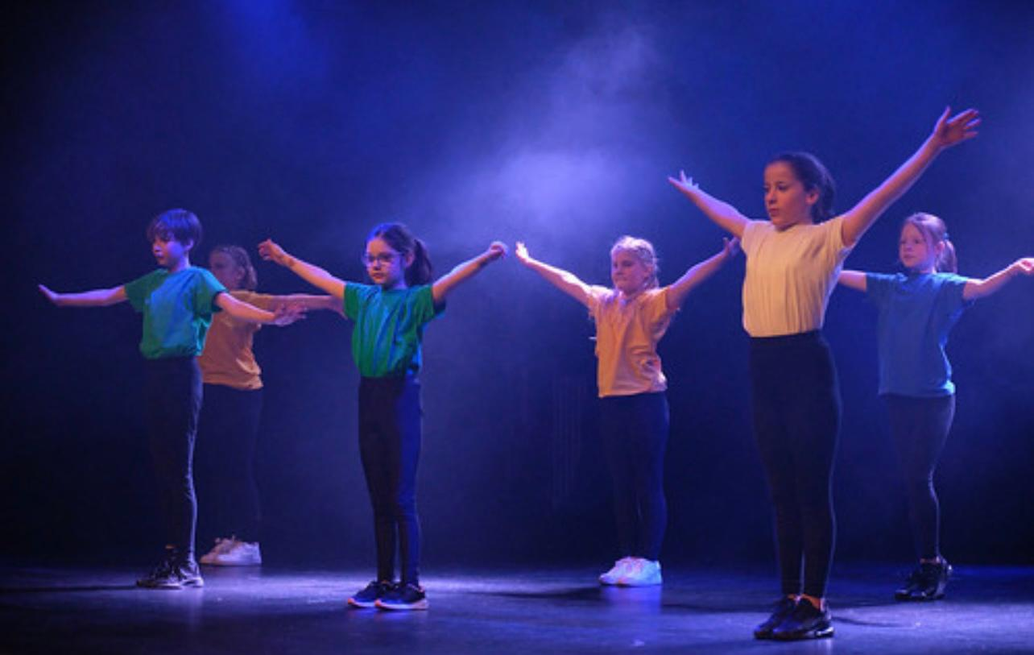

**DanceFest**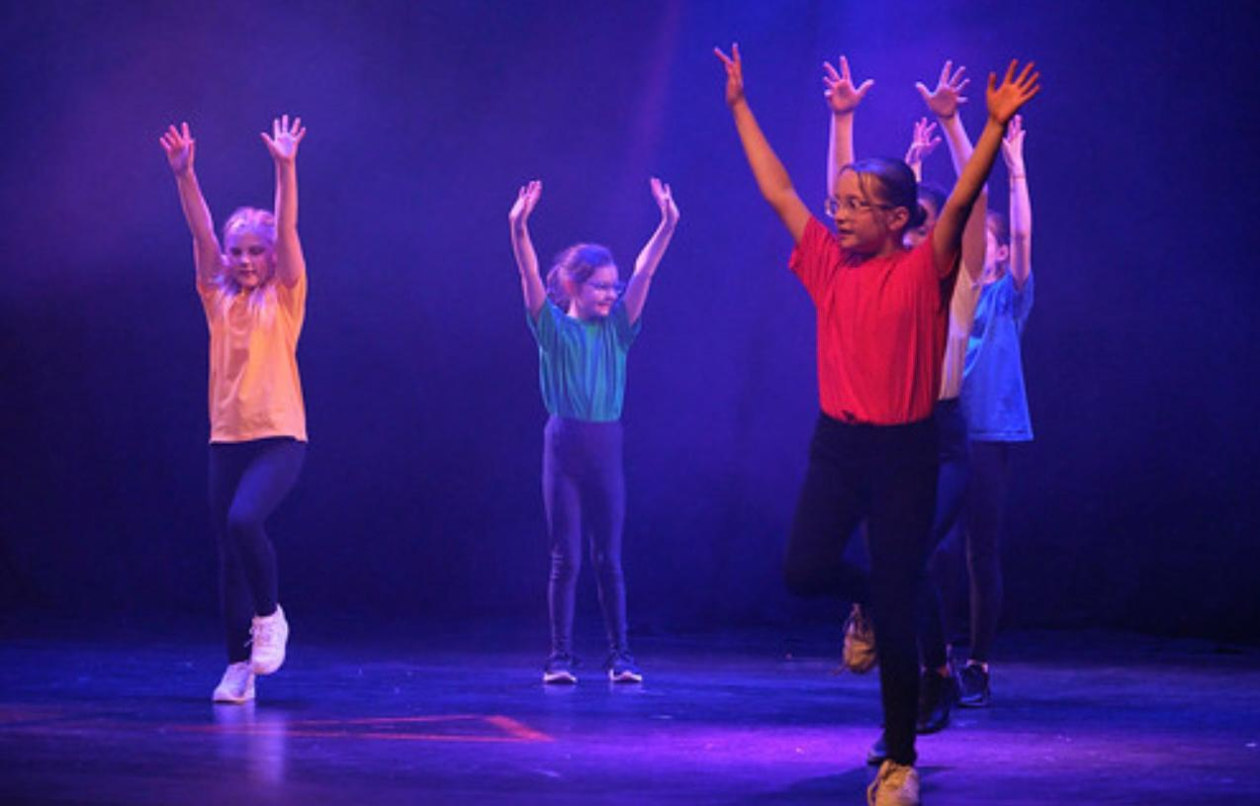

We are nearly ready to pair up with our nursery pupils who we will buddy next term. We will continue to visit and build relationships with them, making transition easier for everyone. We simply had the best time on Newmilns ski slopes and we all improved over the 8 week term. We had a fantastic time at DanceFest, celebrating dance in the Palace Theatre. We have a very exciting term planned ahead including sports day, Coronation Day activities and much more.

Learning across the Curriculum

We are

Learning about Adaption and Interdependency!!

* Habitats, Food Chains, Food Webs

Also we will be learning

* Weather and date in french
* Family types in HWB

Literacy

We are

* Reading and investigating all aspects of our novel ‘The Butterfly Lion’
* Consolidating apostrophe’s and similes
* Working on metalinguistic and grammar
* Starting our 2-week spelling program
  + Letters this month /l/ /f/

**Darvel Primary School**

**P6 R12 Class Newsletter**

**Mrs MacLeod/ Mrs. Smith**

**April 2023**