Find 50% (half) of the following numbers: 100, 30, 40, 300, 1000, 36, 150, 450, 38, 54.  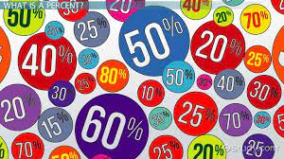 | Play ‘hit the button’ on topmarks.  P6 Numeracy & Maths Homework January  Choose ‘Match fractions, decimals and percentages’ game.  https://mathsframe.co.uk/en/resources/resource/120/match_fractions_decimals_and_percentages#.UCdcd2MsCEY | Roll and ball to and from a partner. Count up In 3’s, 4’s, 6’s, 7’s. How high did you go?  
Find numbers on food labels. Divide the number by 10. Eg. 1030 kcal div 10 = 103.0  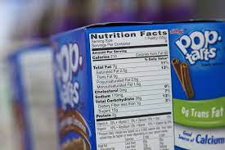  Choose 6 different food labels. |  | Get a partner to choose a number up to 50. Make the perfect number by saying the number to make 100.  Eg. Partner says 22, you say 88  Partner says 56, you say 44
Count the number of cups in the cupboard. Times this number by 10 and 100.  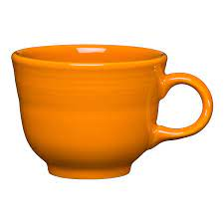  Do the same with knives and forks and 3 other items in your kitchen. | Find quarter of a number on the label of food packets. Remember quarter is 25% and it’s also ¼ which means, divide the number by 4.  Eg. 1504kcal = 1504 div 4 = 376 | Do the worksheet if your teacher has provided you with one this week.

