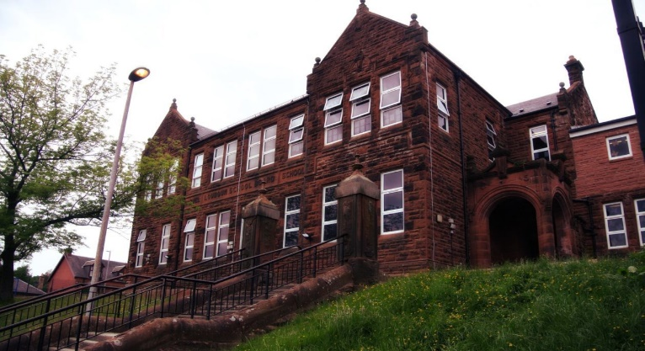

We have some bulbs sprouting from our Edina Project. We are going to be measuring them over the next few weeks.

Literacy

We are

* Learning our Burn’s Poem ‘To a Mouse’
* Focusing on reading and grammar including
  + Inferential / literal questions
  + Irregular / Imperative verbs
  + Speech marks
* Starting our 2-week spelling program
  + Letters this month /oa/ /oo/

Numeracy

We have been working on

* Increasing speed and accuracy on our 5 minute frenzy
* Fractions of a shape and number
* Equivalent and simplification of fractions

Next we will be progressing with

* Percentages and decimals

**Darvel Primary School**

**P6 R12 Class Newsletter**

**Mrs MacLeod/ Mrs. McCluskey**

**January 2023**

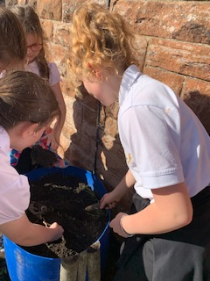 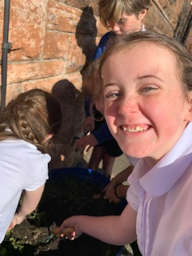

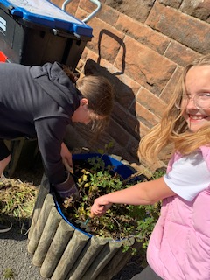

Learning across the Curriculum

We are

Learning about Transport

* Development through time
* Clydebank and the world of ship building

Also we will be learning

* Our World
* Climate Change

What a fantastic Christmas fayre we had and our calendars were a great success. We have finished our ‘Massage in schools program and have learned 14 strokes.’ We have some exciting news: we will be skiing for an 8-week block, starting Tuesday 24th January. Let’s hope for some real snow!