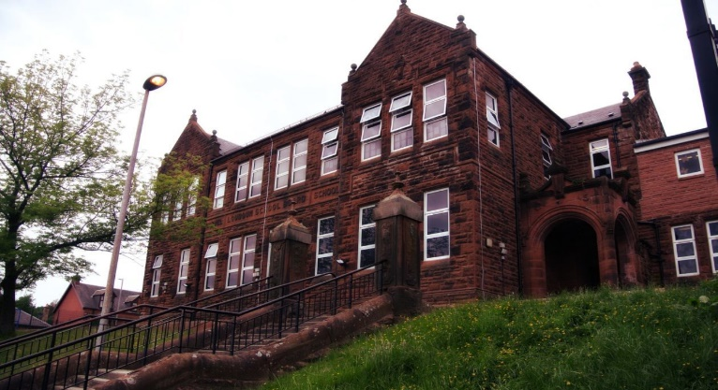

Getting up close and personal, getting our hands dirty… Outdoor Learning.

Numeracy

We have been

* Revising addition/subtraction
* Revising multiplication/division
* Progressing our money learning

Next we will be progressing with

* Money
* Addition strategies
* Extending ‘Number Talks’

Literacy

We are

* ‘Shared reading’ our class novel “The Chessmen Thief” by Barbara Anderson
* Focusing on reading strategies
* Starting our 2-week spelling program
  + Letters this month /ae/ /a./

**Darvel Primary School**

**P6 R12 Class Newsletter**

**Mrs MacLeod/ Mrs. McCluskey**

**September 2022**

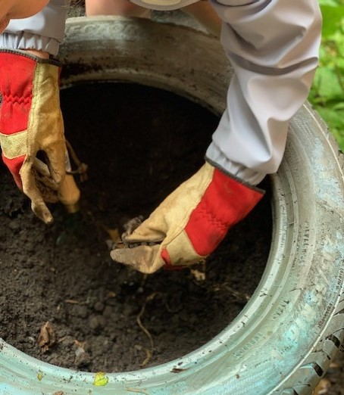 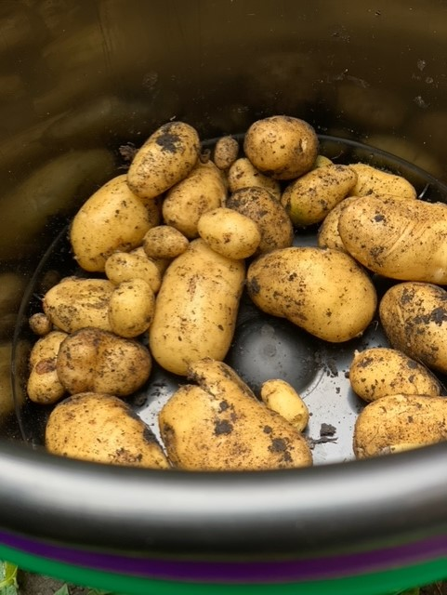

Learning across the Curriculum

We are

Learning about Vikings

* + Where they came from and their invasion on Britain.
  + Their writing and how they live

Also we will be learning

* My Body in Science
* And this

Welcome back and welcome to Primary 6b.

We are very excited to be a couple of weeks into Term 1. We are loving our Outdoor Learning and we have harvested potatoes and are maintaining our outdoor learning spaces.