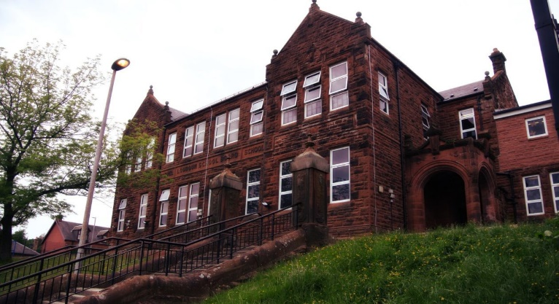

Weeding and Walking … Outdoor Learning.

What a busy beginning to our year. We have been weeding our outdoor spaces and we all finished a walking challenge, the class and both teachers together. Our French is progressing, basic instructions, how we are feeling and classroom resources.

We will be creating a booklet to raise funds for a school trip. Details to follow, watch this space...

Learning across the Curriculum

We will be finishing our Vikings topic. We have explored: origin, invasion and raids, housing, longboats, characteristics and Gods.

Also we will be starting our “Talking to wee people” topic and visiting infant classes practising our strategies.

Numeracy

We have been

* Exploring and consolidating various mental addition/subtraction strategies
* Learning about money and budgeting

This month we will be progressing with

* Money
* Multiplication and division

Literacy

We are

* Using “The Chessmen Thief” through shared reading; exploring characters, imagery, language and completing various literacy task map activities
* Creating newspaper articles
* Continuing our 2-week spelling program.
  + Letters this month /b/ /d/

**Darvel Primary School**

**P6 R12 Class Newsletter**

**Mrs MacLeod/ Mrs. McCluskey**

**October 2022**



