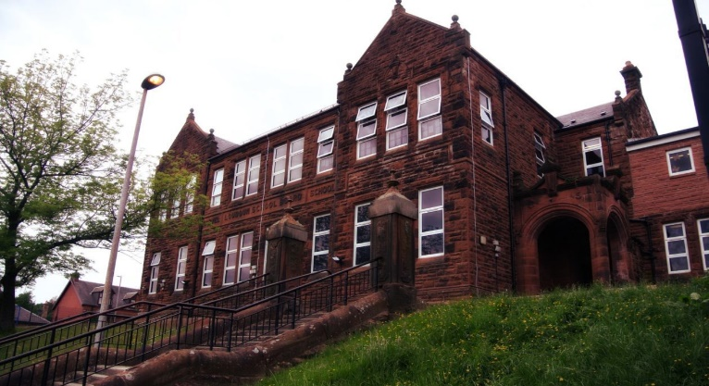

We have had a busy month. We visited Vikingar, learned about the Battle of Largs and did some role-play. We also went along to Kilmarnock v Hibernian football match. We have been learning how to lead a PE session with Active Schools and we will be inviting another class to join us and lead the session with our training.

Vikingar and attending the Kilmarnock Football Game.

Learning across the Curriculum

We have been learning about Road Safety, Body Systems and we have been training in ‘Massage in Schools Program.’ Also have been visiting the P1 classes, learning how to communicate with them, letting the wee ones lead and supporting them.

Numeracy

We have been

* Improving times table recall speed through daily challenges
* Shape
* Fractions and Equivalent Fractions

This month we will be progressing with

* Fractions
* Decimals and Percentages

Literacy

We are

* Extending our comprehension strategies; inference and Metalinguistics
* Daily ERIC (independent reading)
* Creating leaflets and writing letters
* Continuing our 2-week spelling program.
  + All diagraphs related to /e/

**Darvel Primary School**

**P6 R12 Class Newsletter**

**Mrs MacLeod/ Mrs. McCluskey**

**December 2022**



