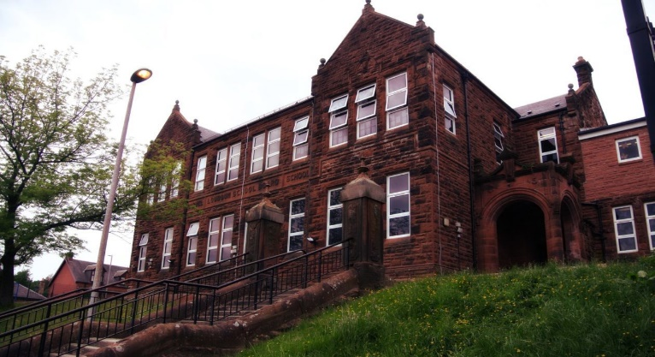

Our sunflower today May 3rd. Watch this space…

Winning ‘Nurse’s Day’ poster – Eilidh Campbell

We have the King’s Coronation this week where we will be crowning our King at the Coronation Day at school. We have been learning songs and preparing to celebrate.

We have been enjoying our Outdoor Learning and we have given each class a sunflower to grow in class. We are having a competition for the tallest flower by the end of the school term.

We will be visiting Dean Castle for a day of Danger Detectives later in the month.

Finally we will be inviting parents for our annual Parent’s Evening to see the children’s work and speak to the teacher.

Numeracy

We have been working on

* Time and Measure

Next we will be doing for the last term

* Increasing accuracy and speed on mental maths
* Taking our learning outdoors

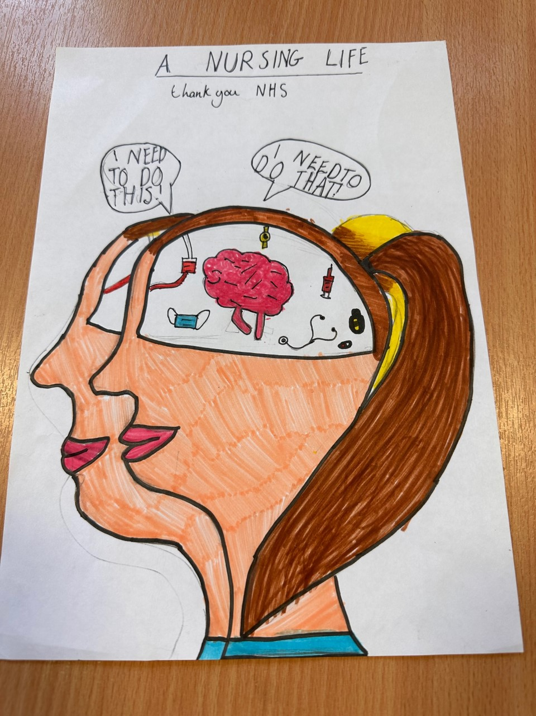

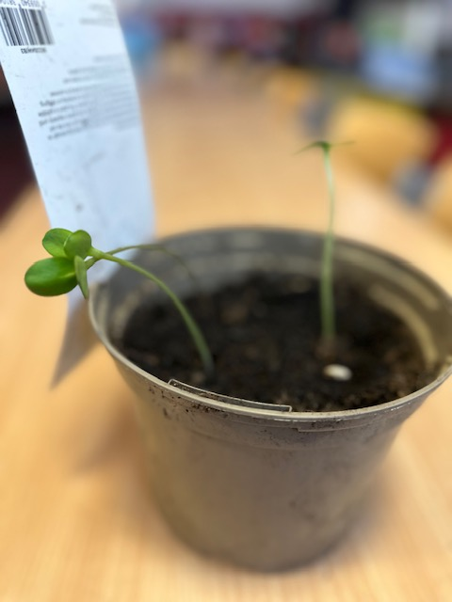

Learning across the Curriculum

We are

Learning about Adaption and Interdependency!!

* Habitats, Food Chains, Food Webs

Also we will be learning

* Parenthood in HWB

Literacy

We are

* Continuing to read and investigate all aspects of our novel ‘The Butterfly Lion’
* Consolidating apostrophes, summarising and investigating metalinguistics
* Starting our 2-week spelling program
  + Letters this month /g/ /ow/

**Darvel Primary School**

**P6 R12 Class Newsletter**

**Mrs MacLeod/ Mrs. Smith**

**May 2023**