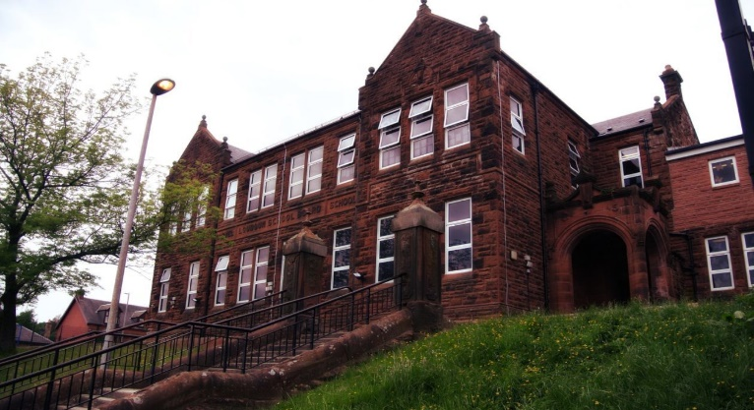

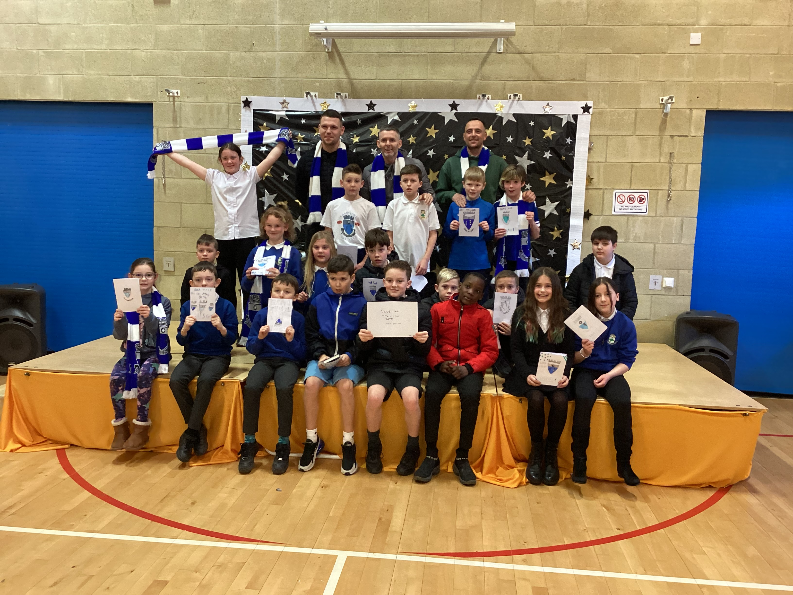

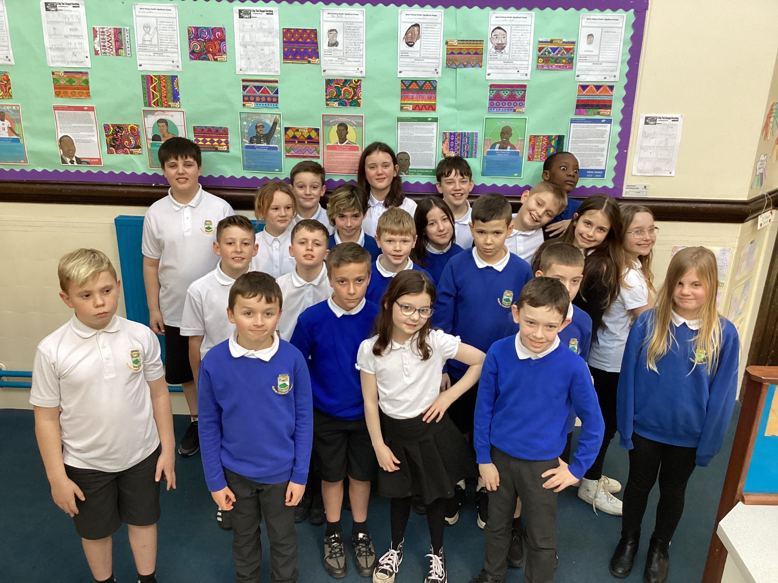

Numeracy

We have been working on

* Percentages and decimals

Next we will be starting

* Time

We continue to have daily speed and accuracy changes and try to beat previous scores.

Literacy

We are

* Continuing to progress with our Burn’s poem
* Fine tuning our poem in Big Writing
* Working on questioning and summarising
* Starting our 2-week spelling program
  + Letters this month /yoo/ /u/
  + Working on ‘topic words’ and words that are commonly misspelt

**Darvel Primary School**

**P6 R12 Class Newsletter**

**Mrs MacLeod/ Mrs. McCluskey**

**February 2023**

Learning across the Curriculum

We are

Learning about Transport and Logistics!!

* Food transport, railways, city bikes, shipping, internet shopping

Also we will be learning

* Days and months in French
* More on Climate Change

We have started our visits to the nursery and will visit every 4 weeks. We will choose buddies for each child in term 4.

Obviously we have been celebrities, appearing on several national TV channels and we are going to continue to support our local football team as they continue to climb up the football ladder. And, our skiing visits have started, which we LOVE!