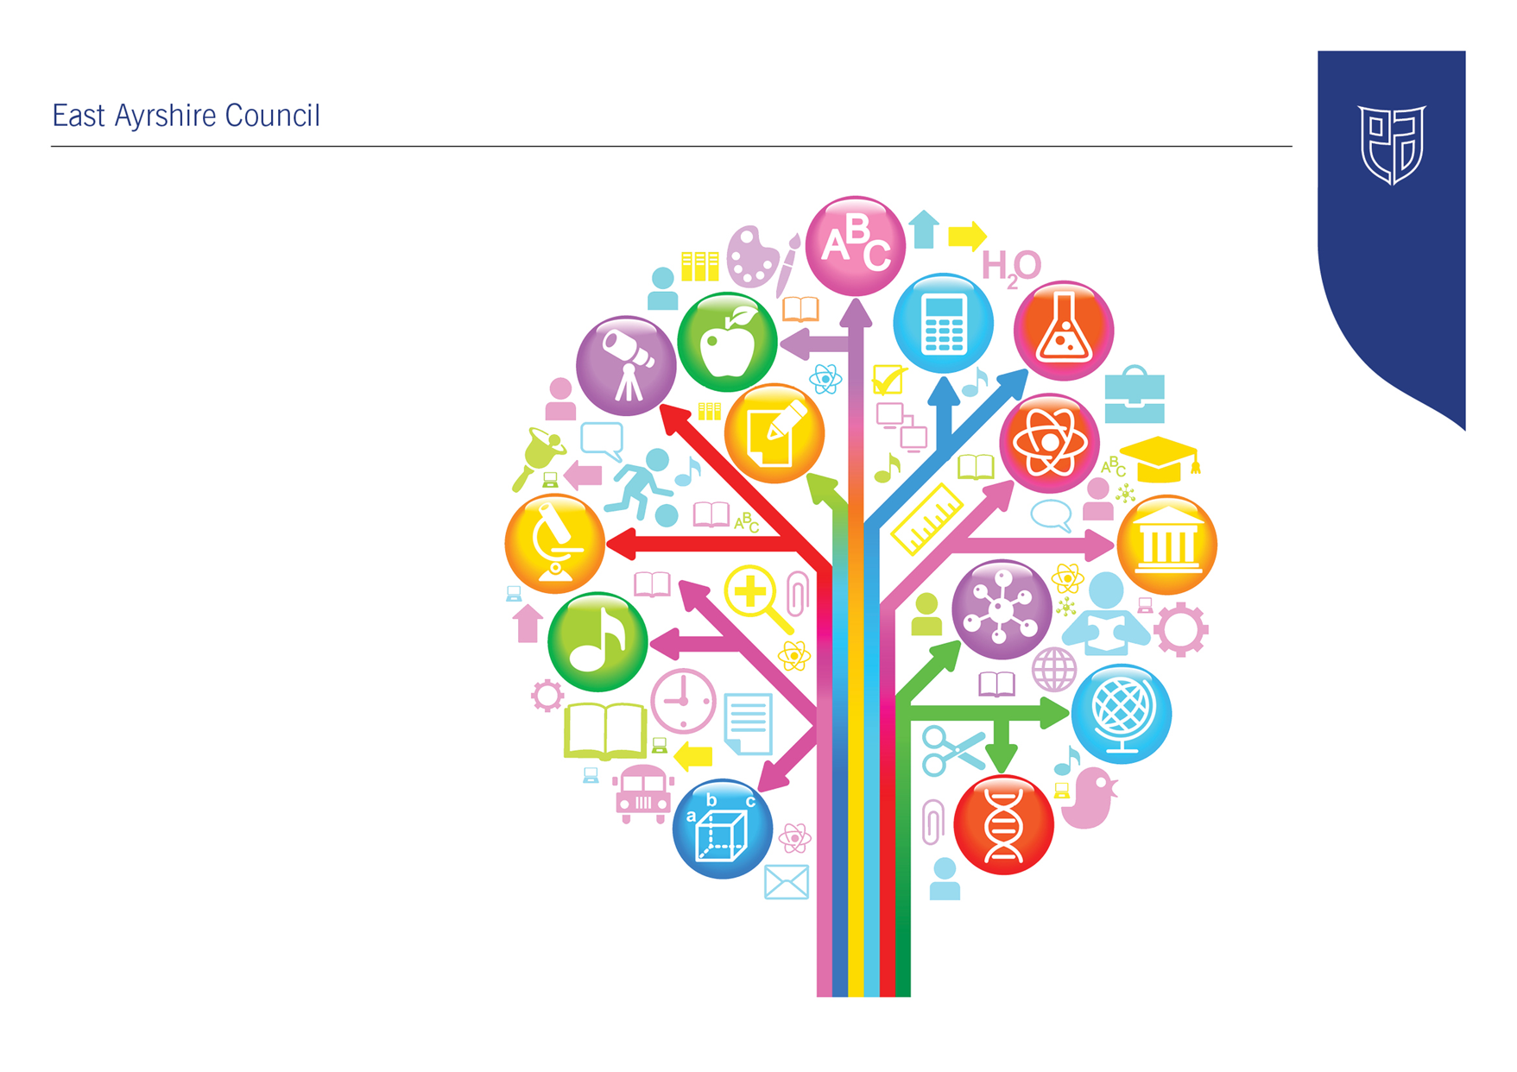
Standards and Quality Report
2022-23

Dalrymple Primary School and Early Childhood Centre
Establishment Context
Key Purposes of this is to report on our progress in implementing priorities listed in the school/centre improvement plan, taking into account national and local priorities. To provide an evaluative summary of the quality of the work across a range of areas in the school using quality indicators to support self-evaluation and to highlight strengths and identify priorities for next year.

The Head Teacher has responsibility for both Dalrymple and Littlemill Primaries and Early Childhood Centres. The establishment and staff work together across schools in partnership.

Dalrymple Primary School & Early Childhood Centre is situated in the village of Dalrymple and is part of the Doon Education Group. When pupils reach secondary age, they transfer to Carrick Academy in Maybole, South Ayrshire. At present the school has six classes and an Early Childhood Centre staffed by seven teachers (two on a job-share basis), a Depute Head Teacher (who works across both schools), one Principal Teacher (who works across both school), six early learning and childcare practitioners (two on a job-share basis), one support assistant, a senior early learning and childcare practitioner, two classroom assistants, two clerical assistants and Head Teacher. The ECC staff are permanent with the exception of one supply practitioner. The senior post is full time temporary this year.

The school currently comprises of six classrooms, ICT suite, Pupil Support Room, Health and Wellbeing Room, Gym Hall, Dining Hall, three nursery rooms with substantial outdoor play area, and offices. We are also registered to accommodate 2 years olds within the ECC and have recently had a variation with the Care Inspectorate to increase the number of children within the ECC. The ECC is catering for 1140 hours provision since August 2021.

The school also has access to the Community wing and uses one of the rooms as a staffroom/base due to COVID mitigations. This has continued into this year.

The staffroom is also the base for the breakfast club which was started in August 2023 and runs 5 mornings a week. This provision will extend in to after-school care in October 2023 and is a paid service.

At present we have 124 pupils in the primary years and 26 registered children in the Early Childhood Centre in Dalrymple.

One of the key strengths of the school are a culture where children, families and staff feel valued and rightly prioritise, as a whole school, the wellbeing of all. The staff team is committed to individual and establishment wide professional learning. This includes learning on local, national and global platforms. Staff feel motivated to use their learning in their work and this has had a positive impact on staff wellbeing during the pandemic.

The school and ECC now work well together and there is a sense of team across the school.
Children attending the ECC enjoy access to a range of indoor and outdoor play areas. Children are happy and confident making choices in their activities and learning to play together. They are well supported in their play and learning.

The school and ECC engage with staff, children and parents to explore views and interests. The staff team makes use of curricular frameworks that result in teachers planning effectively so that children can build on their prior learning effectively. They make use of national and international research to inform developments. We have identified the need to continue our work to ensure children experience a broad and relevant curriculum. Plans are in place to refresh the contexts for learning across the school and to continue to place the rich local environment at the centre of our curriculum.

The school and ECC received a Follow-Through Visit from Education Scotland HMIe on 6th December 2021. A copy of the reporting letter is available here:
https://www.education.gov.scot/media/l3ulzezl/dalrymple-ps-vl-300822.pdf

The ECC received an unannounced visit from Care Inspectorate on 10th December 2010
From this inspection the Care Inspectorate graded this service as:
Quality of care and support 4 – Good
Quality of environment 4 – Good
Quality of staffing 4 – Good
Quality of management and leadership 4 – Good

The full report can be found here:
https://www.careinspectorate.com/berengCareservices/html/reports/getPdfBlob.php?id=310666

School Profile
Census Rolls (#) | 2015/16 | 2016/17 | 2017/18 | 2018/19 | 2019/20 | 2020/21 | 2021/22
 | 156 | 164 | 163 | 157 | 149 | 138 | 128

2021/22 Census FMR (%) | 26 | 2021/22 EAC Census FMR (%) | 24

2021/22 Census ASN (%) | 27 | 2021/22 EAC Census ASN (%) | 23

Stage Profile (2021/22 Census)
Stage | P1 | P2 | P3 | P4 | P5 | P6 | P7
Total (#) | 13 | 22 | 17 | 19 | 18 | 17 | 22
% each pupil accounts for | 8 | 5 | 6 | 5 | 6 | 6 | 5
# Males | 5 | 9 | 9 | 8 | 9 | 7 | 12
# Females | 8 | 13 | 8 | 11 | 9 | 10 | 10
# ASN | 1 | 7 | 7 | 6 | 7 | 4 | 3
% ASN | 8 | 32 | 41 | 32 | 39 | 24 | 14
EA % ASN | 9 | 17 | 23 | 24 | 30 | 26 | 28

SIMD Profile (2021/22 Census)
SIMD Decile | 1 | 2 | 3 | 4 | 5 | 6 | 7 | 8 | 9 | 10 | N/A
P1 (#) | - | - | 5 | - | 7 | 1 | - | - | - | - | -
P2 (#) | - | 1 | 10 | - | 11 | - | - | - | - | - | -
P3 (#) | - | - | 6 | - | 9 | 2 | - | - | - | - | -
P4 (#) | - | - | 10 | - | 4 | 4 | 1 | - | - | - | -
P5 (#) | - | - | 7 | - | 9 | 2 | - | - | - | - | -
P6 (#) | - | - | 6 | - | 11 | - | - | - | - | - | -
P7 (#) | - | - | 8 | - | 9 | 2 | 2 | - | - | 1 | -
Total (#) | - | 1 | 52 | - | 60 | 11 | 3 | - | - | 1 | -
% of Roll | - | 1 | 41 | - | 47 | 9 | 2 | - | - | 1 | -
East Ayrshire % | 17 | 16 | 13 | 12 | 9 | 7 | 6 | 8 | 6 | 4 | 1

Attendance & Exclusions
Attendance | 2016/17 | 2017/18 | 2018/19 | 2019/20 | 2020/21 | 2021/22
All Pupils (%) | 94 | 94 | 94 | 92 | 96 | 89
SIMD 1&2 Pupils (%) | 92 | 96 | 94 | 94 | 99 | 21
SIMD 3-10 Pupils (%) | 94 | 93 | 94 | 92 | 96 | 89
Education Group (%) | 94 | 93 | 93 | 93 | 93 | 90
East Ayrshire (Sector %) | 95 | 94 | 94 | 94 | 94 | 91
East Ayrshire SIMD 1&2 (Sector %) | 93 | 93 | 92 | 92 | 92 | 88
East Ayrshire 3-10 (Sector %) | 95 | 95 | 95 | 95 | 95 | 92
National (%) | 95 | - | 95 | - | TBC | TBC

Exclusions | 2016/17 | 2017/18 | 2018/19 | 2019/20 | 2020/21 | 2021/22
# Pupils Excluded | 0 | 1 | 0 | 2 | 2 | 0
# Exclusion Incidents | 0 | 1 | 0 | 2 | 2 | 0
# East Ayrshire Primary Exclusion Incidents | 199 | 110 | 185 | 79 | 47 | 60
# Exclusion Openings | 0 | 2 | 0 | 13 | 10 | 0
# East Ayrshire Primary Exclusion Openings | 568 | 313 | 635 | 274 | 128 | 156

Establishment Vision, Values and Aims
Our Values:

- Community
- Trust
- Joy
- Ambition

Our Vision:
Today in Dalrymple Primary, our aim is simple. It’s community at the heart of all we do – to make the very best use of the resources, places and people around us. To shape the journey, not only of our learners, but alongside the community which we serve.
Today, it requires trust, with strong and lasting foundations. Building and sustaining partnerships – the mortar which holds together the building blocks of lifelong learning.
Today it requires bringing joy to the classroom. This not only enables children to be informed, but to be inspired, inquiring and independent, ready to face the challenges of an ever changing landscape.
Today our ambition is again simple – we want excellence in all that we do, for all whom we serve. We don’t want our learners to reach their potential. We want them to exceed it.
https://youtu.be/4DEThk2Ttnw

Our Aims:

Working Together  - Learning from each other  - Sharing resources  - Investing in others  Providing Excellence  - Pushing the boundaries of achievement  - World Class | Raising Capability  - Helping people learn  - Laying foundations for later success  Focusing on the Value Added  - Holding hope for every child  - Every gain a victory  A Hunger for Improvement  - High hopes and expectations

Improvement Priority  (Expressed as outcomes for learners) | To develop teacher professionalism and leadership at all levels across the school to ensure the highest quality of learning and teaching for pupils | Rationale for improvement priority based on evidence  Research indicates that investment in teacher professionalism and school leadership has the most significant impact on pupil progress and outcomes
NIF Priorities  Improvement in attainment, particularly in literacy and numeracy | NIF Driver  School Leadership & Teacher Professionalism | HGIOS/ HGIOSELCC QI’s for self-evaluation  1.1 – Self Evaluation for self-improvement  1.2 – Leadership of Learning  1.3 – Leadership of Change  1.4 – Leadership of staff  1.5 – Management of resources to promote equity  2.3 – Learning, teaching & assessment  3.2 – Raising Attainment and Achievement
Progress and Impact | - Froebel Network opportunities across SWEIC and nationally – Cowgate Under 5 Nursery, Edinburgh; Our Wee Garden Kindergarten, Royal Botanic Gardens Edinburgh; Froebel Trust have all been accessed and staff have shared experiences with each other and this has informed practice across the early years. Outdoor areas have charged and indoor experiences have become more fluid and child-led.  - Staff have been able to collaborate with colleagues across their own early year’s establishment and Littlemill ECC and discussed how their own learning has impacted on their learners.  - Participation levels in CLPL opportunities by staff have increased ensuring an increase in effective learning and teaching for pupils. Staff have had access to the World Summit CLPL Programme, Deep Learning on a global level, Froebel. Learning Journals,DLD training, PATHS,  - Sustained staff attendance at work ensuring continuity and consistency of learning for pupils  - Vulnerable pupils and families and those under GIRFEC have been supported by PT (HWB) who was the lead in the PATHS programme and attended DDP training.  - Glasgow Motivation & Wellbeing Profile (GMWP), Wellbeing Webs: ‘Small Test of Change’ – Pilot and Implemented with the support of YIPworld  - Increase in attainment levels of pupils as seen in ACEL data:
Next Steps | - Early years need to concentrate on future planning and a more structured environment as to ensure coverage of experiences and outcomes.  - Glasgow Motivation & Wellbeing Profile (GMWP), Wellbeing Webs should be rolled out to the whole school and tracked and monitored by HWB coordinator.  - Continued CLPL calendar for all staff including associations with SWEIC.  - A robust quality assurance calendar to include self-evaluation over a three-year rolling programme

Improvement Priority  (Expressed as outcomes for learners) | To implement whole school improvements and increase pupil engagement by introducing New Pedagogies for Deep Learning  - developing 6 global competencies (6Cs) including: character, communication, collaboration, critical thinking, creativity and citizenship  - enabling pupils to survive and flourish in a globally challenging and complex world. | Rationale for improvement priority based on evidence  ‘A new approach to look beyond academic learning’ by the OECD Education and Skills Today, 2021, examines measuring social and emotional skills (alongside the global metrics for academic schooling outcomes) which they believe to make individuals, businesses and counties successful.  The work continues to determine measurement of these skills and states that it covers a range of outcomes,  “Which research shows are highly predictive for labour-market and social success, such as open-mindedness (including creativity and curiosity), task performance (including responsibility, self-control and persistence), sociability and assertiveness, collaboration as well as stress resistance and emotional control.”  Andreas Schleicher (2021)  Together with the findings from Jean Clinton, Child Psychiatrist and Professor of Neurosciences at McMaster University., Hamilton, Canada to promote equity through SEL. She states that:  “A focus on the 6Cs immunizes and protects against social and emotional difficulties, thus building positive mental health and resilience … (and) levels the playing field for kids from challenging backgrounds.”  (2021)
NIF Priorities  Closing the attainment gap between the most and least disadvantaged children | NIF Driver  School improvement | HGIOS/ HGIOSELCC QI’s for self-evaluation  1.2 Leadership of Learning  1.3 leadership of Change  1.4 Leadership and Management of Staff  2.3 Learning, Teaching and Assessment  2.7 Partnerships  3.1 Improving Wellbeing, Equality and Inclusion  3.2 Raising Attainment and Achievement  3.3 Increasing Creativity and Employability
Progress and Impact | - Staff initially shared evidence of collaboration with colleagues across both Littlemill and Dalrymple Primary Schools and ECCs about how their own learning has impacted on learners.  - Curiosity bags were given out prior to the summer breaks to embed the Cs in the EEC and start conversations with parents/carers. This enhanced relationships with the school/ECC.  - Participation levels in CLPL opportunities by a small group of staff from both schools and ECCs, will have ensuring an increase in effective learning and teaching for pupils incorporating IDL  - CLPL amongst staff both nationally and globally
Next Steps | - Decide as a school whether to continue with Deep Learning as a priority/enhance IDL

Improvement Priority  (Expressed as outcomes for learners) | To improve parental empowerment across the school to ensure parent/carers are aware of pupil targets and supporting them in achieving these. | Rationale for improvement priority based on evidence  Pupil attainment and achievement improves considerably with increased parental engagement in their learning
NIF Priorities  Improvement in children and young people’s health and wellbeing | NIF Driver  Parental engagement | HGIOS/ HGIOSELCC QI’s for self-evaluation  2.5 – Family Learning  3.1 Ensuring wellbeing, equality and inclusion  3.2 – Raising attainment and achievement
Progress and Impact | - Increased participation levels at parent workshops – especially in relation to teacher/parent tracking and monitoring meetings – this has led to better access and understanding for pupils/parents/carers and better awareness of pupils’ own learning journey.  - Increased usage of Learning Journals among ECC and P1 parents.  - Pupils and parents are able to identify targets and progress in relation to achievement of a level.  - Increased level of parent/carer participation has impacted upon improved wellbeing indicators for pupils  - Pupil attendance has increased as a result of priorities with various organisations.
Next Steps | - Evidence impact of parental involvement/participation in relation to pupil’s HWB.

Pupil Equity Fund: Evaluation
Approach/Intervention | Impact  Report on how you have improved outcomes for learners impacted by poverty | What evidence do you have of positive impact?  Outline the data that supports your findings.
PT GIRFEC/HWB | Rise in pupil attendance through links with various organisations including Home link. | Attendance rates have gone from 85 % to 93%
 | Pupil’s ability to regulate emotions through PATHS programme.  Parental understanding about the PATHS programme has helped them to support their children at home. | Workshop attendance, informal conversations at Parent Council meetings, feedback from parents though PTP meetings.  Children and parents using the language of PATHS at home and at school.
Classroom Assistant | Target HWB groups of children to lower anxiety for secondary transitions in P7.  To target literacy and numeracy groups to increase attainment illiteracy and numeracy across the stages | Individual pupil data demonstrates that pupil progress as increased in literacy and numeracy due to targeted support in the class.  P7 pupils have left with confidence as conversations with both them and their families have shown that the intervention has absolutely made a difference this year.

Establishment Self Evaluation: How Good is Our Early Learning and Childcare? Quality Indicators
Quality Indicator 1.3 Leadership of Change | 3/4
Quality Indicator 2.3 Learning, Teaching and Assessment | 4
Quality Indicator 3.1 Ensuring Wellbeing, Equality and Inclusion | 5
Quality Indicator 3.2 Securing Children’s Progress | 4

Establishment Self Evaluation: How Good is Our School? 4 Quality Indicators
Quality Indicator 1.3 Leadership of Change | 3
Quality Indicator 2.3 Learning, Teaching and Assessment | 4
Quality Indicator 3.1 Ensuring Wellbeing, Equality and Inclusion | 5
Quality Indicator 3.2 Raising Attainment and Achievement | 4

Establishment Capacity for Improvement
Community
Dalrymple Primary School has fabulous potential for developing local and community links. The green space to the side of the school is being developed into a pathway with ponds and gardens and we have already begun working with the local community groups to help develop this space further in line with their projects.

Parents have asked to be on board with the parental body of the school and create a sub-group to create a welcome space to talk about supporting with the P7 transition this year. This is a welcome addition to our parent council as we are cross boundaries for South Ayrshire and our pupil’s transition in to Carrick Academy.

Trust
Our staff and community members are highly motivated and dedicated to this school and Early Years Setting. We all want the best we can possible achieve across the stages and trust that all of the people involved are working together to achieve this. We will continue to strive to work together, taking ownership of the improvements we wish to make and trust in each other to make positive changes to both the school and ECC.

Joy
Our high hopes and ambitions for everyone in the ECC and school includes sustaining a welcoming ethos and creative learning environment. A place where staff welfare is as important as the pupils and parents we work with every day. We will continue to put health and wellbeing at the forefront of everything we do.

Ambition
We believe in having high expectations for everyone who lives, breathes and works with us at Dalrymple. Aim high and achieve high. Live in a wold that there are no barriers to learning and any we may then encounter, we encounter and break down together.

Have ‘blue sky thinking’ and allow everyone the opportunity to gain new experiences and realise their own ambitions and potentials through the art of discovery.

