Create your own character using objects in your house.

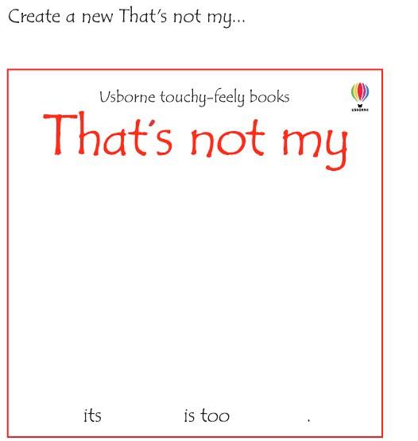E.g. that’s not my monkey. (Using a towel) it’s tummy is too soft/rough/colourful