Dalmellington Primary School and ECC
Relationship Policy
How we achieve this
Values  - We aspire to do our best.  - We care for each other.  - We make each other happy.  - We are achieving.  - We respect each other.  - We work together as Team Dalmellington. | Vision | UNCRC  Dalmellington PS and ECC is an accredited Rights Respecting School. We have achieved our ‘Silver – Rights Aware’ accreditation. This means children’s rights are learned,  understood and lived in our school and ECC.
Getting It Right For Every Child  - Dexter’s Learning Squad  - Nurture Groups  - Targeted Support Boost Groups  - Social/Emotional Check-ins  - Growth Mindset  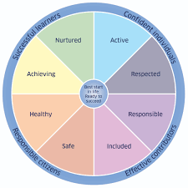  - EAL Support  - LIAM groups  - Exchange referrals | PATHS  In Dalmellington PS and ECC we Promote Alternative Thinking Strategies to support Emotional Literacy.  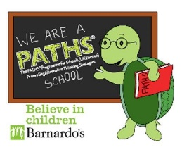 | Restorative Approach  All staff use restorative questions to support all pupils when they require it.  - What happened?  - How do you feel?  - Was anyone upset by this?  - What do you think needs to happen to fix this?  - Is there anything we can do to help you right now?
Charters  Our whole school and class charters provide a way for us to demonstrate a commitment to our vision and values. We have a range of Charters at Dalmellington PS and ECC.  - Class Charters  - Playground Charter  - Football Charter | Inclusive Schools / Communication Friendly  We have achieved our Silver accreditation for Inclusive Schools, this means we actively support, engage and challenge all pupils. We are working towards our Communication Friendly accreditation. We aim to make all communication consistent, easy and effective. | Parental Engagement  Our parents work closely with us to ensure the best support is given at all times.  - Parent Council  - Stay and Play  - Feedback Questionnaires  - Focus Groups  - ECC Parent Helpers  - Information Workshops  - Regular Communication
Pupils Lead Across our School and ECC
- Our pupils actively engage and lead learning across Dalmellington PS and ECC. We have many active pupil groups where our pupils are empowered to take elements our school improvements forward.

Pupil House Captains and Vice Captains | PATHS B’s Buddies
Primary 7 Buddies | Dexter’s Learning Squad
Junior Librarians | RRS Squad
Digital Leaders  Pupil Council | Eco Committee and Property Pledge Team

Celebrating Success
We celebrate every pupil’s success whether they happen in or out of school.
Wider Achievement | House Points Awards
Prize Giving Celebrations | Values Certificates at Assemblies

Dalmellington Primary School and ECC
Relationship Policy

Rationale:
In Dalmellington Primary School and ECC we are committed to providing children with the best possible learning and teaching experiences. We believe that this can be best achieved through building positive relationships across the school community, embedding nurture principles in our daily practice and ensuring a focus on social and emotional wellbeing and an ethos of community, mutual respect and trust.

Aims of Policy:
- To develop a whole school positive relationships policy supported by parents, staff and pupils and underpinned by the school’s values of Aspiration, Caring, Happiness, Achieving, Respect and Teamwork, which themselves are underpinned by local and national policy and guidance.
- To support staff by providing a clear and consistent framework for promoting positive relationships and by communicating expectations in a clear way.
- To create a safe and positive environment which promotes enjoyment in learning and raises attainment.
- To develop a shared vision and understanding of restorative practices, approaches and methodologies.
- To support pupils in dealing with difficulties and resolving conflict in a positive manner.
- To support children in understanding the impact of their behaviours through restorative conversations.
- To ensure that we work closely with parents at all times to support their child’s personal development.

National Context
Scottish Ministers have set an ambition for our country: that Scotland is the best place to grow up and bring up children.
“To achieve that we require a positive culture towards children. One where children are welcomed and nurtured. One where we all are alert to their needs and look out for them. Where they are listened to – whatever their age – and where their views are heard and their rights protected. They should be respected as people in their own right. Not as economic units for the future. But as members of Scottish society now with rights to a present day life that allows them to fulfil their potential.” (Scottish Government 2014)
EAC Context
East Ayrshire Council has developed a Relationships Framework in 2017, this highlights the importance of 5 key areas:
· Restorative Approaches
· Resilience
· Rights Based
· Solution Orientated Approaches

Nurturing Approaches
Nurture Principles are embedded in every aspect of school life as we continue to create a safe, welcoming environment for pupils to flourish.
“At the heart of nurture is a focus on wellbeing and relationships and a drive to support the growth and development of children and young people.” (Nurture as Whole School Approach)
This will be implemented through the Nurturing Principles:
- Children’s learning is understood developmentally
- Classroom offers a safe base
- The importance of nurture for the development of wellbeing
- Language is a vital means of communication
- All behaviour is communication
- The importance of transition in children’s lives

Policy Creation
In creating this policy, we have consulted with staff and children to identify key policy aims and to develop a pro-active approach to developing positive relationships and behaviours between all members of our school community. Pupils, parents, teachers and support staff will take collective responsibility for promoting positive relationships in Dalmellington Primary School and ECC. We regularly self-evaluate for continuous improvement.

Relationship Flow Chart for Pupils
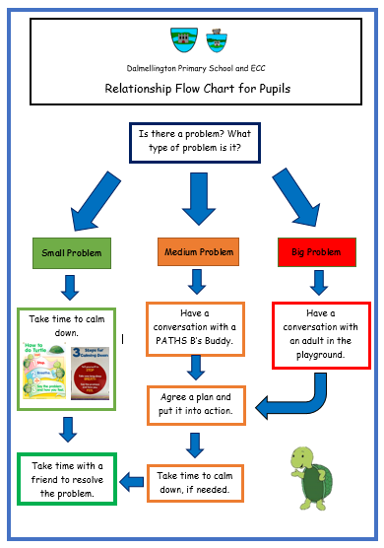
*Consultation with pupils scheduled for Friday 23rd June

